

**Prairie**

**View**

**A&M**

University

**FINGERPRINT BASED ATTENDANCE MANAGEMENT SYSTEM**

**ASHA MERNEDI**

A Project

Submitted to the Department of Computer Science

In Partial Fulfillment of the Requirements for

The Degree of

MASTER OF SCIENCE

IN

COMPUTER SCIENCE

PRAIRIE VIEW A&M UNIVERSITY

COLLEGE OF ENGINEERING

PRAIRIE VIEW, TEXAS

DECEMBER 2014

PRAIRIE VIEW A&M UNIVERSITY

COLLEGE OF ENGINEERING

PRAIRIE VIEW, TEXAS

**FINGERPRINT BASED ATTENDANCE MANAGEMENT SYSTEM**

A Project

Submitted to the Department of Computer Science

In Partial Fulfillment of the Requirements for

The Degree of

MASTER OF SCIENCE

IN

COMPUTER SCIENCE

Submitted By:

**ASHA MERNEDI**

**Certificate of Approval:**

_____________________________ ____________________________

Kiranmai Bellam Akhtar H. Lodgher

Student Advisor Student Co-Advisor

Assistant Professor Associate Professor

Department of Computer Science Department of Computer Science

_____________________________

Lin Li

Graduate Program Coordinator

Associate Professor

Department of Computer Science

_____________________________

Yonggao Yang

Associate Professor

Department Head

Department of Computer Science

December 2014

# ABSTRACT

Fingerprint Based Attendance Management System.

(December 2014)

Asha Mernedi

M.S., Prairie View A&M University

Student Advisor: Dr. Kiranmai Bellam

Over the past few decades manual attendance roll call has been the only way to monitor record and track students’ presence in schools. Recently, significant changes have been observed in tracking human resources in various organizations. So, now it is time to create a unique and automatic process to track and monitor human resources. Biometric Fingerprint Attendance Management System is one of such processes to track and monitor students. Biometric Access Control System provides the highest level of security available today by eliminating the stolen, transferred and duplicating. It will minimize the manual work and eliminate the associated paper and punch card based monitoring and recording systems.

The main goal of this project is to develop a Fingerprint based attendance Management system. This project involves development of the fingerprint identification system along with development of attendance management system. This attendance system is designed using a responsive web design tool, Bootstrap. This can be viewed on handheld devices also. The Futronic Fingerprint Reader will be configured to scan and store the student finger prints with the login names and passwords in the instructor computer. This shall be achieved by developing fingerprint identification system .The device interactively communicates student names, date and time to compatible applications and websites. These applications and websites will automatically update the attendance in database so that can be used by all Instructors and students for their respective courses. This application allows the faculty and students to view attendance and edit their details whenever required

The system integrates Futronic scanner with graphical user interface (GUI). The system is developed using current technologies such as ASP.NET MVC 4.0, JQuery, .NET Framework, SSRS (SQL Server Reporting Service)

TABLE OF CONTENTS

ABSTRACT iv

LIST OF FIGURES xi

LIST OF TABLES xiv

SECTION 1 1

INTRODUCTION 1

1.1 PURPOSE 1

1.2 MOTIVATION AND CHALLENGES 2

1.3 SCOPE 3

1.4 OUT OF SCOPE 4

1.5 DEFINITIONS, ACRONYMS, AND ABBREVIATIONS 4

1.6 OVERVIEW 5

SECTION 2 6

PROJECT GOALS & OBJECTIVES 6

2.1 GOAL 6

2.2 OBJECTIVES 6

2.3 POJECT SIGNIFICANCE 6

SECTION 3 9

REQUIREMENT MODELING 9

3.1 FUNCTIONAL REQUIREMENT 9

3.2 NON-FUNCTIONAL REQUIREMENTS 10

3.3 HARDWARE REQUIREMENTS (Minimum Requirement) 11

3.4 SOFTWARE REQUIREMENTS (Minimum Requirement) 12

SECTION 4 13

LITERATURE REVIEW 13

4.1 DEVELOPMENT ENVIRONMENT AND TECHNOLOGIES 13

4.2 BOOTSTRAP FRAMEWORK 3, 3.1 13

4.3 MVC SOFTWARE PATTERN 14

4.4 DEVELOPMENT TOOLS 18

4.5 BIOMETRIC TECHNOLOGIES 20

SECTION 5 24

OVERALL DESCRIPTION 24

5.1 PROJECT PLANNING 25

5.2 SYSTEM OPERATION 27

5.3 DESIGN CONSTRAINTS 29

5.4 ASSUMPTIONS AND DEPENDENCIES 29

SECTION 6 31

FINGERPRINT IDENTIFICATION SYSTEM 31

6.1 HOW FINGERPRINT IDENTIFICATION WORKS? 31

6.2 FINGERPRINT IDENTIFICATION SYSTEM FLOWCHART 31

6.3 PROCESS OF FINGERPRINT IDENTIFICATION: 32

6.3 DESIGN DESCRIPTION 33

6.4 MINUTIAE EXTRACTION 35

6.5 RECOGNITION OF MINUTIAE 37

6.6 FINGERPRINT MATCHING 39

SECTION 7 42

ATTENDANCE MANAGEMENT FRAMEWORK 42

7.1 HARDWARE LEVEL DESIGN 42

7.2 ATTENDANCE MANAGEMENT APPROACH 43

7.3 PROPOSED SYSTEM 43

7.4 CHARACTERISTICS OF THE PROPOSED SYSTEM 44

7.5 ATTENDANCE MANAGEMENT FRAMEWORK FLOW CHART 45

7.6 COMPARISON WITH OTHER STUDENT ATTENDANCE SYSTEMS 46

7.7 ON-LINE ATTENDANCE REPORT GENERATION 47

7.8 NETWORK AND DATABASE MANAGEMENT **Error! Bookmark not defined.**

SECTION 8 48

FUNCTIONAL MODELLING 48

8.1 USE CASE DIAGRAMS 48

8.1.1 BOOTSTRAP: System Behaviour 48

8.1.2 USERS : Access Features Based on Authorization 49

8.1.3 LOGIN 50

8.1.4 ADMIN: Adding Faculty 53

8.1.5 FACULTY: Generating Report 56

8.1.6 STUDENT: Creating Account 59

8.1.7 STUDENT: Assigning Courses 62

8.1.8 DESKTOP USERS: Access Features Based on Authorization 65

8.1.9 DESKTOP: Faculty Login 66

8.1.10 DESKTOP FACULTY: Taking Attendance 69

8.1.11 DESKTOP FACULTY: Collect Fingerprints 72

8.2 ACTIVITY DIAGRAMS: 75

8.2.1 LOGIN 75

8.2.2 ADMIN: Functions 76

8.2.3 FACULTY: Functions 77

8.2.4 STUDENTS: Functions 78

8.3 STATE DIAGRAMS 79

8.3.1 LOGIN 79

8.3.2 PRINTING ATTENDANCE REPORT 79

8.4 SWIM LANE DIAGRAMS FOR LOGIN: 80

8.4.1 LOGIN 80

8.4.2 ADMIN : ADDING NEW FACULTY 81

8.4.3 STUDENT: Attendance Report Generation 82

SECTION 9 85

DATA DESIGN 85

9.1 INTERNAL APPLICATION DATA STRUCTURE 85

9.2 DATA FLOW DIAGRAMS 86

SECTION 10 89

SCREENSHOTS AND CODE SNIPPETS 89

10.1 SCREEN SHOTS AND CODE SNIPPETS 89

SECTION 11 103

TESTING 103

11.1 TEST CLASSES 103

11.2 EXPECTED SOFTWARE RESPONSE 104

11.3 PERFORMANCE BOUNDS 105

SECTION 12 106

CONCLUSION & FUTURE WORK 106

12.1 FUTURE WORK 106

SECTION 13 107

REFERENCES 107

# LIST OF FIGURES

FIGURE 1: Example of fingerprint [8]. 21

FIGURE 2: Flowchart of Project planning 26

FIGURE 3: Flowchart of Attendance System Using Biometrics (Fingerprint). 28

FIGURE 4: Fingerprint Identification System Flowchart. [16] 31

FIGURE 5 (a) Ridge Ending 32

FIGURE 5 (b) Ridge Bifurcation 33

FIGURE 6: System Flow. 33

FIGURE 7: Detailed Design Descriptions. [14] 35

FIGURE 8 (a): Image after Binarization.[14] 36

FIGURE 8 (b): Image before Binarization.[14] 36

FIGURE 9 (a): Image before. [14] 39

FIGURE 9 (b): Image after thinning. [14] 39

FIGURE 10: Intra-Fingerprint minutiae comparison.[17] 41

FIGURE 11: Attendance Management Framework Flow chart 46

FIGURE 12: ER Diagram for Students Database and Attendance Records 83

FIGURE 12: Use Case Diagram Bootstrap: System Behavior 48

FIGURE 13: Use Case for Users: Access Features Based on Authorization 49

FIGURE 14: Use Case: Login 52

FIGURE 16: Use Case Diagram for Faculty: Generating Report 58

FIGURE 19: Use Case Diagram for Users: Access Features Based on Authorization 65

FIGURE 20: Use Case Diagram of Desktop for Faculty Login 68

FIGURE 21: Use Case Diagram for Taking Attendance 71

FIGURE 22: Use Case Diagram for Collecting Fingerprints 74

FIGURE 23: Activity Diagram for Login 75

FIGURE 24: Activity Diagram for Admin Functions 76

FIGURE 25: Activity Diagram for Faculty Functions 77

FIGURE 26: Activity Diagram for Student Functions 78

FIGURE 27: State Diagram for Login 79

FIGURE 28: Printing Attendance Report 79

FIGURE 29: Swim Lane Diagram for Login 80

FIGURE 30: Swim Lane Diagram for Admin: Adding New Faculty 81

FIGURE 31: Attendance Report Generation 82

FIGURE 32: Class diagram **Error! Bookmark not defined.**

FIGURE 33: Internal Application Data Structure 85

FIGURE 34: Context Level DFD 86

FIGURE 35: Context Level 1 DFD 86

FIGURE 36: Context Level 1 DFD 87

FIGURE 37: Context Level 2 DFD 87

FIGURE 38: Login Sequence Diagram 88

FIGURE 39: Login Sequence Diagram Take Attendance 88

FIGURE 40: Users Login Screen 90

FIGURE 41: Admin Home Screen 91

FIGURE 42: Faculty Panel 91

FIGURE 43: Checking Email 92

FIGURE 44: Login Screen 92

FIGURE 45: Taking Attendance Interfaces 93

FIGURE 46: Collecting Fingerprints 94

FIGURE 47: Course Cumulative Report of Class Math112 95

FIGURE 48: Course All Event’s Report of Class DBMS 95

# LIST OF TABLES

TABLE 1: Scope 3

TABLE 2: Table of Acronyms 4

TABLE 3: Login 50

TABLE 3: Adding New Faculty 53

FIGURE 15: Use Case for admin: Adding New Faculty 55

TABLE 5: Generating Report 56

TABLE 6: Student Creating Account 59

FIGURE 17: Use Case Diagram for Student: Account Creation 61

TABLE 7: Assigning Courses to Student 62

FIGURE 18: Use Case Diagram for Student: Assigning Courses 64

TABLE 8: Desktop: Faculty Login 66

TABLE 9: Taking Attendance 69

TABLE 10: Desktop Application for Collecting Fingerprints 72

# SECTION 1

# INTRODUCTION

**This chapter focuses on project’s background, manual system and associated problems, objectives, scope and significance of biometric fingerprint attendance system.**

## 1.1 PURPOSE

**At PVAMU, student’s attendance is taken manually by using attendance sheets by instructor in classrooms. With this manual system, there is a scope for students to cheat by asking their friends to tick or sign for them. This can happen due to cut off attendance requirement per course for the semester; otherwise they will not be permitted to the final examination at the end of the semester, without a reasonable cause.**

**Instructor cannot monitor all students in the class, and it is difficult for him to record the attendance of students accurately and efficiently. Instructor is responsible to monitor the entire student’s attendance for the whole semester. For those students who fail to meet their cut off attendance requirement shall be reminded by a warning from faculty as early as possible. Due to this problem, a system may be required for recording students’ attendance accurately with minimal effort by lecturers.**

A fingerprint device will be provided at each class and laboratory. This device will record students’ attendance in class **at the beginning and at the end to ensure that the students have attended the entire class (until end of the lecture). The other advantage in developing this system is to generate quick reports. Reports can be generated in the middle of the session or at the end.**

**The benefits associated with this system are:**

* Ease of use.
* Quick or Less time consumed
* High reliability
* **Efficient re**port generation

**The main purpose of developing website using responsive web design is to achieve readability and navigation on any device with a minimal resizing and scrolling by the user. The practice of designing such a website requires knowledge of flexible grids, layouts, images and an intelligent use of CSS media queries. It allows a user to get the same user interaction and feel the same resolution irrespective of different devices.**

## 1.2 MOTIVATION AND CHALLENGES

Every organization whether it be an educational or business has to maintain a proper record of student or employee attendance for effective functioning. Designing a better attendance management system for students, with easy and accurate record maintenance system was the key motivating factor for this project. It eventually improves accuracy of student attendance records, and removes all the hassles associated with manual attendance roll calling. The system saves valuable time of students as well as instructors.

Image processing and fingerprint recognition are very advanced in today’s technology. It was our responsibility to improve efficiency of fingerprint identification system. The matching time has been decreased by partitioning the database to one-tenth and improved matching using key based one too many matching.

## 1.3 SCOPE

The scope of this project is to research, design and develop a biometric fingerprint student attendance system. This includes;

###### TABLE 1: Scope

|  |  |
| --- | --- |
| Research: | * + Researching on Biometric Fingerprint Algorithms.   + Familiarizing with Microsoft Visual Studio 2012. |
| Design: | * + Designing the User-friendly interface with extended GUI (using Microsoft visual studio 2012 and C sharp programming language.)   + Developing the basic information database with student names, student id and emails etc. |
| Develop: | * + Developing fully functional software that can work on Microsoft Windows platform.   + Testing the flexibility and performance of the system. |

## 1.4 OUT OF SCOPE

* Grading features.
* Automatic generation of reports(monthly, weekly)
* Enhancing bootstrap limitations

## 1.5 DEFINITIONS, ACRONYMS, AND ABBREVIATIONS

* DEFINITIONS

Responsive Web Design: Flexible designs make no assumptions about a browser window’s width, and adapt to devices that have portrait and landscape modes.

Bootstrap: It is an open source, includes collection of tools for creating websites and web applications which contains HTML and CSS-based design templates to extend web design experience at its responsive level.

* ACRONYMS

###### TABLE 2: Table of Acronyms

|  |  |
| --- | --- |
| CSS | Cascading Style Sheets |
| HTML | Hyper Text Markup Language |
| URL | Uniform Resource Locator |
| PC | Personal Computer |
| RAM | Random Access Memory |
| IDE | Integrated Development Environment |

## 1.6 OVERVIEW

The remainder of the document is organized as follows:

The Section 2 provides information on project goals and objectives. Section 3 discusses the project modeling requirement. Section 4 gives a briefing on literature review of the project. Section 5 describes the overall project. Section 6 explains the fingerprint identification system. Section 7 describes the attendance management framework. Section 8 describes functional modeling. Section 9 focuses on data design. Section 10 shows the project screen shots and code snippets. Section 11 describes various testing methods. The project conclusion & future work are discussed in section 12. Finally all the references used for project completion are listed in Section 13.

# SECTION 2

# PROJECT GOALS & OBJECTIVES

## 2.1 GOAL

The goal of this project is to design and implement the attendance system web application using the responsive web design tool, bootstrap. The interaction screens designed for different user types (admin, faculty and student) can scale and adjust automatically according to the display device.

## 2.2 OBJECTIVES

The following objectives are important to achieve the above goal. The main objectives of this project are:

* Understand the concept of Biometric Algorithms.
* Design and implement fingerprint identification system
* Design and implement attendance system
* Install Visual studio 2012 on development machine.
* Install SQL server on development machine.
* Install Fingerprint scanner drivers on development machine.

## 2.3 POJECT SIGNIFICANCE

The significance must be considered in every proposed system to ensure the benefits to all involved parties. For this project, the significance has been identified. The beneficiary parties have been categorized into 2 groups. They are:

* FACULTY:

The project reduces paper usage and eliminates human error. All activities are done by computer and technology. The ease of system access enhances the task of recording students’ attendance. The associated calculations and report generations will be done at enhanced pace and accuracy.

* STUDENTS

The primary use of this system will either motivate or compel the students to be disciplined and punctual. This shall be accomplished by following the below mentioned steps:

* The system uses fingerprints to authenticate students. The physical hardware device i.e, the FUTRONIC fingerprint scanner will capture the fingerprint impressions of students. The fingerprints will be stored in a unique database.
* The system administrator registers new students. He/she registers the unique code (template) of the student generated by the fingerprint scanner. This template is generally an alphanumeric code and it is stored in the database.
* The student scans his fingerprint when he/she enters and leaves the classroom for attendance. The scanner generates a code and is compared against the stored code in the database.
* The attendance is marked for the corresponding student when template code matches with the generated ones. If there is no match with the template code then the administrator will take in charge to check whether the person is a new student or not.
* The duration time, in and out times are recorded and student is marked as present. The database will be updated with the registered date and times.
  + The Instructor can view and generate their class attendance reports. Students can view only their attendance reports of classes. They can download and email their reports in pdf, excel or word format.

# SECTION 3

# REQUIREMENT MODELING

## 3.1 FUNCTIONAL REQUIREMENT

A function is described as a set of inputs, the behavior, and outputs. A functional requirement defines the function of a [system](http://en.wikipedia.org/wiki/System) or its component that defines the system’s accomplishment.

Following are some functional requirements:

* Student Fingerprints Collection
  + The instructor will register each student, their name and unique fingerprint.
  + Later on this information is used for identification and marking attendance.
* Student Identification
  + The system will uniquely identify each student in a class.
  + The student is supposed to scan his finger print upon entry and exit into a classroom for marking attendance.
* Data Storage and Verification
  + The system will store all student information into database.
  + The system will verify the scanned fingerprint against the stored data.
  + When the verification process is done, it automatically updates records with student name, date and time stamps for the class.
* Attendance
  + The system’s main function is to generate attendance report
  + The system will mark student’s attendance by verifying student’s fingerprint against the stored fingerprint in the local database, as soon as he scans his fingerprint.
  + The student scans his finger on the fingerprint scanner, then the device will take the image of the fingerprint, the application developed will search the database to check whether it has been previously registered or not.
* Display and Announce Verified Information
  + The system displays a message with student’s name, time and whether their login attempt was successful.
  + The success or failure of the login attempt will be announced (audio).
* Time Stamping
  + The date, arrival time and exit time will be published and verified against the stored data in database. This will ensure the student’s attendance for the entire class period.
* Generate Reports
  + The system allows report generation by both instructor and student. The system allows flexibility in report generation using excel, word and pdf formats.

## 3.2 NON-FUNCTIONAL REQUIREMENTS

Non-functional are properties and qualities the software system must possess providing its intended functional requirements.

* Operational Requirements: These requirements specify the environment in which the software will be running, including, hardware platforms, external interfaces and operating systems. This project is done using Csharp .Net and SQL Server 2012 in Windows 8 environment.
* Performance Requirements
  + These requirements specify possibly lower and upper bounds on speed, calculation of time and storage characteristics of the software. The attendance calculation time is minimized.
* Maintainability Requirements
  + These requirements specify the expected response time for dealing with various maintenance activities. The maintenance of the fingerprint attendance system is good.
* Security Requirements
  + These requirements specify the levels and types of security mechanisms that need to be specified during the operations of the system. The attendance system is highly securable as we use fingerprint impression.

## 3.3 HARDWARE REQUIREMENTS (Minimum Requirement)

* Minimum RAM: 1GB
* Hard Disk: 128 GB
* Processor: Intel Pentium 4 (1.50 GHZ) or above

## 3.4 SOFTWARE REQUIREMENTS (Minimum Requirement)

* Operating system: Windows XP
* Front-End Design: Visual C SHARP version 11.0, Dot NET framework 4.5
* Front-End Language: C sharp
* Back-End: MS-Access and SQL 2012
* Back-End Connectivity: ADO Dot NET

# SECTION 4

# LITERATURE REVIEW

## 4.1 DEVELOPMENT ENVIRONMENT AND TECHNOLOGIES

This section will focus on literature review. This section will introduce the following:

* The history of the technologies,
* The definition,
* The identification pattern,
* The fingerprint application,
* The verification pattern,
* The summary of development tools which includes Bootstrap framework, Microsoft visual studio 2012 as a system development platform, and Futronic Fingerprint Scanner as a hardware device.

## 4.2 BOOTSTRAP FRAMEWORK 3, 3.1

Bootstrap is a framework tool which is used for front-end design and development which contains several powerful features used for responsive web design [1]. A few of the main features are listed below:

* Bootstrap Grid system for responsive layout: - Based on “Mobile First” approach, bootstrap grid system designed by targeting from mobile device screens and expands to the large screens.[3]
* Responsive images with class name “img-responsive”.
  + CSS for buttons, labels, forms and table controls
  + Bootstrap 3 has some advanced J-Query Plug-in for features like:
  + Modal: Bootstrap modal is a flexible dialog prompt used to provide important notification or information to the user.
  + Drop Down: Bootstrap drop down plug-in helps to add drop down list to navigation bar, tabs, buttons etc.
  + Scroll Spy: The Scroll Spy plug-in provides automatic menu targets based on scroll position as well as navigation mechanism that direct users to the specific content of the page. It also highlights drop down sub contents.
  + Toggle Tabs: Toggle tabs separate contents in to different panes within a page.
  + Collapse - Expand panel using accordion: It provides flexible collapsible pan-els.
  + Carousel: Provides flexible and nice way to showcase slideshows.

## 4.3 MVC SOFTWARE PATTERN

According to the MVC enclose code pattern, the system ought to have a minimum of 3 components: The Model, View and Controller. The MODEL part includes the core of application data and logic domain functionality. The view obtains data from the Model and displays them to the user. The CONTROLLER receives and interprets input into the requirements for the Model or the view

The Model represents the information of the domain downside that the applying is meant and business rules that govern data access and update. Since the Model should be freelance, it cannot have a reference either to the read or to any a part of the applying Controller.

The read part is to blame for presenting info to the user [10]. Totally different Views represent info from the Model in numerous ways in which. Every read defines the procedure to update the knowledge exhibited to the user that is activated by the amendment propagation mechanism. Once such procedure is termed, the read searches the present price of knowledge that may show from the Model and displays them on the screen.

During format, all Views are a part of the Model and square measure registered by the amendment propagation mechanism. Every read creates associate applicable Controller and one Controller matches one read. The Views usually offer practicality that enables Controllers to govern the show. It’s usable for the operations started by the user and that don't have an effect on the Model, like scrolling, for instance.

Consistency of Views with the Model is provided in an exceedingly approach that the Model categories outline the modification notification mechanism, typically victimization the Observer pattern that's applied in Smalltalk also. This enables the read and Controller parts to learn regarding changes within the Model. Since these parts register themselves with the Model and therefore the Model has no data of any explicit read or the Controller, it doesn't violate the independence of the Model. The notification mechanism is that the one that allows immediate update, that is characteristic of MVC application with graphic interface.

The read obtains knowledge from the Model and displays them to the user. The read represents the exit from the applying and it reflects the Model content. The read accedes to the applying knowledge through the Model and specifies the way during which the info ought to be displayed. The Model is accountable to keep up its presentation consistency with the changes. The Controller transfers user interactions into the specified Model actions to be allotted. Within the standalone user interface shopper, user interactions are also a click of a button or a menu selection, whereas within the internet application they seem as GET and POST HTTP requests. [11], [10]. Actions performed by the Model embrace activating business processes or changes of the Model standing. The Controller responds by choosing the appropriate View based on user interactions and exits from the actions performed by the Model.

The view usually has free access to the Model; however it should not modification the Model standing. The Views solely browse the shows of the Model standing. The read reads the information from the Model by victimization the inquiry decision technique, whose execution is provided by the Model. The Controller part accepts user input as events.

The manner of delivery of events towards the Controller depends on the computer programmed platform. For simplicity, allow us to assume that every Controller implements the procedure for handling events that square measure caught up any relevant event. Events square measure translated into needs on the Model or the associated read. If the behavior of the Controller depends on the Model standing, the Controller is registered with the modification propagation mechanism and can implement the update procedure. For instance, this is often necessary once the Model modification permits or prevents associate item on the menu. The system consists of Controller, View class and Model class. Upon system start, the Controller creates models and views instances [11]. Views then register with the Model. The Controller class accepts user commands and calls the operation to set data in the Model. Then, using Observer pattern, the Model calls the update method of all registered Views in order to reflect on the Views all changes that were made in the Model.

In the MVC pattern, the Controller is not an intermediary between Views and Models, and it does not sit between Models and Views. The separation of the tasks of the Models and Views can be achieved by using the Observer pattern, not through the Controller. The separation of control aspects from the Views, allows a combination of several different Controllers with one View.

* Advantages Of MVC:

The application of MVC patterns permits multiple views over one model [11]. MVC strictly separates the Model from the program elements and so multiple views are often enforced and used with one Model. Throughout execution, multiple Views are often opened at constant time, and that they are often closed dynamically.

MVC permits the read synchronization. Model modification propagation mechanism provides that each one View registered with the article of observer are notified concerning changes of application information precisely on time. This enables synchronization of all dependent Views and Controllers.

MVC permits creation of pluggable Views and Controllers. Abstract separation of MVC permits finding a replacement for read and Controller object. Program objects will even get replaced throughout the time of execution.

The profit relates to the likelihood of ʺlook and feelʺ modification of the program characteristics. Since the Model is freelance of the program code, transferring of the MVC application to a brand new platform doesn't have an effect on the useful application core. The acceptable models implementations of the read and Controller elements for every platform are the sole needs.

## 4.4 DEVELOPMENT TOOLS

* Microsoft Visual Studio 2012:

Microsoft Visual Studio has been chosen as the development platform for this project due its integrated development environment (IDE). It provides console and graphical user interface applications along with Windows Forms or WPF applications, web sites, web applications, and web services in both native code and managed code for all platforms supported by Microsoft Windows.

Visual Studio supports different programming languages by means of language services, which allow the code editor and debugger to support (to varying degrees) nearly any programming language, provided a language-specific service exists [12].

Visual Studio also includes a web-site editor and designer that allow web pages to be authored by dragging and dropping widgets. It is used for developing VB Net application efficiently to get input and output designs. It will run on windows application based services provided by the user.

* C SHARP.Net

C SHARP is an elegant and type-safe object-oriented language that enables developer to build a variety of secure and robust applications that run on the Dot Net Framework [9]. You can use C SHARP to create Windows client applications, XML Web services, distributed components, client-server applications, database applications, and much, much more. Visual C SHARP provides an advanced code editor, convenient user interface designers, integrated debugger, and many other tools to make it easier to develop applications based on the C SHARP language and the Dot Net Framework. Languages

* ADO.Net:

An evolutionary, more flexible successor to ADO.A system designed for connecting environments. A programming model with advanced XML support A set of classes, interfaces, structures, and enumerations that manage data access from within the Dot Net Framework [20].

* Data Providers
* MS SQL Server 7.0+
* Oracle
* OLE DB (old SQL & Access- Jet 4.0)
* Open Database Connectivity (ODBC)- earlier Visual Studio, Access Driver, ODBC for Oracle
* SQL Server 2012:

SQL stands for “Structured Query Language” and can be pronounced as “SQL” or “sequel – (Structured English Query Language)” [12]. It is developed for accessing and modifying information in the database. IBM first developed SQL in 1970s. It is of ANSI/ISO standards as well. It has become a Standard Universal Language used by most of the relational database management systems (RDBMS). Some of the RDBMS systems are: Oracle, Microsoft SQL server, Sybase etc. Most of these have provided their own implementation thus enhancing its feature and making it a powerful tool. Some of the SQL commands used in SQL programming are SELECT Statement, UPDATE Statement, INSERT INTO Statement, DELETE Statement, WHERE Clause, ORDER BY Clause, GROUP BY Clause, ORDER Clause, Joins, Views, GROUP Functions, Indexes etc.

## 4.5 BIOMETRIC TECHNOLOGIES

* Definitions

According to Bowman, E, 2000, biometric technologies are defined as “automated methods of identifying or authenticating the identity of a living person based on a physiological or behavioral characteristic” [14]. Automated methods can be broken down into a mechanism used to scan, a processing or comparison unit and an interface with a variety of application systems. Identification refers to when characteristics are selected from a group of stored images; this produces a list of possible or likely matches.[17].

* Biometric Identification System (BIS)

Biometric Identification Systems provide unique identification. Biometrics is used for identity access management and access control. Biometrics approach in student attendance management system is a safe and sound approach. There are many types of biometric systems like fingerprint recognition, face recognition, voice recognition, palm recognition [15] etc. This project, utilizes FINGERPRINT recognition system.

* What?

A fingerprint is the image of ridges and valleys pattern on a fingertip. The endpoints and crossing points of ridges are called MINUTIAE [4]. It is a widely accepted theory that the minutiae pattern of each finger will be unique and does not change during one's life. Ridge endings are the points where the ridge curve terminates, and bifurcations are where a ridge splits from a single path to two paths at a Y-junction.

FIGURE 1 [8]. illustrates an example of a finger print. In this example, the black pixels correspond to the ridges, and the white pixels correspond to the valleys.



##### FIGURE 1: Example of fingerprint [8].

The matching degree between two minutiae patterns is the only way to determine if two fingerprints are from the same finger. The minutiae-based matching method is the most widely studied matching method.

* Why?

The fingerprints identification is best and easiest method for biometrics. They are secure to use, unique for verification and do not change in one's lifetime. The fingerprint recognition system implementation is cheap, easy and accurate. Fingerprints are widely used in both forensic and civilian applications. Fingerprint based biometrics is the most proven technique and has the largest market shares [4]. It is not only faster than other techniques but consumes less energy.

* Futronic FS88 Fingerprint Scanner

FS88 is an enhanced version of FS80 USB2.0 Fingerprint Scanner from Futronic. It was certified by FBI to be compliant with PIV-071006 Image Quality Specification (view PDF) for Single Finger Reader. So, FS88 meets the required US Federal Information Processing Standards 201(FIPS 201) for Personal Identification Verification (PIV) of Federal Employees and Contractors.

The advanced CMOS sensor technology and precise optical system of FS88 meets the rigorous requirements on fingerprint image quality of PIV-071006.

The FS88 fingerprint scanning window is made of 14mm thick crown glass that is scratch and other stress resistant to ensure long term heavy duty usage. It is a robust finger print capture device and is very cost effective. It is ideal for applications including border control, identity card, driver license, election and any type of civilian AFIS application.

FS88 device includes a special built in electronic circuit for Live Finger Detection (LFD). The compatible PC software selects this LFD feature so that only live fingers will be scanned into PC. Fake fingers made from silicone, rubber, play-doh, etc, will be rejected.

A unique serial number is factory-programmed into the USB Device descriptor for each FS88 device, So that every FS88 is traceable especially for federal government identity management projects.

Futronic provides Application Programming Interface (API) for FS88 to capture fingerprint image on the following platforms [5] :

* + Windows XP/2003, 32 bit and 64 bit.
  + Windows Vista/2008/2012, 32 bit and 64 bit.
  + Windows 7/8, 32 bit and 64 bit.
  + Linux with kernel 2.4 or higher (for both x86 and ARM9)
  + Windows CE 5.0 and 6.0 (for both x86 and ARM9)
  + MAC OS(version 10.5, 10.6 and 10.7, Intel CPU)
  + Android 3.1 and higher with USB Host port
* Specifications [5] :
  + Fingerprint scanning window size is 16.26 x 24.38mm
  + Image resolution is 480x320 pixel, 500 DPI
  + Image format is 8 bit 256 grayscale
  + Raw fingerprint image file size is 150K byte
  + With Live Finger Detection (LFD) feature
  + USB 2.0 compatible interface, plug and play device
  + Unique serial number programmed to USB Device Descriptor
  + With 16K Byte memory for application-specific data storage
  + With a 2M standard USB cable
  + Small size, 66 x 66 x 29 mm
  + Light weight, 150 gram
  + Operation temperature: -10 to +55 Degree Celsius

# SECTION 5

# OVERALL DESCRIPTION

The biometric based attendance system is developed for PVAMU University. The purpose of this project is to overcome the disadvantages associated with manual attendance system, to determine the student eligibility requirement criteria for examinations, to reduce time consumption, and finally to eliminate human error.

This system uses the configured fingerprint device on instructor’s computer ready for taking attendance. This system requires the students to place their fingers on the fingerprint device. It will then store the recorded data in an embedded database. C SHARP and Dot Net are used as front-end development tool for GUI and SQL 2012 is used as the backend development tool for creating database.

The project benefits are:

* Time savings when compared to manual system.
* It is Cost Effective on a long run basis.
* It is instructor friendly to generate reports and process data effectively.

## 5.1 PROJECT PLANNING

* PHASE-I:

The phase-I include the following steps:

* + Developing fingerprint identification application,
  + Creating a database system that contains student information (Fingerprint images, Name, I.D with time.)
  + Developing GUI for enrollment process
* PHASE-II:

The phase-II includes DESKTOP application development by integrating fingerprint identification application with scanner. To establish communications between the device and the developed fingerprint identification application, a wrapper is created for API of scanner. Before that, we need to configure the device by installing device drivers (comes with device). A problem might occur when the database fails to communicate with the device due to errors in the database. However In such cases the process will move to the previous step by checking the programming for errors and it will try to fix it.

* PHASE-III:

The phase-III includes developing web based attendance system. This web based attendance system requires creating a database system. The database system should contain the information of students, Instructors, courses and attendance reports etc. The database is created using a SQL server 2012 program.

* PHASE-IV:

The last phase includes connecting the developed web based attendance system with the desktop application .Database contains the fingerprint templates of students and staff members along with their information (names, registration numbers and in-time, out-time). When students or staff members scan their fingers on the scanner then the fingerprint is verified against the stored database information to mark the attendance.

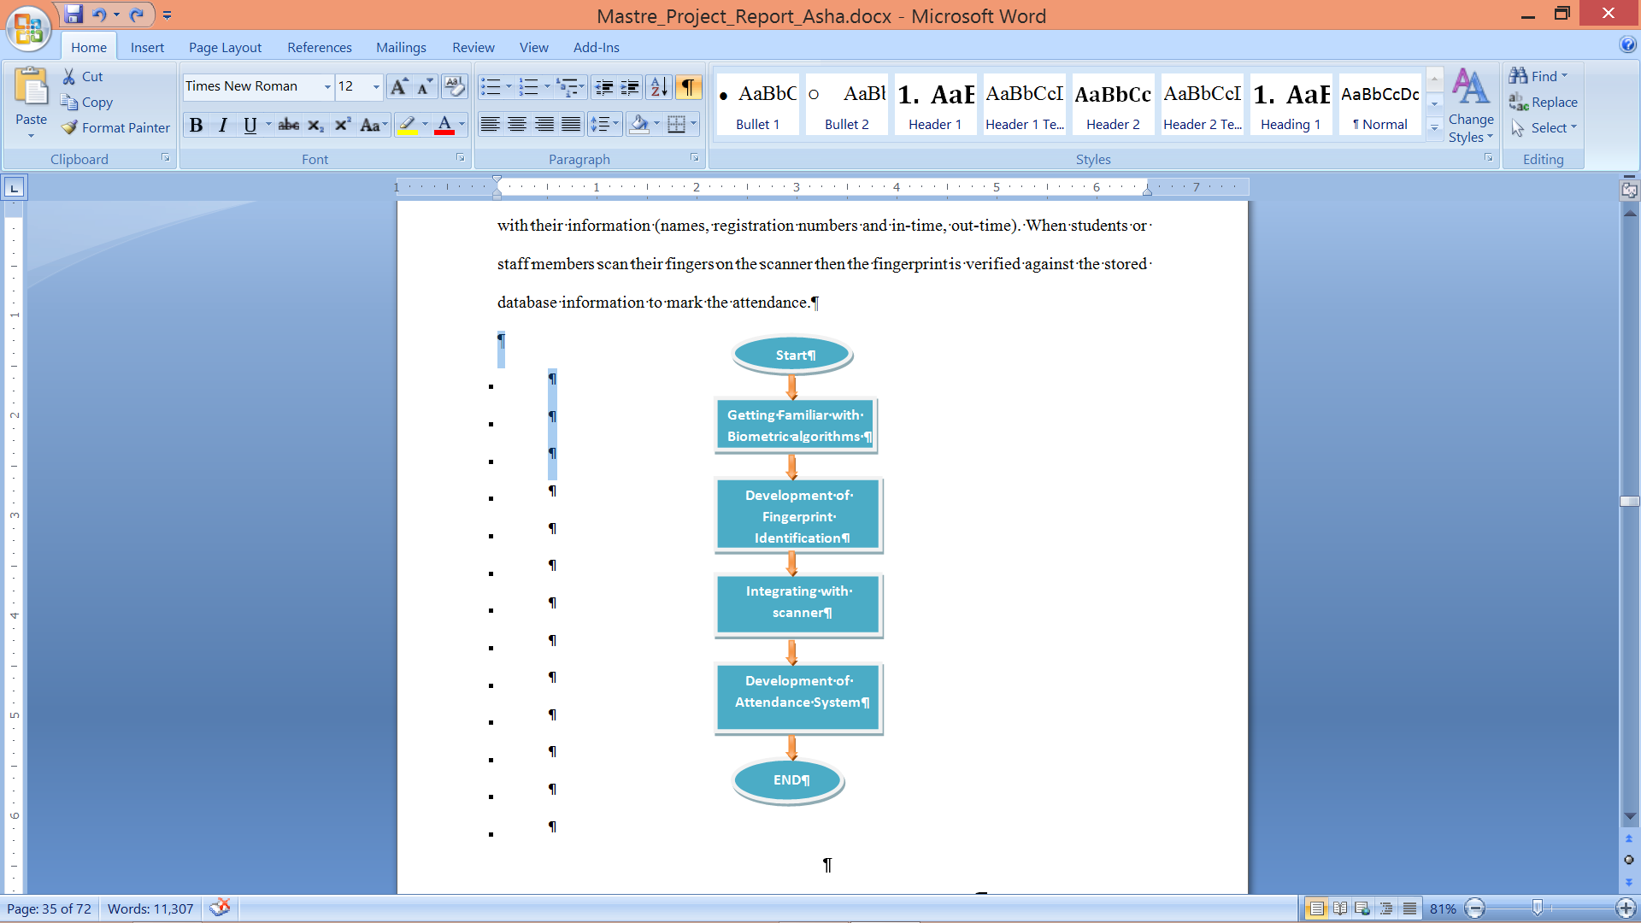

##### FIGURE 2: Flowchart of Project planning

## 5.2 SYSTEM OPERATION

The enrolment and registration phase is an ADMINISTRATIVE phase in which the administrator needs to log in. Hardware equipment will be placed at the classroom entrance. The very first step is to register courses and lecturers. Then the student is required to register their fingerprints as well as other bio-data in their very first class. This step is termed as CAPTURE.

* CAPTURE (Registration): Capture the student’s fingerprint sample and create a feature set. A set of unique features created to match fingerprint is called feature set. The lecturer selects the course code, then the student places his/her fingerprint on the fingerprint reader; the finger recognition unit compares the fingerprint with the stored ones’ in the database. This step is termed as MATCH.
* MATCH (Fingerprint): Captured user fingerprint features are matched against stored fingerprint templates. Upon verification the student is automatically marked attendance for that course. A message box displays for a short interval to show that the user has been identified and granted attendance.
* NON-MATCH**:** If the application failed to match student’s finger print in the database then the user will not be granted attendance and a message will be displayed for a short interval stating that the user has not been identified and has not been granted attendance.
* REPORT GENERTAION: Reports can be generated for each course, listing the total number of students attended and their corresponding status.

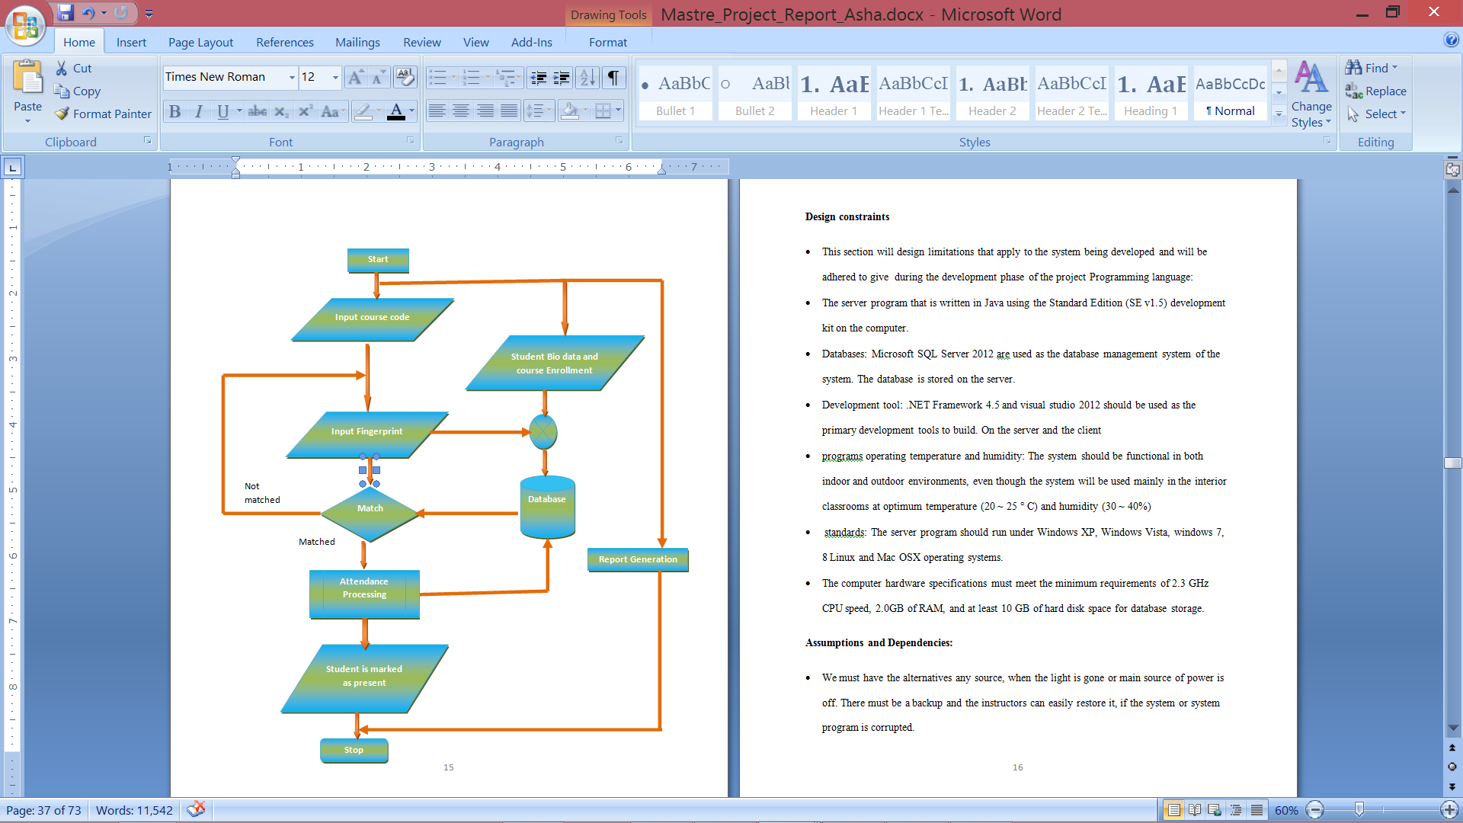

##### FIGURE 3: Flowchart of Attendance System Using Biometrics (Fingerprint).

## 5.3 DESIGN CONSTRAINTS

This section will design limitations that apply to the system being developed and will be adhered to give during the development phase of the project programming language:

* Database: Microsoft SQL Server 2012 is used as the database management system.
* Development Tool: Dot Net Framework 4.5 and visual studio 2012 are the primary development tools.
* Operating Temperature and Humidity: The system should be functional in both indoor and outdoor environments, even though the system will be used mainly in the interior classrooms at optimum temperature (20 ~ 25 ° C) and humidity (30 ~ 40%).
* Standard Operating System: The server program should run without any problems on Windows XP, Windows Vista, Windows 7, Windows 8, Linux and Mac OSX operating systems.
* The computer hardware specifications must meet the minimum requirements of 2.3 GHz CPU speed, 2.0GB of RAM, and at least 10 GB of hard disk space for database storage.

## 5.4 ASSUMPTIONS AND DEPENDENCIES

* In the event of power outage an alternative source is provided.
* If the system or system program is corrupted, then the backup files with easy restoring instructions are provided.
* If finger print machine failed, then there should be an available reserve for immediate procurement.
* Each professor should have access to desktop computer along with tabulated login and passwords.
* General users’ initial login and passwords will be encrypted.
* Fingerprint sensor is connected via peripheral USB slot.
* The system will run on the existing campus network.
* It is developed as a client- server application. The data access services are only provided by the server.
* User has basic knowledge of operating the attendance management system.

# SECTION 6

# FINGERPRINT IDENTIFICATION SYSTEM

## 6.1 HOW FINGERPRINT IDENTIFICATION WORKS?

The scanned fingerprint images with poor quality shall be enhanced. The minutiae of scanned finger print shall be extracted for matching purpose to determine identified fingerprint. The term identified fingerprint is nothing but the stored fingerprint with the same sets of minutiae as the current scanned one. The post-matching steps include displaying details of identified candidate, marking attendance etc. A brief flowchart is shown below.[16].

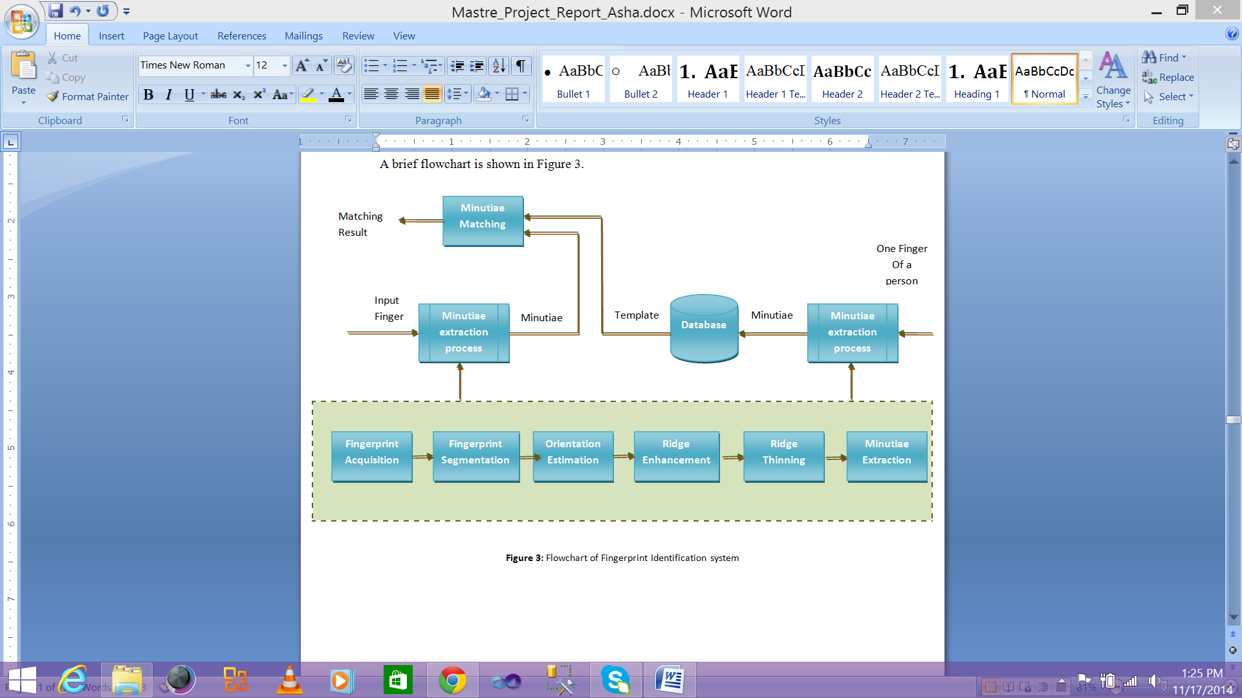

##### FIGURE 4: Fingerprint Identification System Flowchart. [16]

## 6.2 FINGERPRINT IDENTIFICATION SYSTEM FLOWCHART

This attendance management system recognizes an individual by comparing their current scanned biometrics with every stored record in the database. The biometric identification consists of two stages:

* Enrolment
* Authentication

During enrolment, the finger print (biometrics) of the user is captured (FUTRON FS88 fingerprint reader, an optical solid state device). The minutiae is extracted from the finger print and stored in a database as a template for the subject along with the student ID. The template is used to verify the identity of the student, hence, formulating the process of authentication. The enrolment process shall be carried out by an administrator appointed by the department or instructor.

The authentication is nothing but re-capturing the biometrics of the user, extracting minutiae and comparing (using a matching algorithm) with the ones already existing in the database to determine a match.

## 6.3 PROCESS OF FINGERPRINT IDENTIFICATION:

The developed fingerprint Identification System works on minutiae confirmation method. There are two most important minutia features namely Ridge Ending and Ridge bifurcation and Ridge bifurcation. (Figure 5). [14].

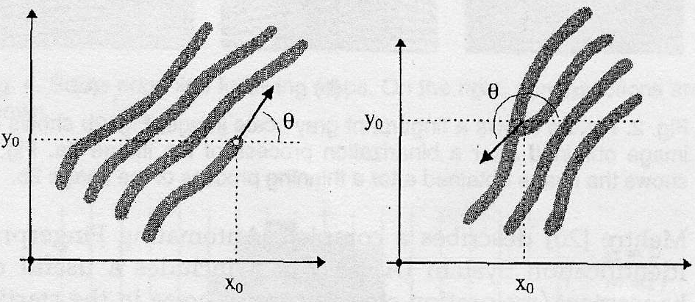

##### FIGURE 5 (a) Ridge Ending



##### FIGURE 5 (b) Ridge Bifurcation

The outline of our approach can be broadly classified into 2 stages - Minutiae Extraction and Minutiae matching. Figure 6 illustrates the flow diagram of the same.[16].

The approach outline is classified into 2 stages: -

* + Minutiae extraction
  + Minutiae matching

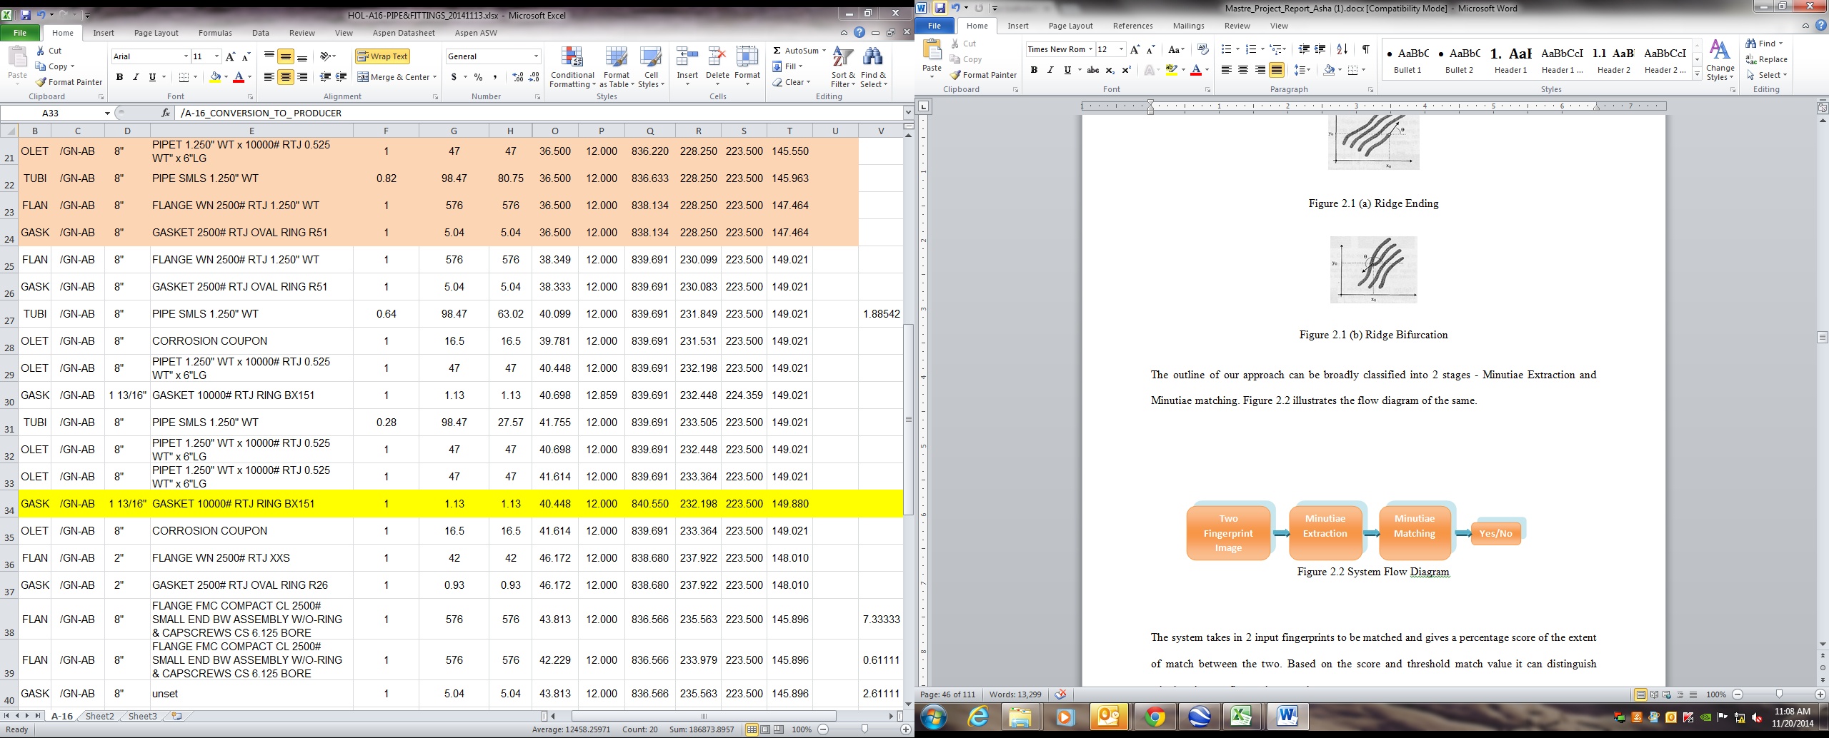

##### FIGURE 6: System Flow.

The system compares 2 fingerprints and gives a percentage of the extent of match between the two. Based on the score and threshold match value it confirms whether the two fingerprints match.

## 6.3 DESIGN DESCRIPTION

The system is further classified into modules and sub-modules. The minutia extraction includes: [14].

* Image Enhancement,
* Image Segmentation
* Final Extraction

The minutiae matching include:

* Minutiae Alignment
* Minutiae Match

The Image Enhancement is nothing but Histogram Equalization which increases the quality of the input image and Image Binarization converts the grey scale image to a binary image.

Then Image Segmentation is nothing but extracting the region of interest using Ridge Flow Estimation and MATLAB’s morphological functions.

The Final Extraction step includes minutiae extraction by Ridge Thinning. The minutiae marking and removal of false minutiae enhances the picture quality. After extracting two sets of minutiae, the matching process iteratively chooses reference minutiae pair and then matches their associated ridges. If the ridges match well, two fingerprint images are aligned and matching is conducted for all remaining minutiae to generate a Match Score.

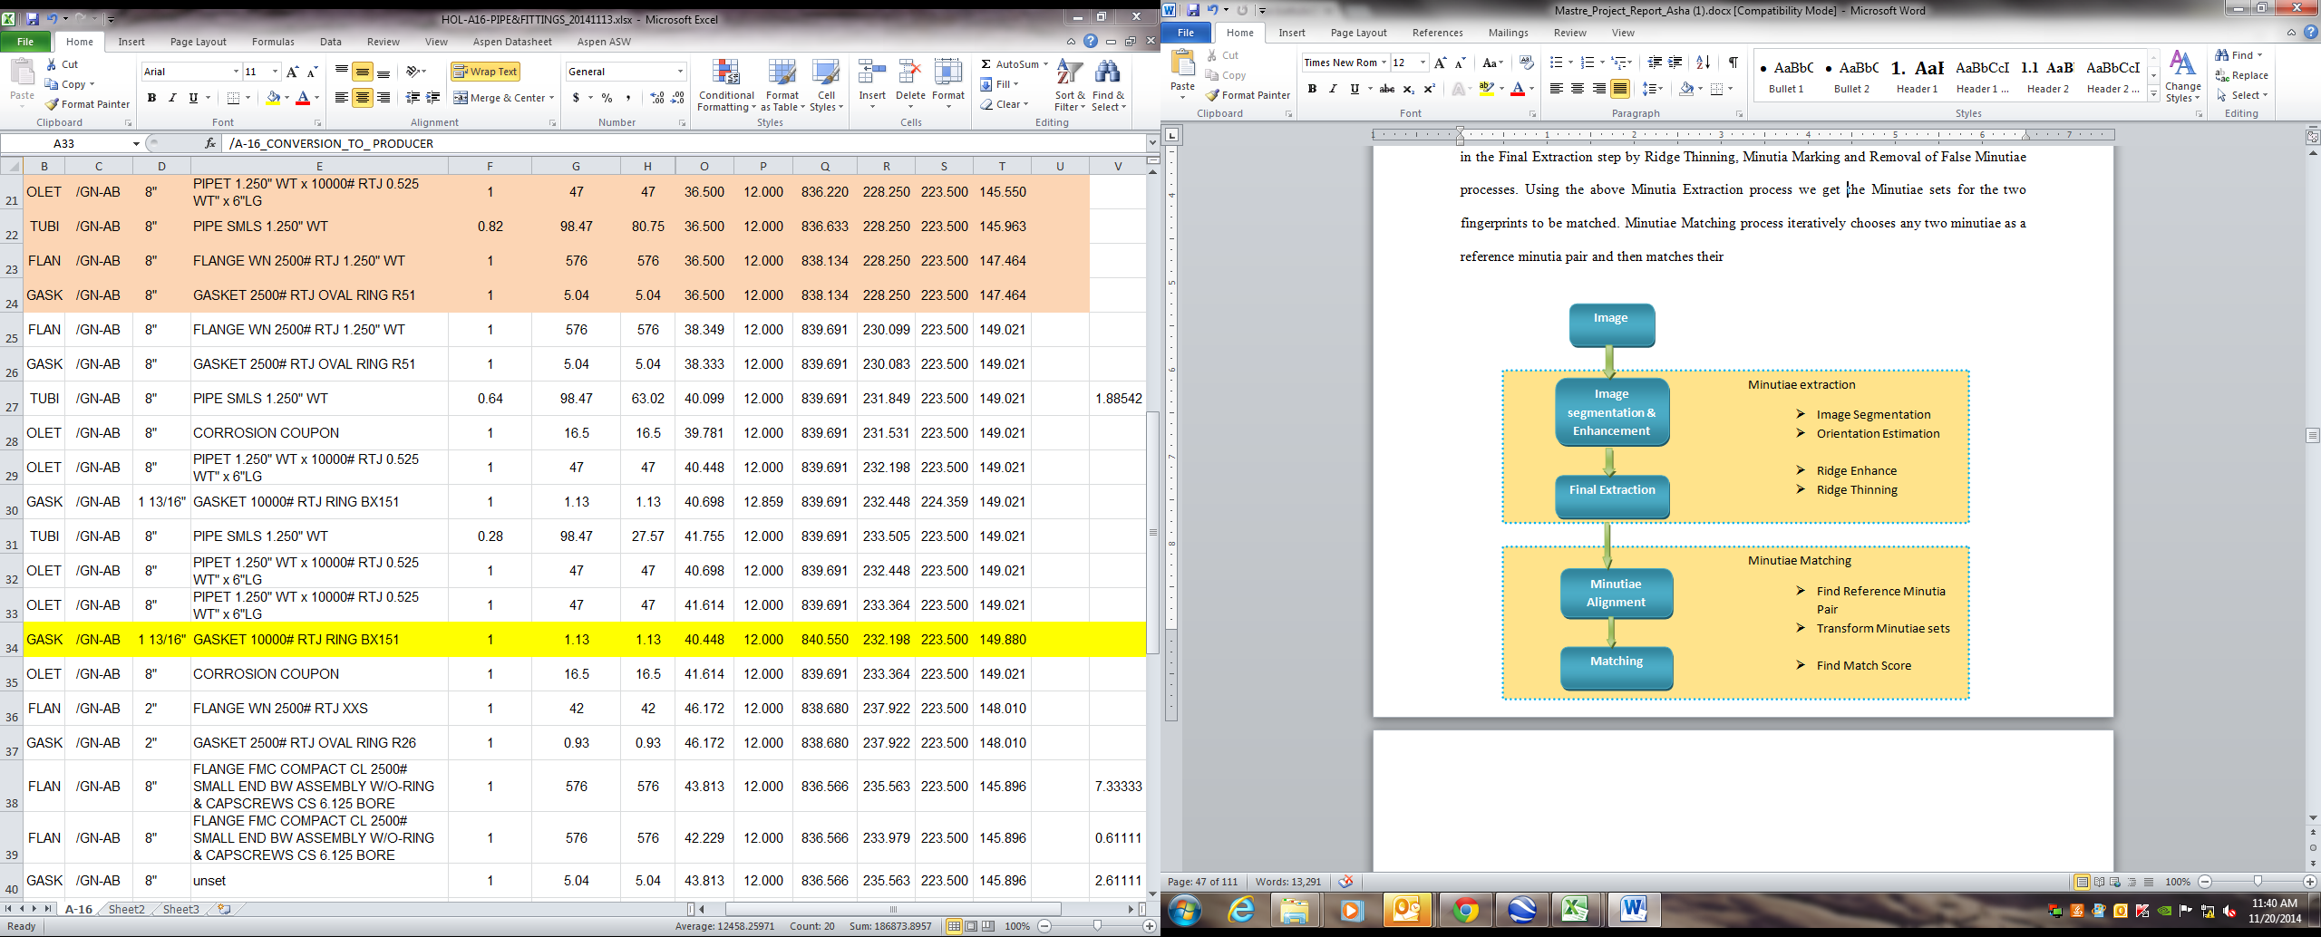

##### FIGURE 7: Detailed Design Descriptions. [14]

## 6.4 MINUTIAE EXTRACTION

As described earlier the Minutiae extraction process includes image enhancement, image segmentation and final Minutiae extraction.

Fingerprint Image Enhancement

The Fingerprint Image enhancement improves the image quality for future operations. The fingerprint images most often lack required contrast and clarity. The image enhancement is a major challenge; it improves the accuracy of matching. It rectifies the image by increasing the contrast between ridges and furrows. If any it connects some broken ridge points either due to insufficient ink or poor quality of sensor input.

The following three techniques have been implemented in our project [16]:

* Histogram Equalization,
* Fast Fourier Transformation and
* Image Binarization.
* Image Binarization

The image binarization is a transformation process, which transforms the 8-bit Gray image to a 1-bit image, with 0-value assigned for ridges and 1-value assigned for furrows [18]. The ridges in the fingerprint are highlighted in black and furrows in white. The adaptive binarization method divides the image into blocks of 16 X 16 pixels and assigns 1 to each block, if the pixel value is larger than the mean intensity value of the current

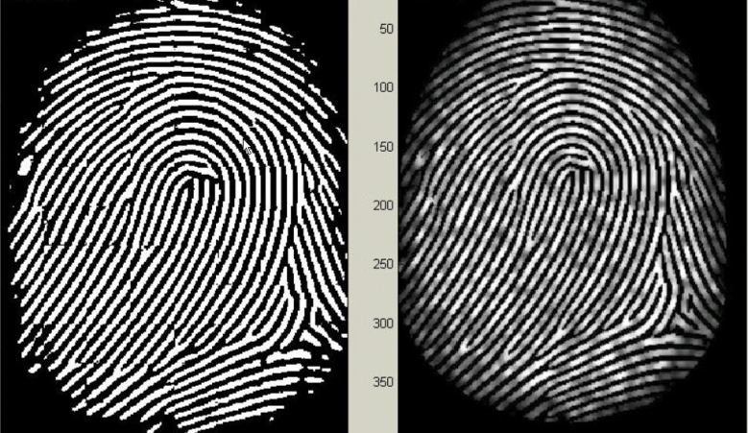

##### FIGURE 8 (a): Image after Binarization.[14]



##### FIGURE 8 (b): Image before Binarization.[14]

* Fingerprint Image Segmentation

To avoid extraction of noisy areas of finger print the background should be separated from finger print area. The segmentation is nothing but distinguishing the difference between image object and the background. The image area without effective ridges and furrows should be discarded as it does not hold any important information.

The region of interest is extracted using two methodologies, they are

* The block direction estimation and direction variety check
* The extraction by morphological operations. Two kinds are chosen, they are:
* “OPEN” - this expands image by removing noise.
* “CLOSE”- this shrinks the image by small cavity elimination.

The interest fingerprint image area = OPEN Area - Closed Area.

## 6.5 RECOGNITION OF MINUTIAE

The binary image is obtained by binarization process, then the minutiae is recognized based on the extraction of minutiae and are submitted to fingerprint ridge thinning stage and marking of minutiae [16], [18].

* Ridge Thinning

The Ridge Thinning is a process of sinking the ridge width to single pixel width. In other words, the elimination of redundant pixels of ridges till it is one pixel wide and it should be watered down to its central pixel

Thinning algorithm is classified by iterative and non-iterative algorithms. Thinning preserves the shape of fingerprint minutiae by eliminating extra information. Thinning is performed due to morphological filtering of segmented image by removing unwanted branches and smoothing up the resultant central path.

The algorithm is written on the following three simple rules [17]:

* Remove the unwanted edge points,
* Add new edge points and
* Shift the edge points to a new location.

The rules are based on the number of edge point neighbors corresponding to an edge point in order to remove erroneous pixels.

STEP 1: If an edge point has zero neighbors then remove the edge point.

STEP 2: If an edge point has one neighbor then search for the neighbor with maximum edge response. To continue the edge, fill gaps. (An edge can be filled by maximum of three pixels.)

STEP 3: If an edge point has two neighbors then there are three cases,

* If point is hanging out of a straight line, then compare edge to the corresponding point.
* If the point is adjoining a diagonal edge then remove it.
* If the above two cases are false then the point is a valid edge point.

STEP 4: If an edge point has more than two neighbors, if point is not having any link between multiple edges then reduce the edge’s size in a logically consistent way.

|  |
| --- |
| C:\Documents and Settings\vinay\My Documents\My Pictures\img3.bmp |

##### FIGURE 9 (a): Image before. [14]

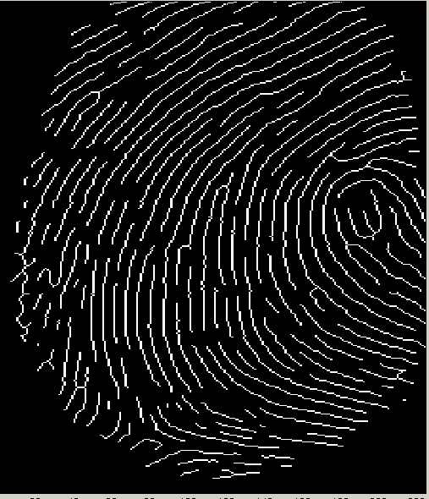

##### FIGURE 9 (b): Image after thinning. [14]

## 6.6 FINGERPRINT MATCHING

This is a difficult approach due to the fingerprint quality change with time for the same user. It can be due to any reason for example change in skin conditions, noise, extraction errors.

Some of the fingerprint matching techniques are [16] :

* Correlation-based matching,
* Minutiae-based matching,
* Ridge feature-based matching.
* Minutiae-based matching,

In minutiae based matching depends on position and orientation of minutiae points obtained from fingerprint. How to find the minutiae coordinates and orientation has been explained in chapter 2. In this work, minutiae based fingerprint detection is performed by using the BOZORTH3 algorithm developed by NIST. This algorithm generates a score based on pairing minutiae of the fingerprints. Total operation of BOZORTH3 is explained below.

Minutiae extraction is difficult in low-quality fingerprint images, whereas other features of the fingerprint ridges pattern (local orientation and frequency, ridge shape) may be extracted more reliably than minutiae. The approaches belonging to this category compare fingerprints in terms of feature extraction from the ridge pattern.

* Bozorth3

BOZORTH3 is an algorithm [17] and utility that matches two minutiae patterns with each other and produces a match score. Matching between the fingerprints can be one-to-one verification or one-to-many identification. Bozorth3 algorithm includes three steps for fingerprint matching:

STEP 1: Construction of Intra-Fingerprint Minutiae Comparison Tables

STEP 2: Construction of Inter-Fingerprint Compatibility Table

STEP 3: Traverse Inter-Fingerprint Compatibility Table constructed in second step

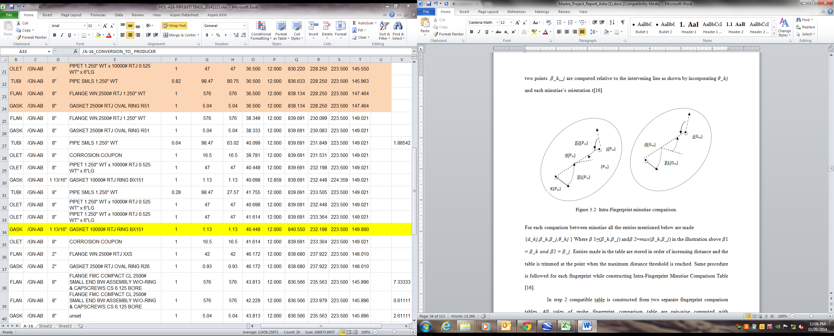

##### FIGURE 10: Intra-Fingerprint minutiae comparison.[17]

# SECTION 7

# ATTENDANCE MANAGEMENT FRAMEWORK

Manual attendance taking and report generation has its limitations. It is well enough for 30-60 students but it will be challenging when it comes to taking attendance for large number of students. Student response time, proxy, and paper wastage etc. are some of the disadvantages of manual attendance system. Moreover, the at-attendance report cannot be generated on time. An automated online attendance management system will overcome these non optimal solutions. So, in this report we present an implementable attendance management framework.

Student attendance system framework is divided into three parts:

* Hardware/Software Design,
* Attendance Management Approach and
* Online Report Generation.

## 7.1 HARDWARE LEVEL DESIGN

Herein the proposed hardware is selected based on ease of maintenance, implementation and availability. Proposed hardware consists following parts:

* Fingerprint Scanner
* Computer
* LAN connection

Fingerprint scanner facilitates teachers/students input fingerprints into the computer. The marked attendance roll will be displayed on the computer. Computer will be interfacing the fingerprint scanner through the network. The scanned fingerprint will be processed to extract features for matching. After matching, it will automatically update the database with student attendance records.

## 7.2 ATTENDANCE MANAGEMENT APPROACH

The attendance management approach explains how students and teachers are supposed to interact with the attendance management system. The following points will ensure the accuracy of attendance management system. :

* The hardware is located inside the classroom.
* Unauthorized access and hardware tampering by students is avoided by placing all parts in a cabin except for the scanner.
* The process starts as soon as the instructor logs-in by inputting his credentials (username and password), followed by course selection.
* If the system is idle for 5mins the attendance marking process stops.
* The system is designed to lock after 10 minutes as the attendance will not be granted for being late. The late entry time can be modified as required.

## 7.3 PROPOSED SYSTEM

The Application is built to simplify and expedite the attendance process. It is provisioned to track reports online by both instructors and students.

The instructors will have login privileges for both login into both applications i.e., desktop and web applications. The desktop application is for recording attendance. As soon as the instructor logs-in and selects course, the registered students list will be displayed. Now, the privileges will be turned over to the students for selecting their name and scanning their fingers for attendance. Instructors and students can login online to view their personal information and attendance reports of each course at any given time.

## 7.4 CHARACTERISTICS OF THE PROPOSED SYSTEM

* User Friendly: The proposed system is user friendly due to its vast data retrieval and storage abilities. Ease of maintenance is an added advantage.
* Efficiency:- The graphical user interface provided in this system adds efficiency.
* Ease of Report Generation: Reports can be easily generated in the proposed system per their requirements.
* No Paper Work:- The proposed system requires no paper work. All the data is fetched into the system immediately and reports can be generated through computer by downloading it. This system eleminates record book keeping.
* System Operator Control:- Computer operator control is provided to eleminate of errors, store and retrieve data easily. So work can be done expedite.

## 7.5 ATTENDANCE MANAGEMENT FRAMEWORK FLOW CHART

The functional requirement of the project is defined under three modules. The first module allows the system Administrator(admin) to log into his account and perform tasks like adding / modifying Instructor / Faculty, student department and courses and courses information.

The second module allows faculty to log into the system to view and modify their personal information along with the courses they teach and enrolled students. They can view, print, and download the course or individual student attendance reports.

The third module allows the students to log into the system. The very first time students have to create their accounts by entering their personal details. After login they are allowed to set department and add courses. They can view their current attendance statistics. No other privileges are given to the student.

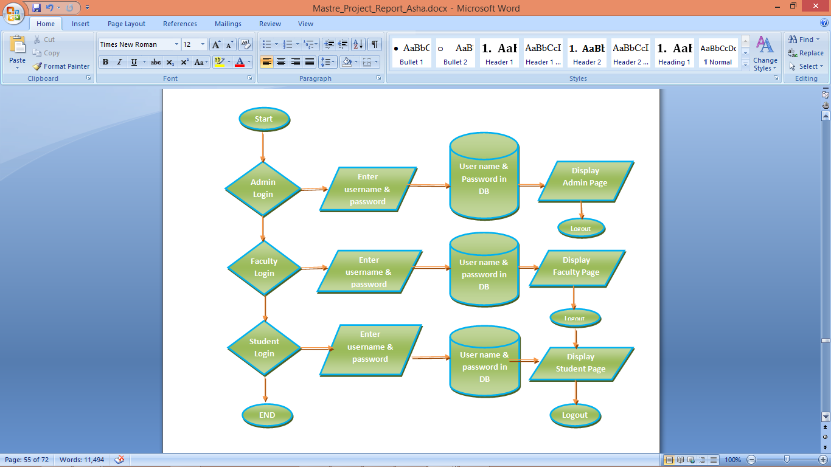

##### FIGURE 11: Attendance Management Framework Flow chart

## 7.6 COMPARISON WITH OTHER STUDENT ATTENDANCE SYSTEMS

There are other kinds of student attendance management systems like RFID based student attendance system and GSM-GPRS based student attendance system. These systems have their own pros and cons. Our system is better because it saves time. Second advantage is portability. The device can be caqrried to various classes per schedule. While GSM-GPRS based systems use position of class for attendance marking which is not dynamic and if schedule or location of the class changes, wrong attendance might be marked. Problem with RFID based systems is that students have to carry RFID cards and RFID detectors are needed to be installed. Nonetheless, students may give proxies by bringing their friend's RFID card. These problems are eleminated in our system. We used fingerprints as recognition criteria to eleminate proxies. If portable devices are used, attendance marking can be done at any time and any place. So our student attendance system to be implemented at PVAMU will be far better.

## 7.7 ON-LINE ATTENDANCE REPORT GENERATION

Attendance database for is a table with following primary fields: Day, Student_ID, Subject_ID and following non-primary fields: Attendance and Report. Using this table, all the attendance can be managed for a student. For on-line report generation, a simple website can be hosted on PVAMU server, which has access to this table. The sql queries will be used for report generation. Following query will give total numbers of classes held in subject COMP1033:

SELECT COUNT(DISTINCT Day) FROM AttendanceTable WHERE COURSE COMP1012 AND Attendance = 1

For attendance of StudentID, against this subject, following query will be used:

SELECT COUNT(Day) FROM AttendanceTable WHERE R STUDENTID = 1P207 AND COURSE = COMP1012 AND Attendance = 1

Now the attendance percent can easily be calculated :

ATTENDANCE = Classes Attended / Classes Held

# SECTION 8

# FUNCTIONAL MODELLING

## 8.1 USE CASE DIAGRAMS

A use case diagram in the Unified Modeling Language (UML) [15] is a type of behavioral diagram defined by and created from a Use-case analysis. The main purpose of a use case diagram is to show what kind of roles and system functions are performed in the system can be depicted. The Use Case model of the UML is used here to specify the functionality of the system and to show the way the users and the system interact to achieve its functions

### 8.1.1 BOOTSTRAP: System Behaviour

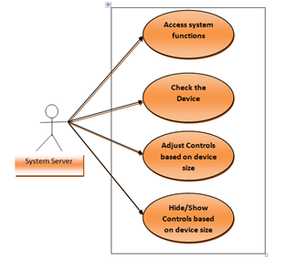

##### FIGURE 12: Use Case Diagram Bootstrap: System Behavior

### 8.1.2 USERS : Access Features Based on Authorization

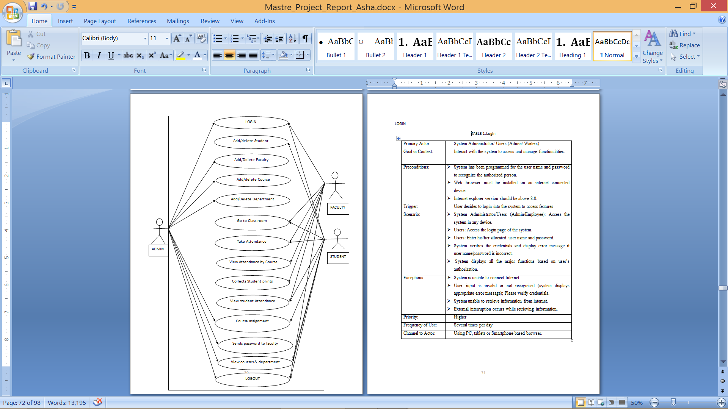

##### FIGURE 13: Use Case for Users: Access Features Based on Authorization

### 8.1.3 LOGIN

###### TABLE 3: Login

|  |  |
| --- | --- |
| Primary Actor: | System Administrator/ Faculty/ Student |
| Goal in Context: | Interact with the system to access and manage functionalities. |
| Pre-conditions: | * + System has been programmed with the user name and password to recognize the authorized person.   + Web browser must be installed on an internet connected device.   + Internet explorer version should be above 8.0. |
| Trigger: | User decides to login into the system to access features |
| Scenario: | * + System Administrator / Faculty / Student: Access the system in any device.   + Users: Access the login page of the system.   + Users: Enter his/her allocated user name and password.   + System verifies the credentials and display error message if user name/password is incorrect.   + System displays all the major functions based on user’s authorization. |
| Exceptions: | * + System is unable to connect Internet.   + User input is invalid or not recognized (system displays appropriate error message); Please verify credentials.   + System unable to retrieve information from internet.   + External interruption occurs while retrieving information. |
| Priority: | Higher |
| Frequency of Use: | Several times per day |
| Channel to Actor: | Using PC, tablets or Smartphone-based browser. |

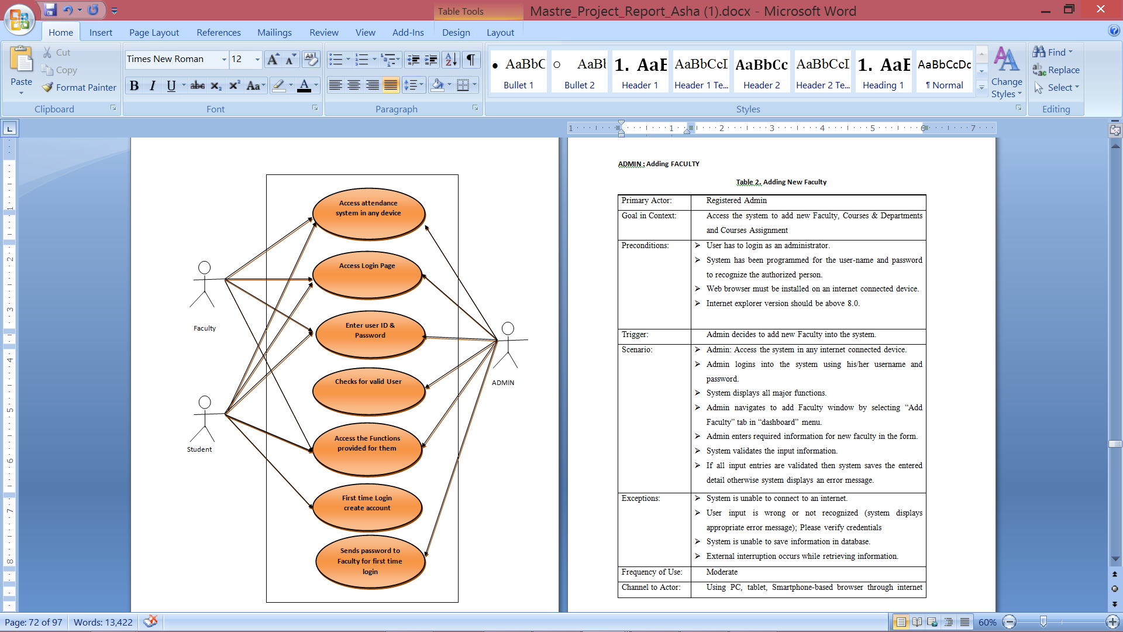

##### FIGURE 14: Use Case: Login

### 8.1.4 ADMIN: Adding Faculty

###### TABLE 3: Adding New Faculty

|  |  |
| --- | --- |
| Primary Actor: | Registered Admin |
| Goal in Context: | Access the system to add new Faculty, Courses & Departments and Courses Assignment |
| Preconditions: | * + User has to login as an administrator.   + System has been programmed for the user-name and password to recognize the authorized person.   + Web browser must be installed on an internet connected device.   + Internet explorer version should be above 8.0. |
| Trigger: | Admin decides to add new Faculty into the system. |
| Scenario: | * + Admin: Access the system in any internet connected device.   + Admin logins into the system using his/her username and password.   + System displays all major functions.   + Admin navigates to add Faculty window by selecting “Add Faculty” tab in “dashboard” menu.   + Admin enters required information for new faculty in the form.   + System validates the input information.   + If all input entries are validated then system saves the entered detail, otherwise system displays an error message. |
| Exceptions: | * + System is unable to connect to an internet.   + User input is wrong or not recognized (system displays appropriate error message); Please verify credentials   + System is unable to save information in database.   + External interruption occurs while retrieving information. |
| Frequency of Use: | Moderate |
| Channel to Actor: | Using PC, tablet, Smartphone-based browser through internet connection. |

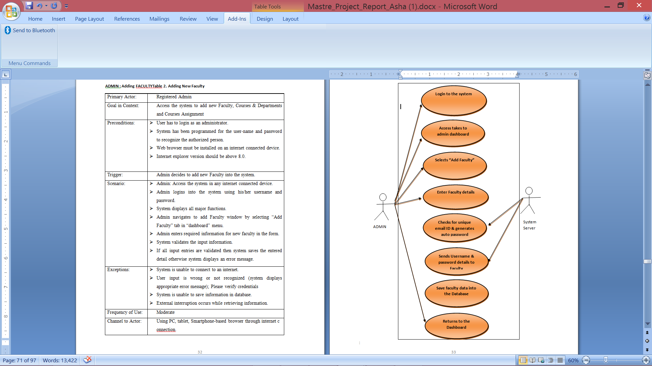

###### FIGURE 15: Use Case for admin: Adding New Faculty

### 8.1.5 FACULTY: Generating Report

###### TABLE 5: Generating Report

|  |  |
| --- | --- |
| Primary Actor: | Registered Faculty |
| Goal in Context: | Access the system to view and save attendance report |
| Pre-conditions: | * + User has to login as a faculty.   + System has been programmed with the user-name and password to recognize the authorized person.   + Web browser must be installed on an internet connected device.   + Internet explorer version should be above 8.0. |
| Trigger: | Faculty decides to view & save attendance report. |
| Scenario: | * + Faculty: Access the system in any internet connected device.   + Faculty logs in into the system using his/her username and password.   + System displays all major functions.   + Faculty navigates to my courses window by selecting “My Courses” tab in “dashboard” menu.   + Faculty selects the course for which he /she want to view reports.   + Faculty navigates to new window and there he/she selects “Attendance Report”.   + A new window pops up where he/she selects between “Report of class” & “Cumulative/All events” field.   + Faculty is navigated to the Attendance report window, then click on Save button   + A window pops up, select the type of report(excel, word, pdf ) and submit. A report is saved on your. If all input entries are validated then system saves the entered detail otherwise system displays an error message. |
| Exceptions: | * + System is unable to connect to an internet.   + User input is wrong or not recognized (system displays appropriate error message); Please verify credentials   + System is unable to save information in database.   + External interruption occurs while retrieving information. |
| Frequency of Use: | Frequently |
| Channel to Actor: | Using PC, tablet, Smartphone-based browser through internet connection. |

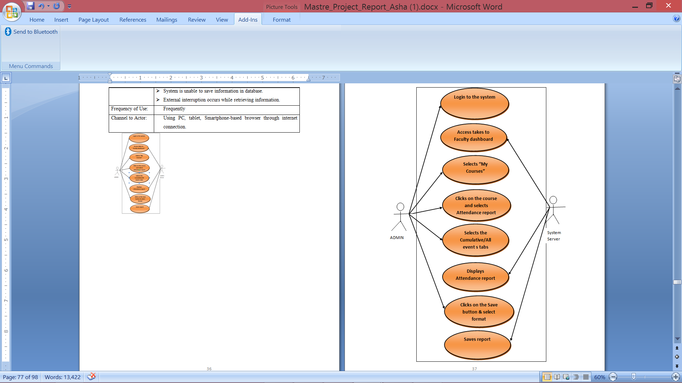

##### FIGURE 16: Use Case Diagram for Faculty: Generating Report

### 8.1.6 STUDENT: Creating Account

###### TABLE 6: Student Creating Account

|  |  |
| --- | --- |
| Primary Actor: | Registered Student |
| Goal in Context: | Access the system to create account for login and to view attendance report |
| Pre-conditions: | * + First time access, Student has to create account to login.   + System has been programmed for the student to create their account   + Web browser must be installed on an internet connected device.   + Internet explorer version should be above 8.0. |
| Trigger: | Student decides to create account to access attendance system. |
| Scenario: | * + Student: Access the system in any internet connected device.   + Student navigates to create student window by clicking on “Create Account” button.   + Student enters required information for creating login credentials in the form.   + System validates the input information.   + If all input entries are validated then system saves the entered detail otherwise system displays an error message. |
| Exceptions: | * + System is unable to connect to an internet.   + User input is wrong or not recognized (system displays appropriate error message); Please verify credentials   + System is unable to save information in database.   + External interruption occurs while retrieving information. |
| Frequency of Use: | Moderate |
| Channel to Actor: | Using PC, tablet, Smartphone-based browser through internet connection. |

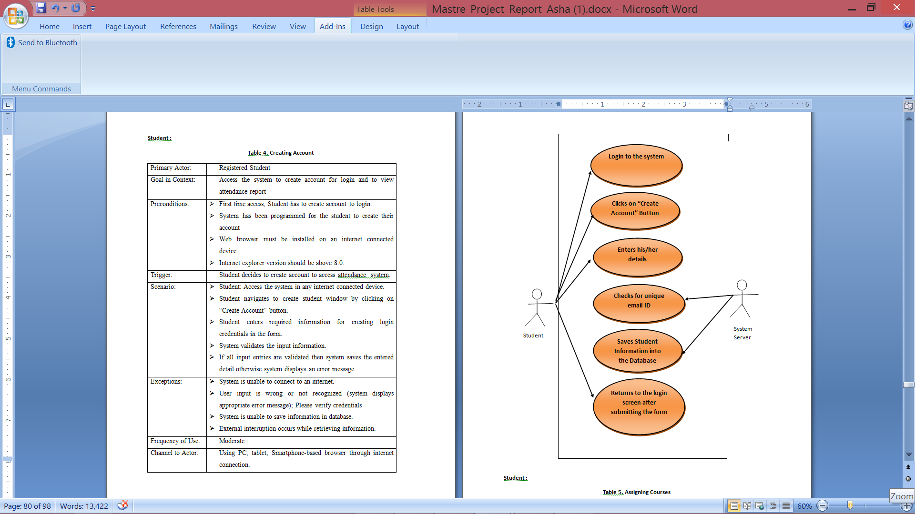

###### FIGURE 17: Use Case Diagram for Student: Account Creation

### 8.1.7 STUDENT: Assigning Courses

###### TABLE 7: Assigning Courses to Student

|  |  |
| --- | --- |
| Primary Actor: | Registered Student |
| Goal in Context: | Access the system to view and assign courses |
| Pre-conditions: | * + User has to login as a student.   + System has been programmed for the user-name and password to recognize the authorized person.   + Web browser must be installed on an internet connected device.   + Internet explorer version should be above 8.0. |
| Trigger: | Faculty decides to view/download attendance report. |
| Scenario: | * + Student: Access the system in any internet connected device.   + Student logins into the system using his/her username and password.   + System displays all major functions.   + Student navigates to my courses window by selecting “My Courses” tab in “dashboard” menu.   + Student checks the “Add course” field, navigates to new window.   + Students After selecting the department from drop down menu then course list is enabled. Then can check all the courses they have registered.   + Student clicks submit button and is navigated to previous page then select view courses button. A table is displayed showing the courses that he/she has registered. Faculty is navigated to the Attendance report window, then click on Email button   + If all input entries are validated then system saves the entered detail otherwise system displays an error message. |
| Exceptions: | * + System is unable to connect to an internet.   + User input is wrong or not recognized (system displays appropriate error message); Please verify credentials   + System is unable to save information in database.   + External interruption occurs while retrieving information. |
| Frequency of Use: | Moderate |
| Channel to Actor: | Using PC, tablet, Smartphone-based browser through internet connection. |

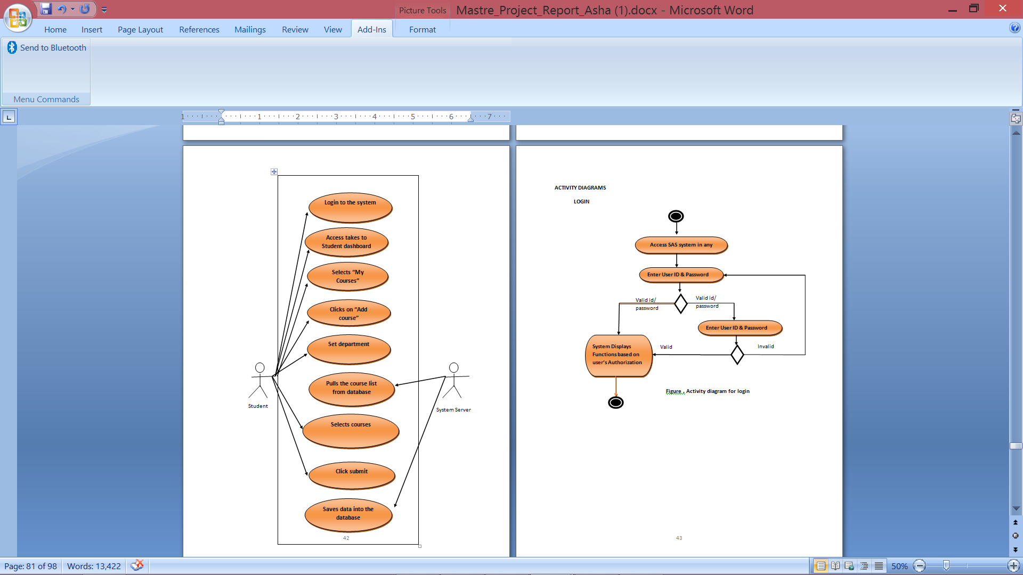

###### FIGURE 18: Use Case Diagram for Student: Assigning Courses

### 8.1.8 DESKTOP USERS: Access Features Based on Authorization

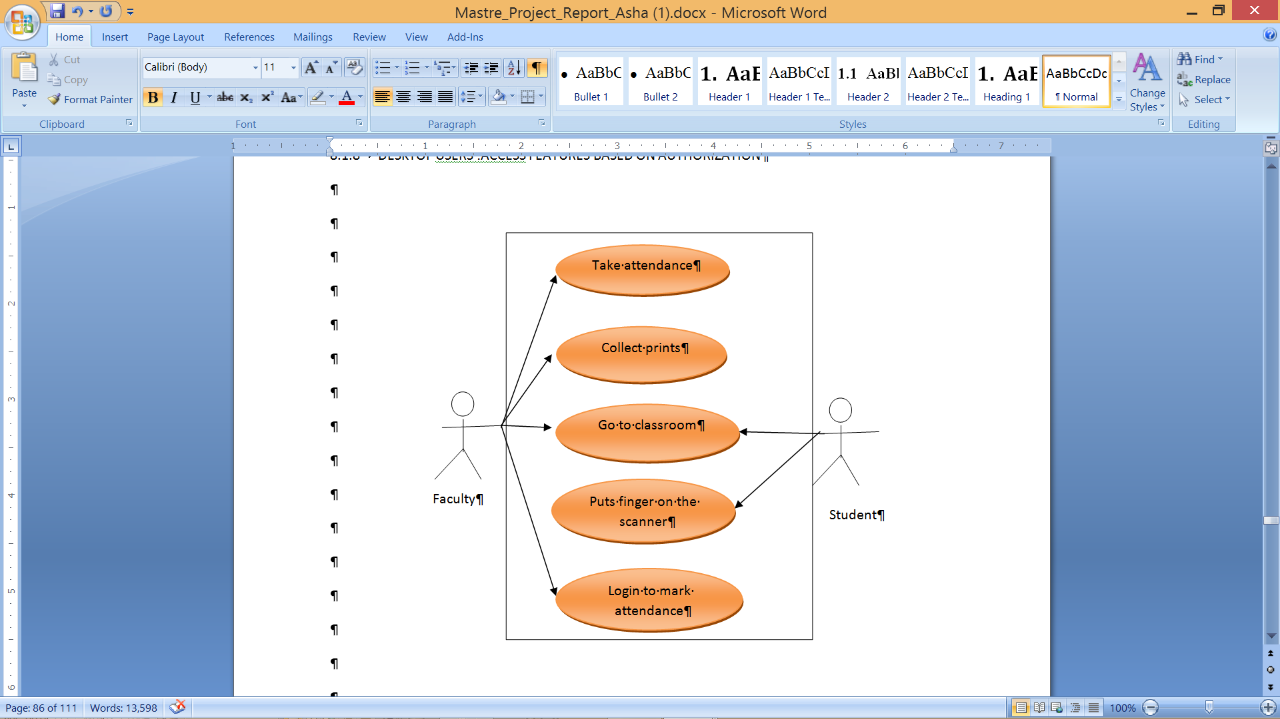

##### FIGURE 19: Use Case Diagram for Users: Access Features Based on Authorization

### 8.1.9 DESKTOP: Faculty Login

###### TABLE 8: Desktop: Faculty Login

|  |  |
| --- | --- |
| Primary Actor: | System Faculty |
| Goal in Context: | Interact with the system to access and manage functionalities. |
| Pre-conditions: | * + System has been programmed for the user name and password to recognize the authorized person.   + Desktop application must be installed on an internet connected device.   + Internet explorer version should be above 8.0. |
| Trigger: | User decides to login into the system to take attendance |
| Scenario: | * + System Administrator/Faculty: Access the system in any device.   + Users: Access the login page of the system.   + Users: Enter his/her allocated user name and password.   + System verifies the credentials and display error message if user name/password is incorrect.   + System displays all the major functions based on user’s authorization. |
| Exceptions: | * + System is unable to connect Internet.   + User input is invalid or not recognized (system displays appropriate error message); Please verify credentials.   + System unable to retrieve information from internet.   + External interruption occurs while retrieving information. |
| Priority: | Higher |
| Frequency of Use: | Several times per day |
| Channel to Actor: | Using PC, tablets or Smartphone-based browser. |

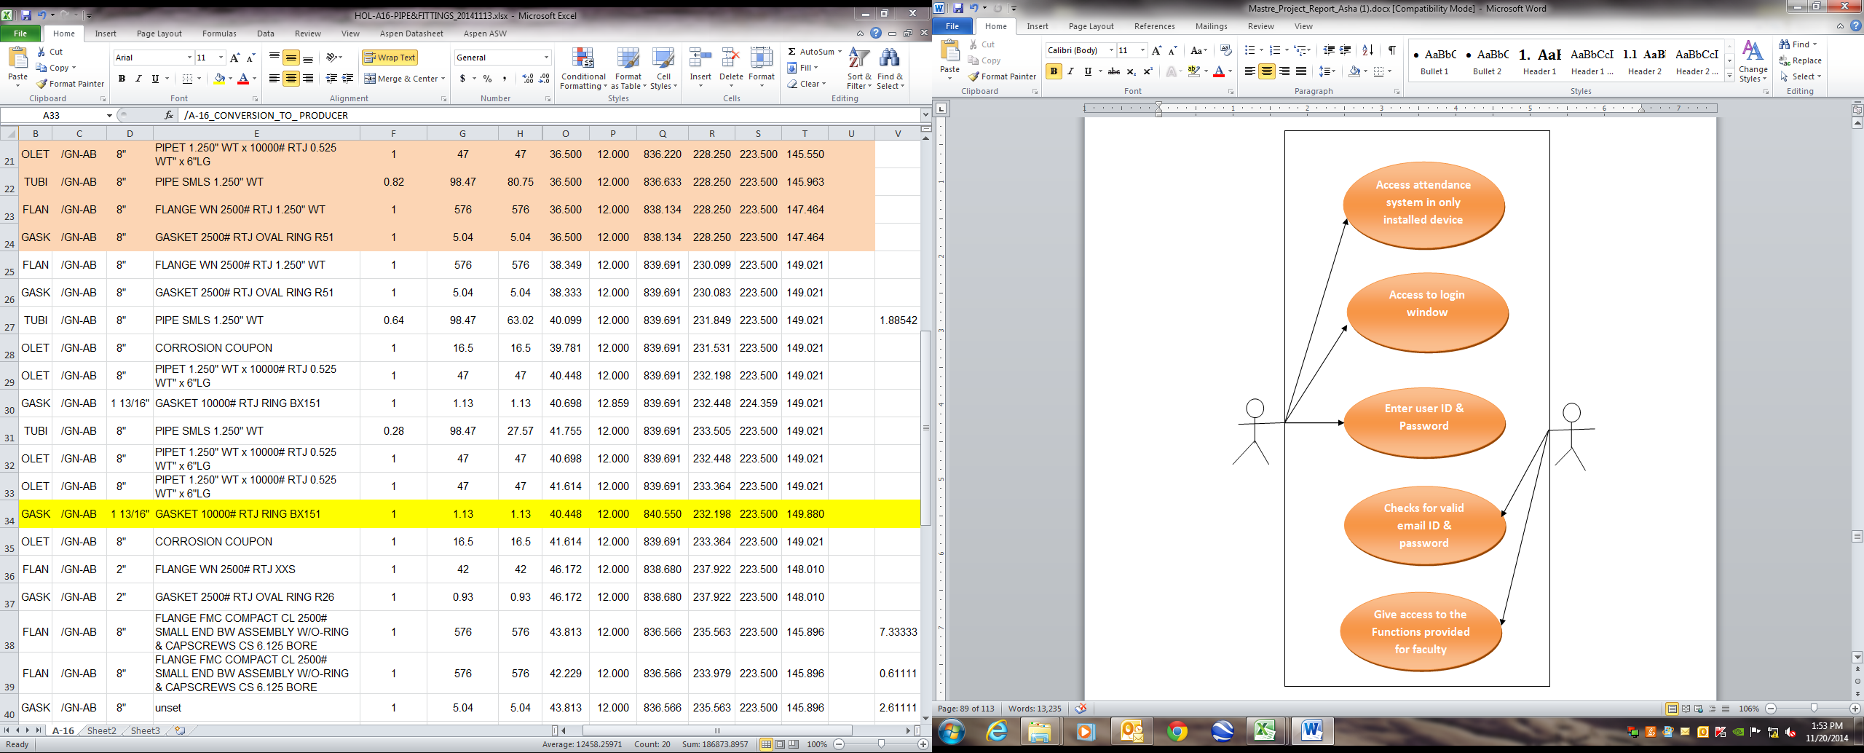

Application

Faculty

##### FIGURE 20: Use Case Diagram of Desktop for Faculty Login

### 8.1.10 DESKTOP FACULTY: Taking Attendance

###### TABLE 9: Taking Attendance

|  |  |
| --- | --- |
| Primary Actor: | System Faculty |
| Goal in Context: | Interact with the system to take attendance. |
| Pre-conditions: | * + System has been programmed for the user name and password to recognize the authorized person.   + Desktop application must be installed on an internet connected device.   + Internet explorer version should be above 8.0. |
| Trigger: | User decides to take attendance |
| Scenario: | * + System Administrator/Faculty: Access the system in only application installed device.   + Faculty: Access the system in any internet connected device.   + Faculty logins into the system using his/her username and password.   + System displays all major functions.   + Faculty navigates to take attendance window by selecting “take attendance” button from menu.   + Faculty select course, then clicks on the “Start” button to begin attendance process   + If the system is idle for 5min the system should stop taking attendance.   + If all input entries are validated then system saves the entered detail otherwise system displays an error message. |
| Exceptions: | * + System is unable to connect Internet.   + User input is invalid or not recognized (system displays appropriate error message); Please verify credentials.   + System unable to retrieve information from internet.   + External interruption occurs while retrieving information. |
| Priority: | Higher |
| Frequency of Use: | Several times per day |
| Channel to Actor: | Using PC, tablets or Smartphone-based browser. |

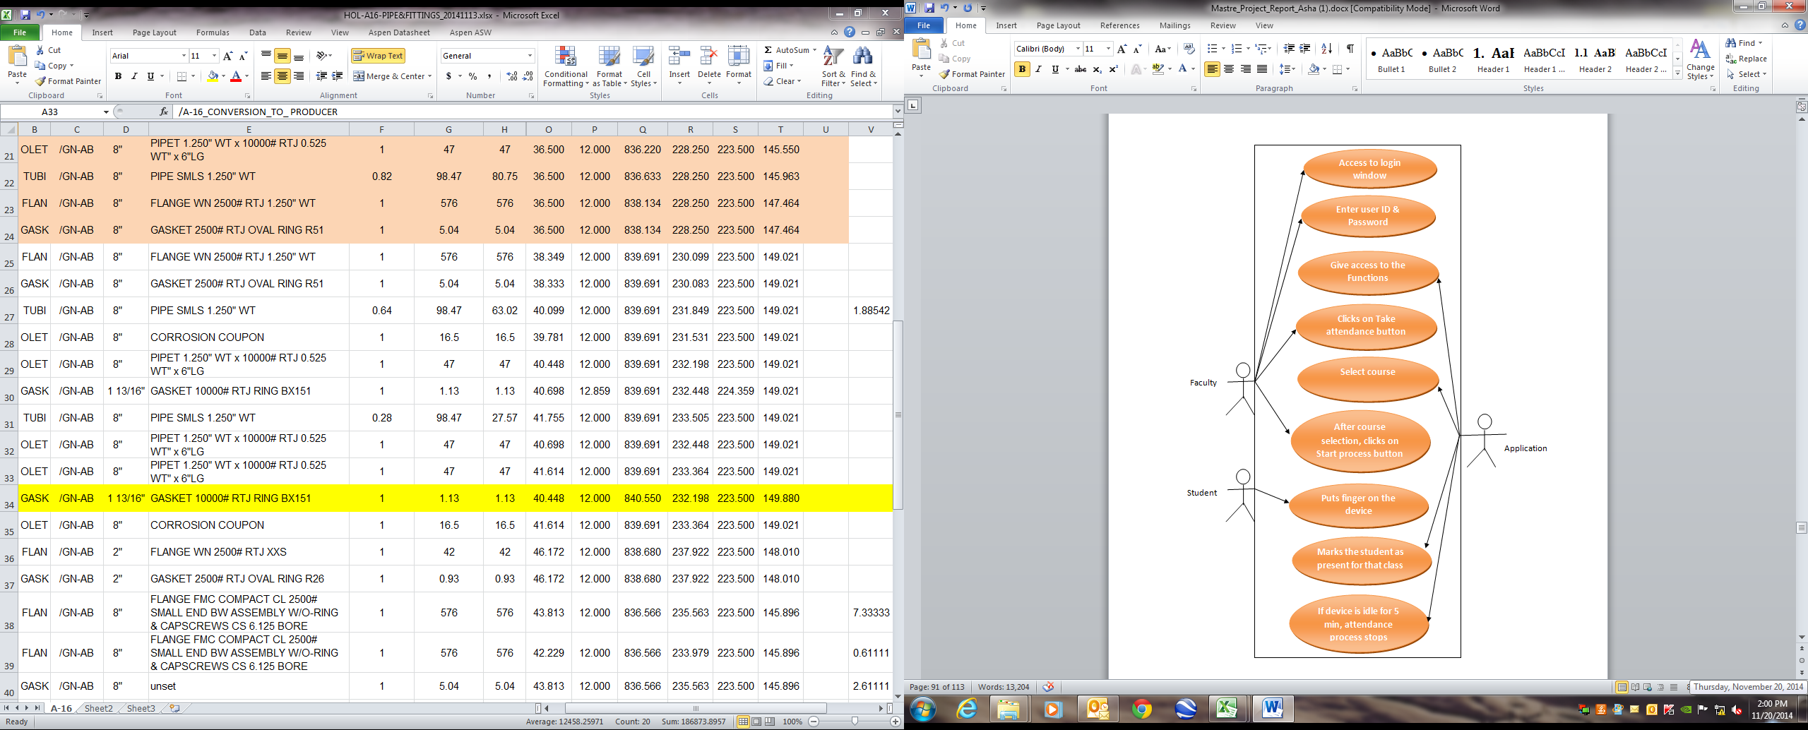

##### FIGURE 21: Use Case Diagram for Taking Attendance

### 8.1.11 DESKTOP FACULTY: Collect Fingerprints

###### TABLE 10: Desktop Application for Collecting Fingerprints

|  |  |
| --- | --- |
| Primary Actor: | System Faculty |
| Goal in Context: | Interact with the system to collect fingerprints |
| Preconditions: | * + System has been programmed for the user name and password to recognize the authorized person.   + Desktop application must be installed on an internet connected device.   + Internet explorer version should be above 8.0. |
| Trigger: | User decides to take attendance |
| Scenario: | * + System Faculty: Access the system in only application installed device.   + Faculty: Access the system in any internet connected device.   + Faculty logins into the system using his/her username and password.   + System displays all major functions.   + Faculty navigates to new window by selecting “Collect prints” button from menu.   + Faculty select course, then navigates to student fingerprints collection window.   + Faculty then clicks on get list button to get the list of students who registered for that particular course.   + Faculty select students one by one and clicks on collect button to get their fingerprints(status changes to YES)   + If all input entries are validated then system saves the entered detail otherwise system displays an error message. |
| Exceptions: | * + System is unable to connect Internet.   + User input is invalid or not recognized (system displays appropriate error message); Please verify credentials.   + System unable to retrieve information from internet.   + External interruption occurs while retrieving information. |
| Priority: | Lower |
| Frequency of Use: | Several times per day |
| Channel to Actor: | Using PC, tablets or Smartphone-based browser. |

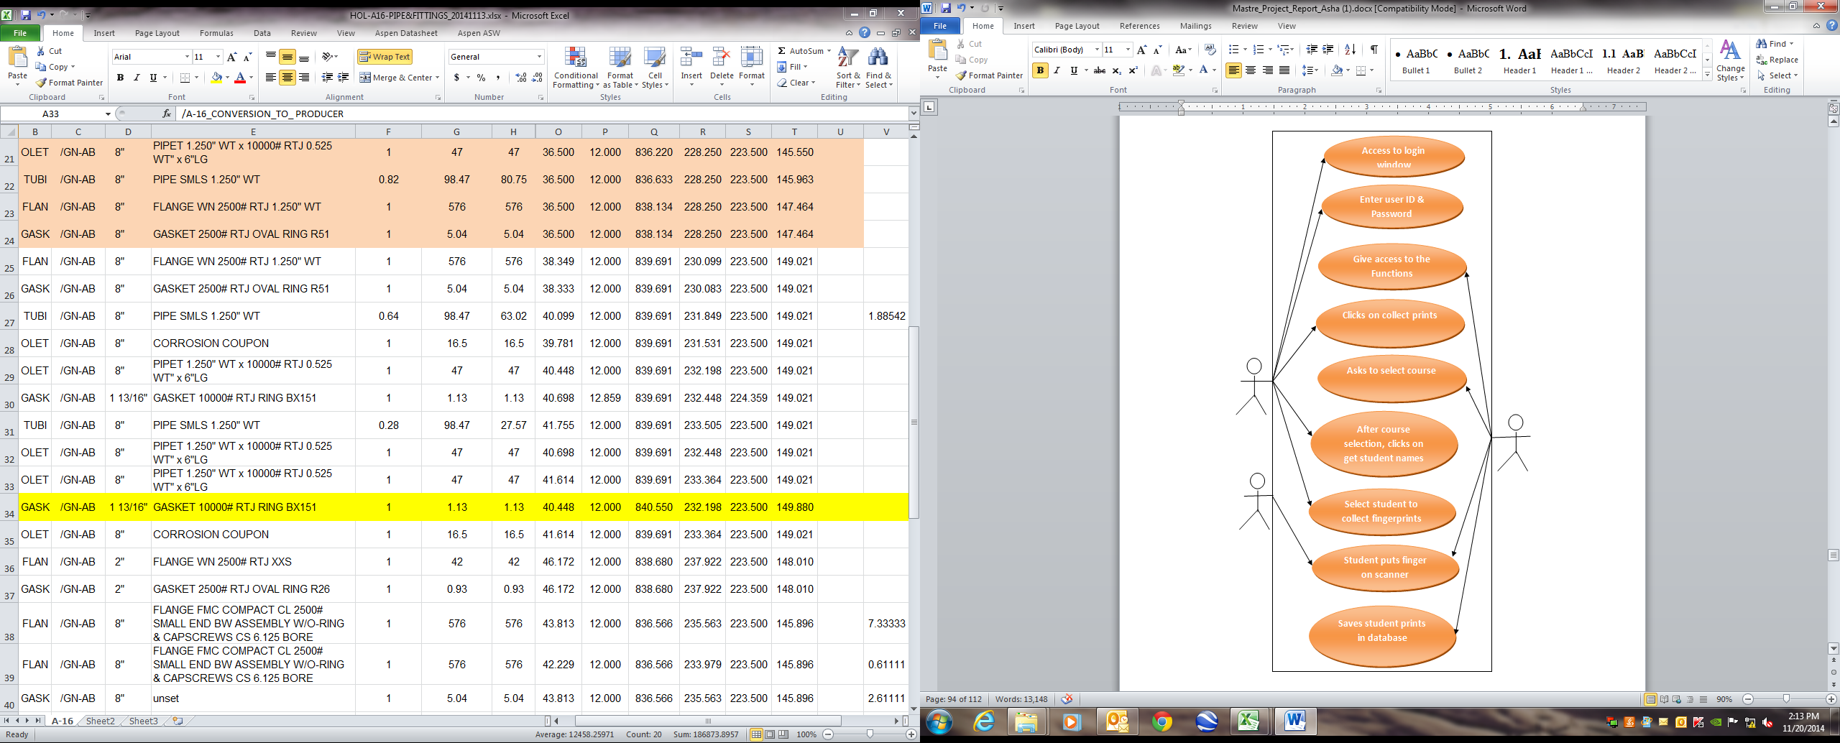

Application

Student

Faculty

##### FIGURE 22: Use Case Diagram for Collecting Fingerprints

## 8.2 ACTIVITY DIAGRAMS:

### 8.2.1 LOGIN

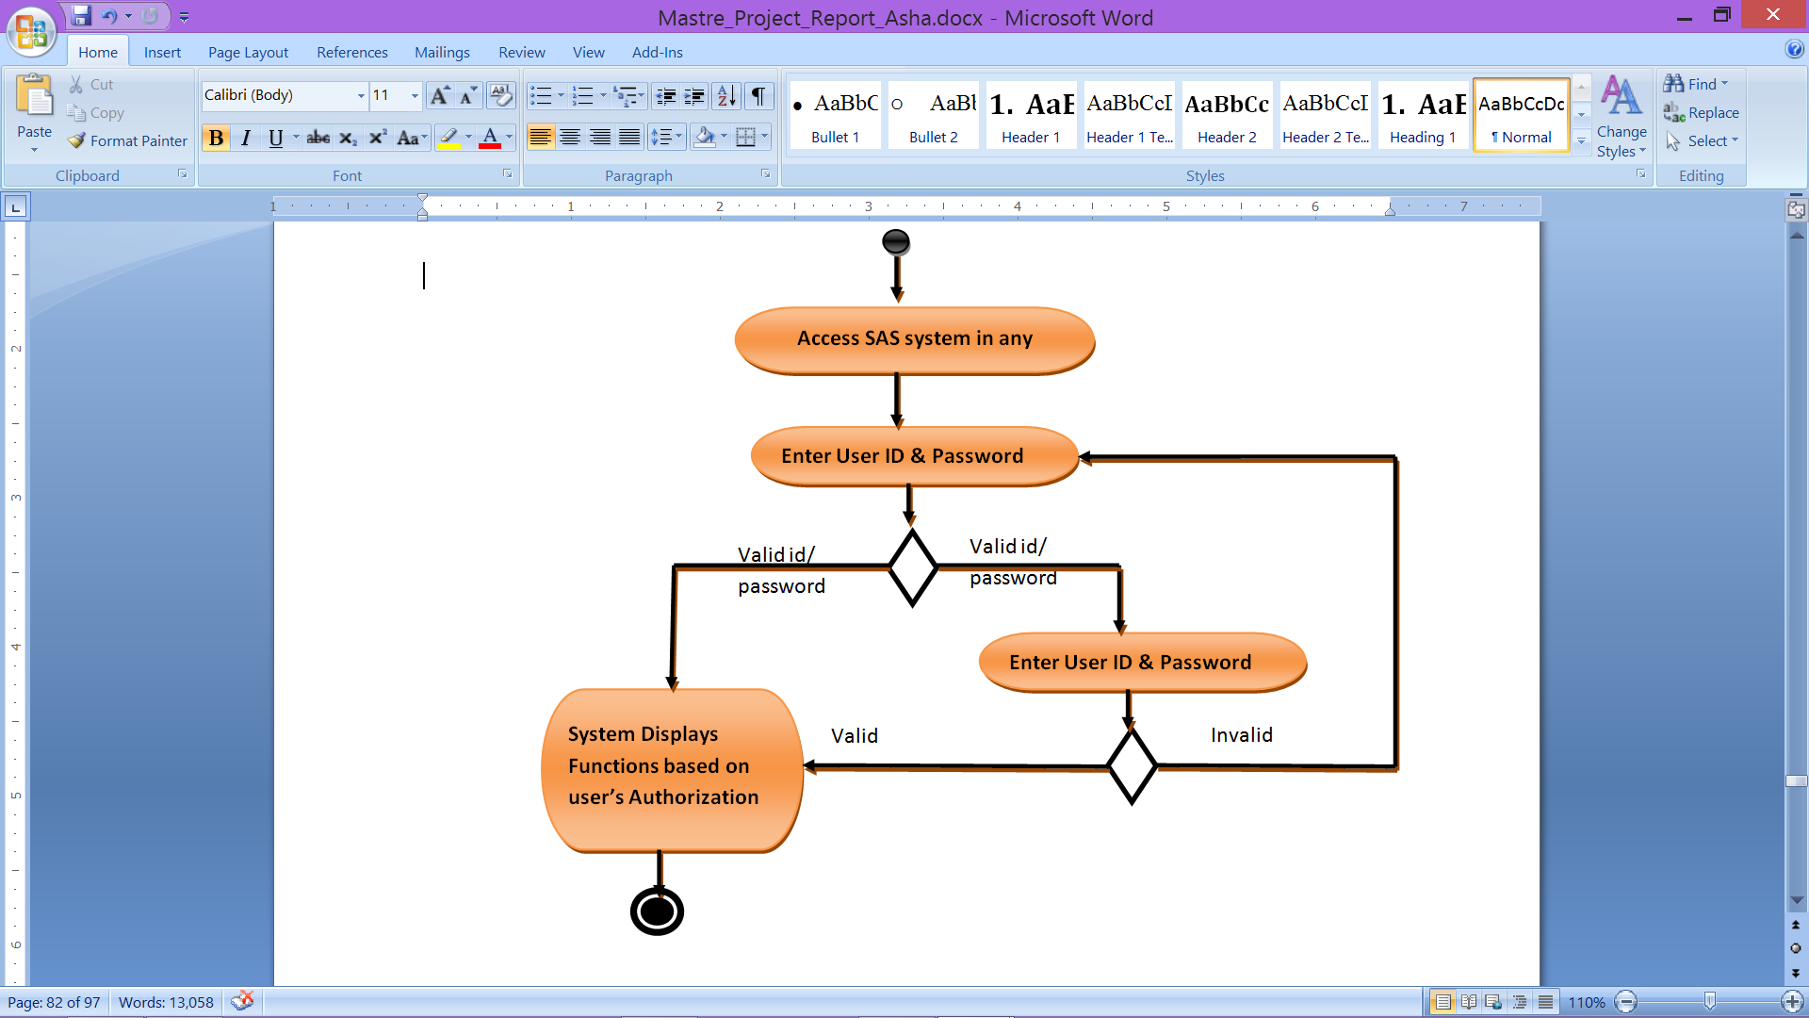

##### FIGURE 23: Activity Diagram for Login

### 8.2.2 ADMIN: Functions

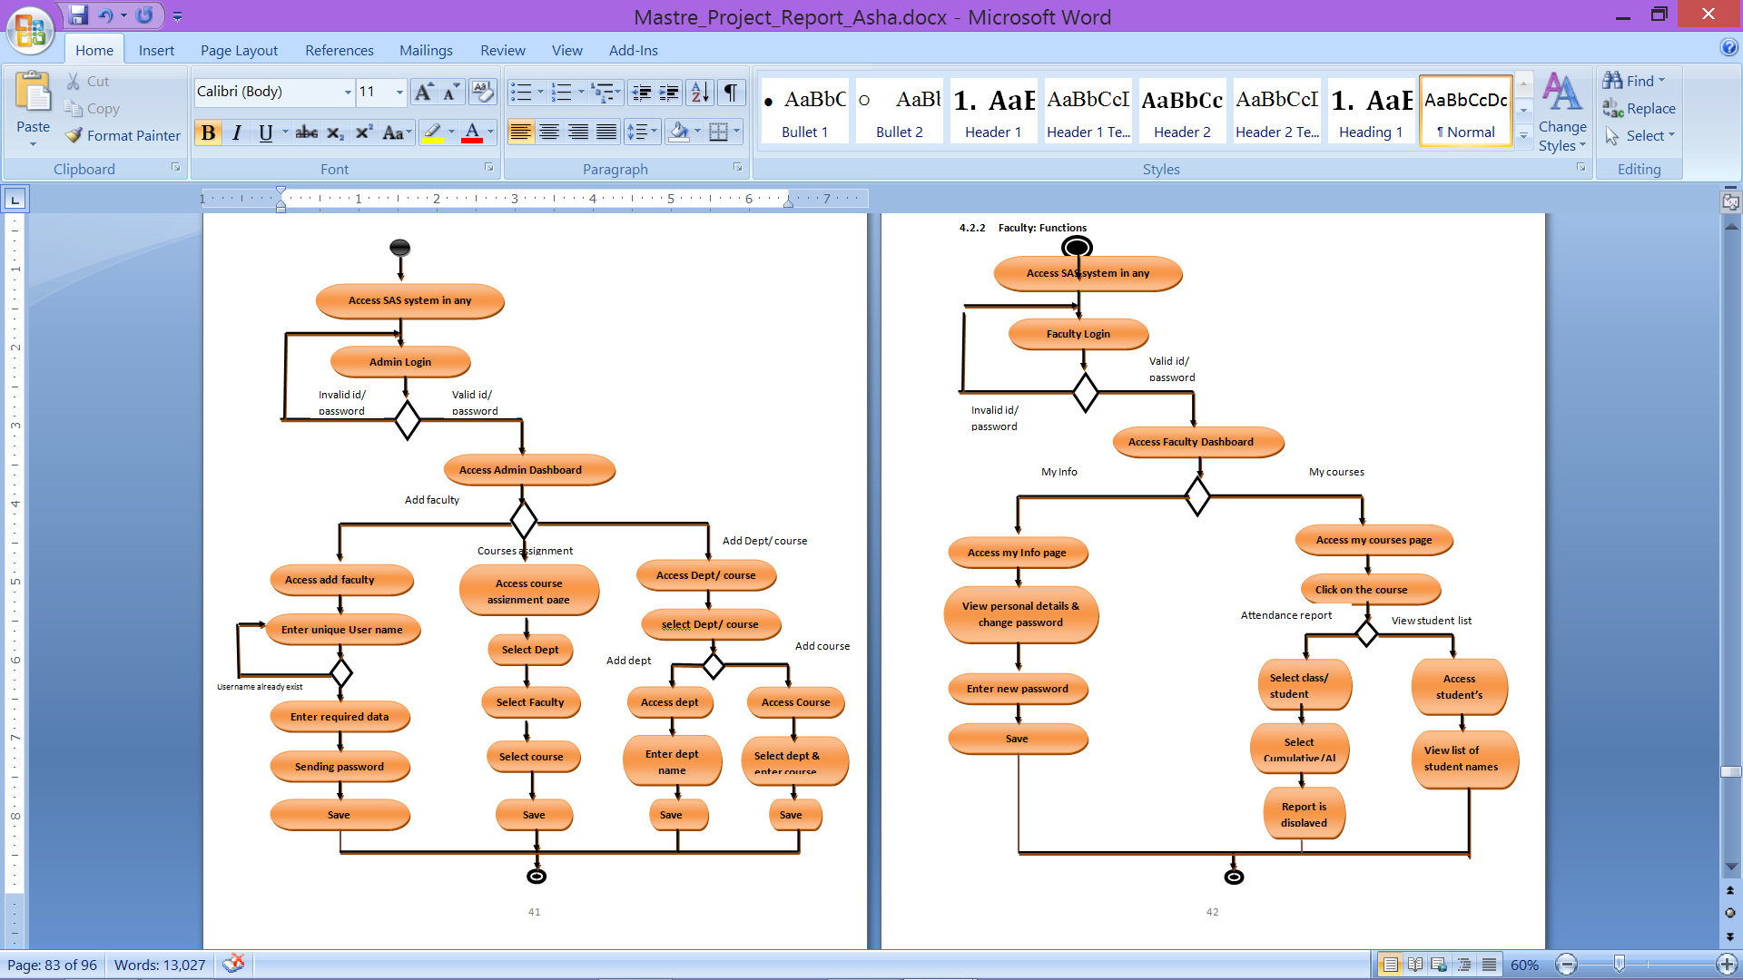

##### FIGURE 24: Activity Diagram for Admin Functions

### 8.2.3 FACULTY: Functions

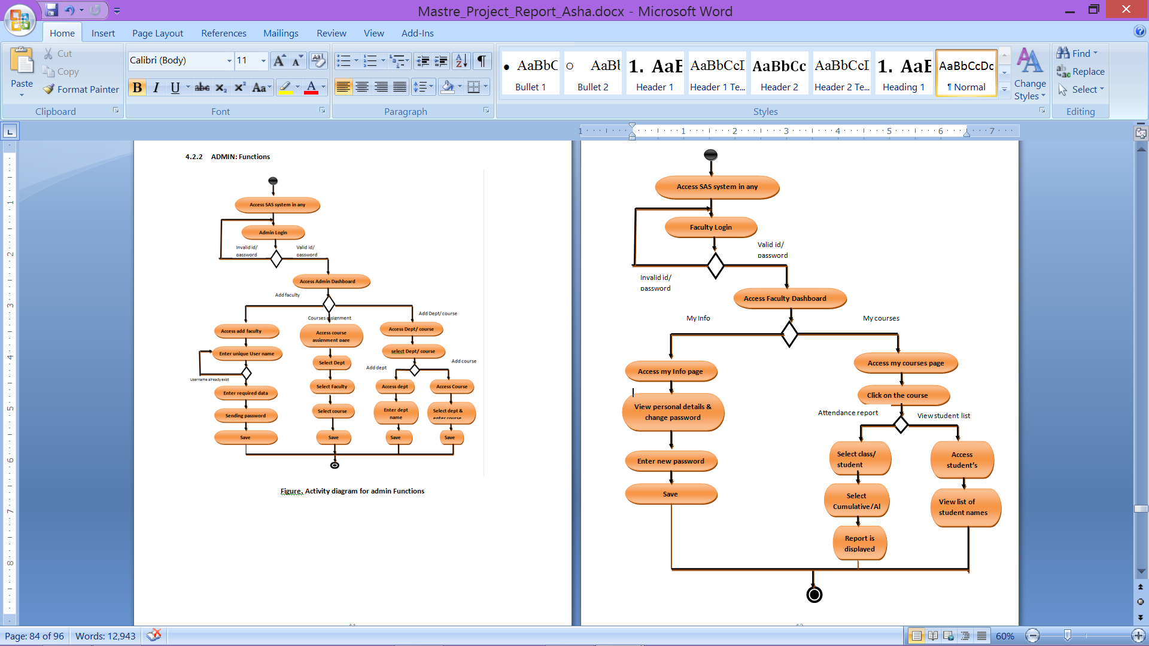

##### FIGURE 25: Activity Diagram for Faculty Functions

### 8.2.4 STUDENTS: Functions

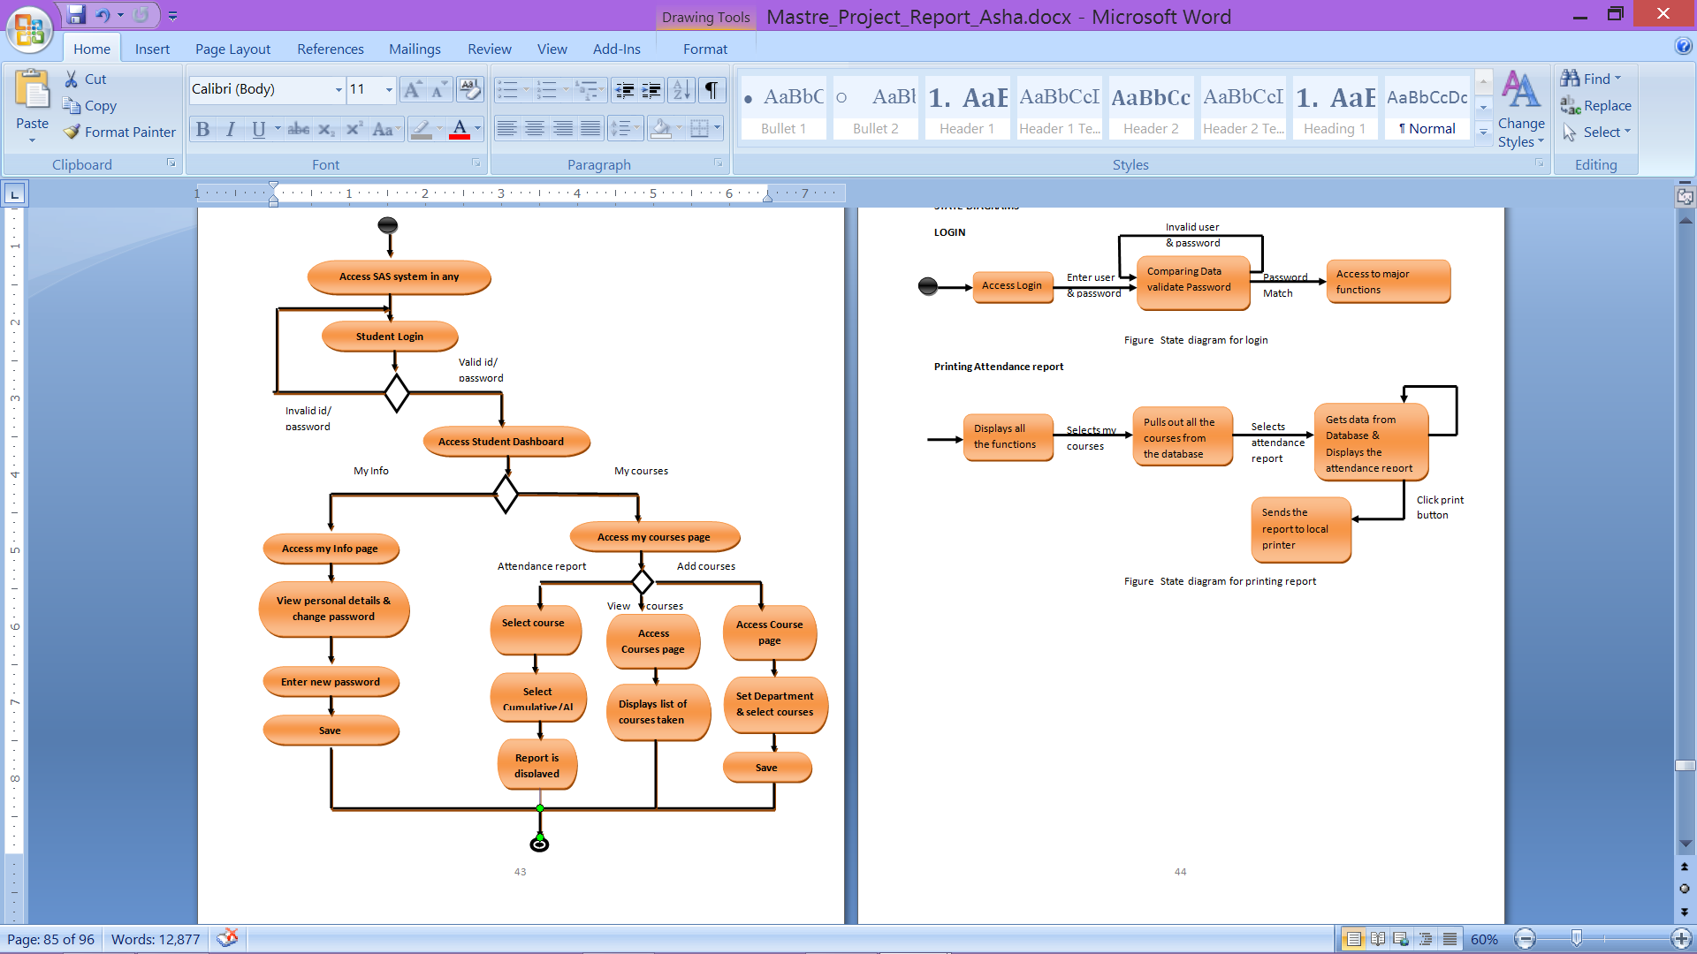

##### FIGURE 26: Activity Diagram for Student Functions

## 8.3 STATE DIAGRAMS

### 8.3.1 LOGIN

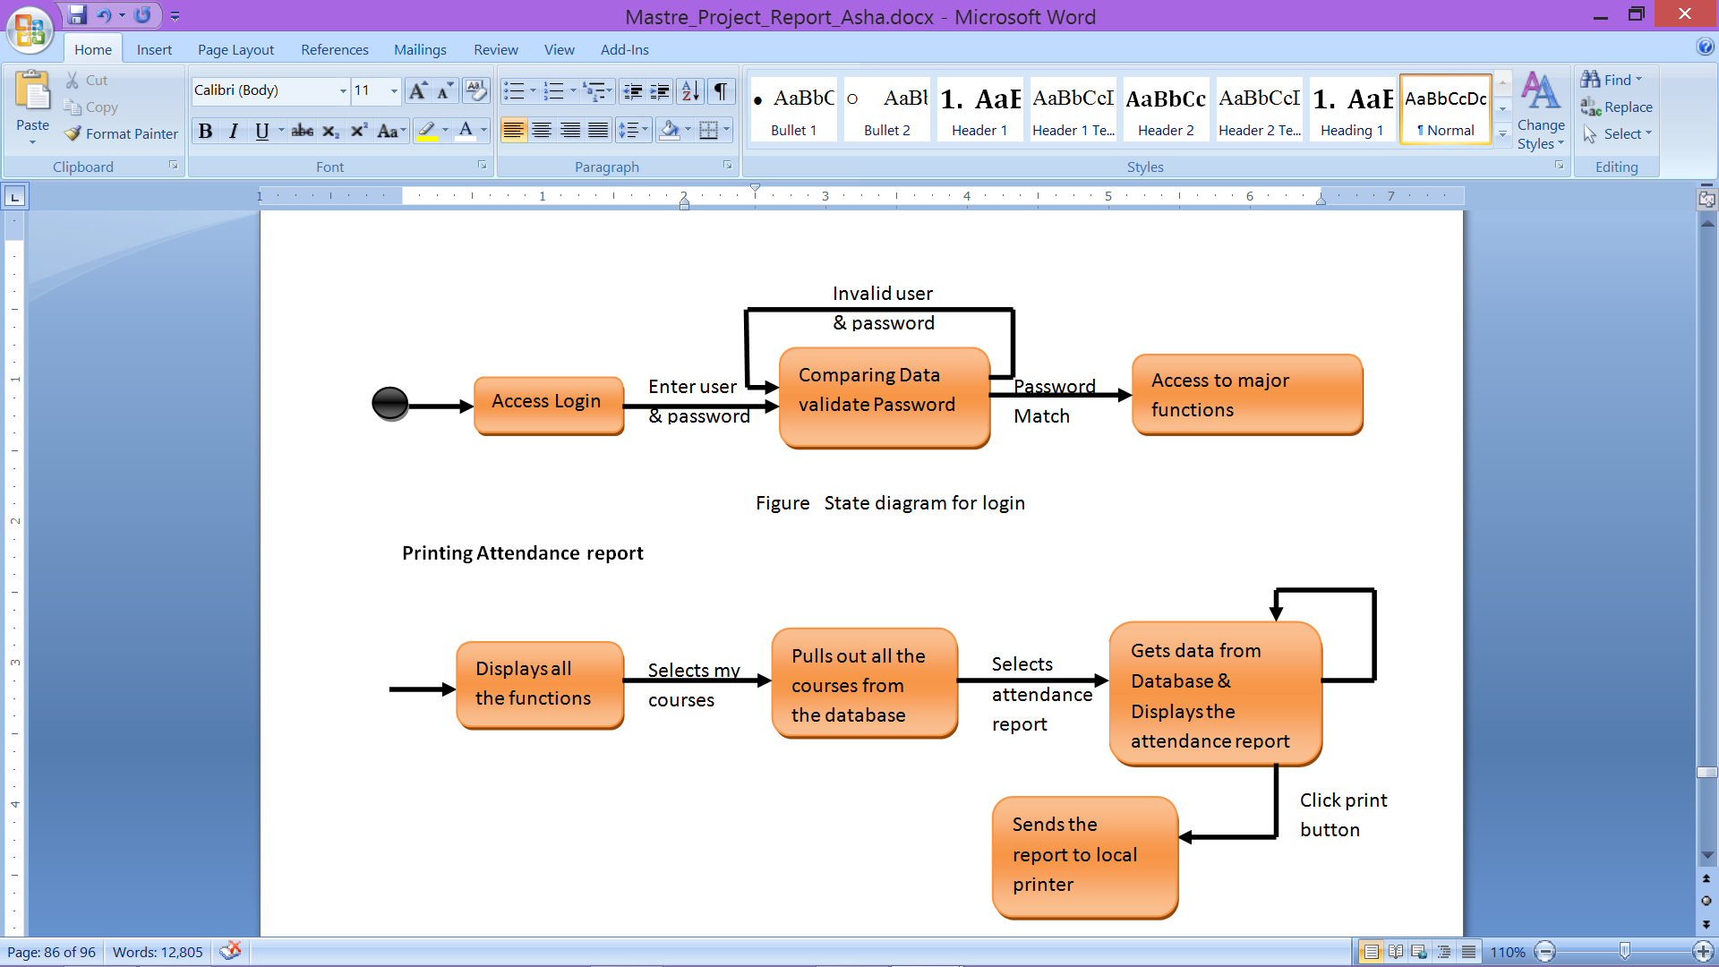

##### FIGURE 27: State Diagram for Login

### 8.3.2 PRINTING ATTENDANCE REPORT

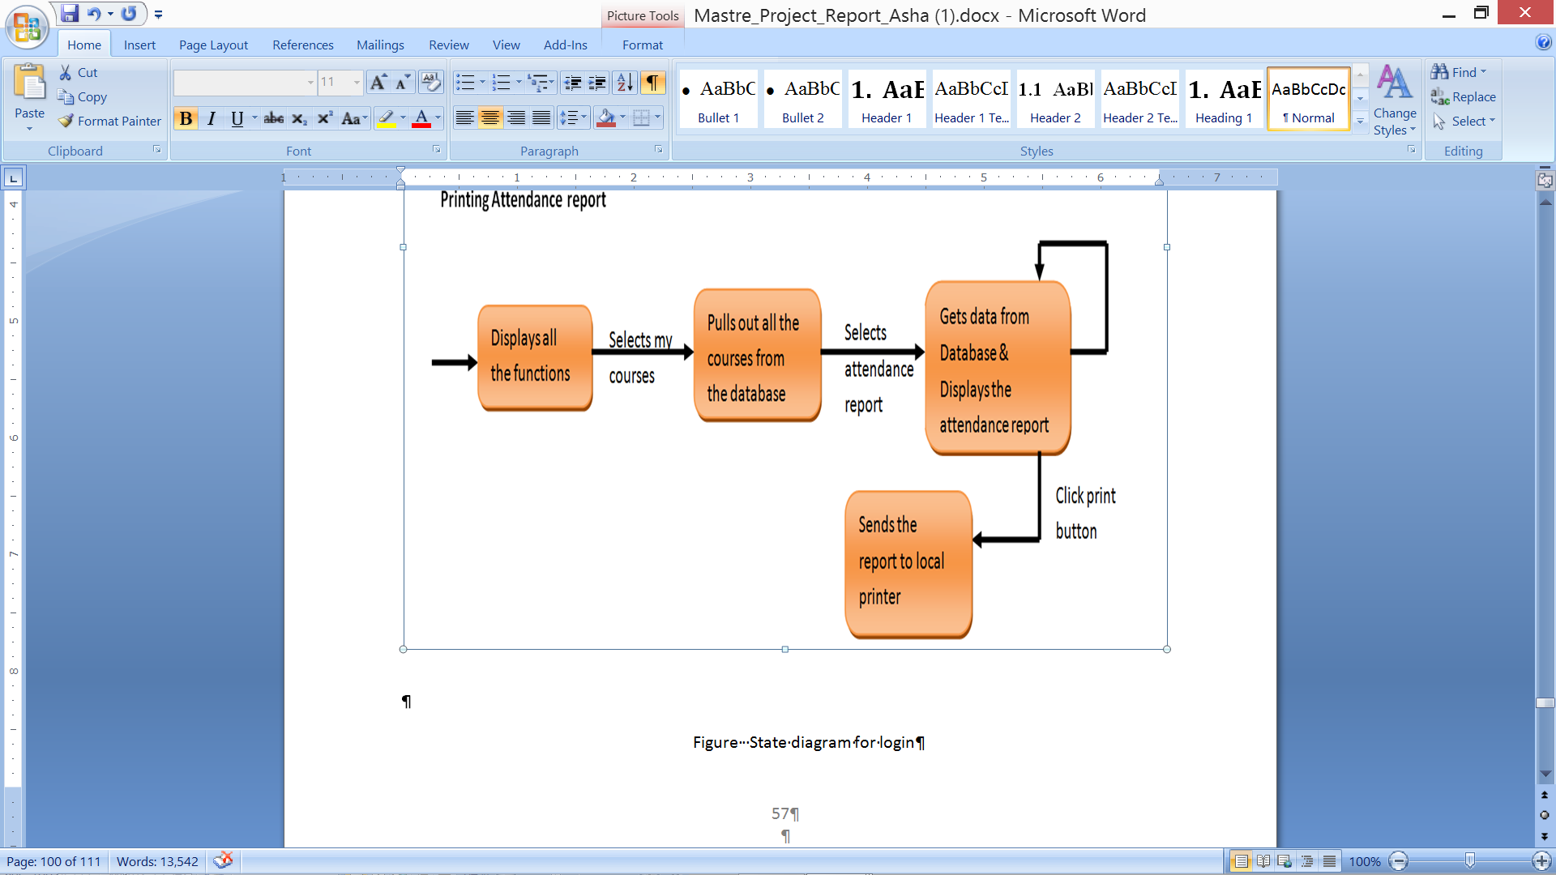

##### FIGURE 28: Printing Attendance Report

## 8.4 SWIM LANE DIAGRAMS FOR LOGIN:

### 8.4.1 LOGIN

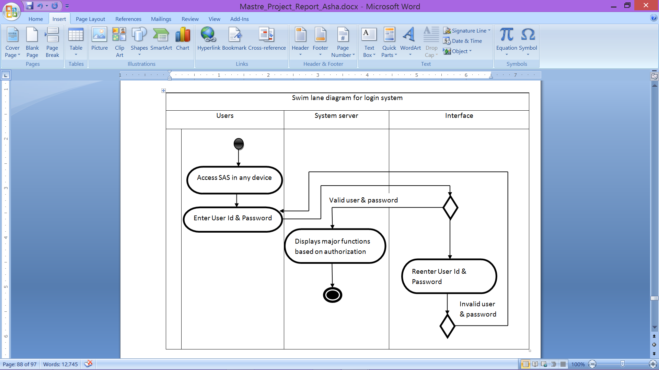

##### FIGURE 29: Swim Lane Diagram for Login

### 8.4.2 ADMIN : ADDING NEW FACULTY

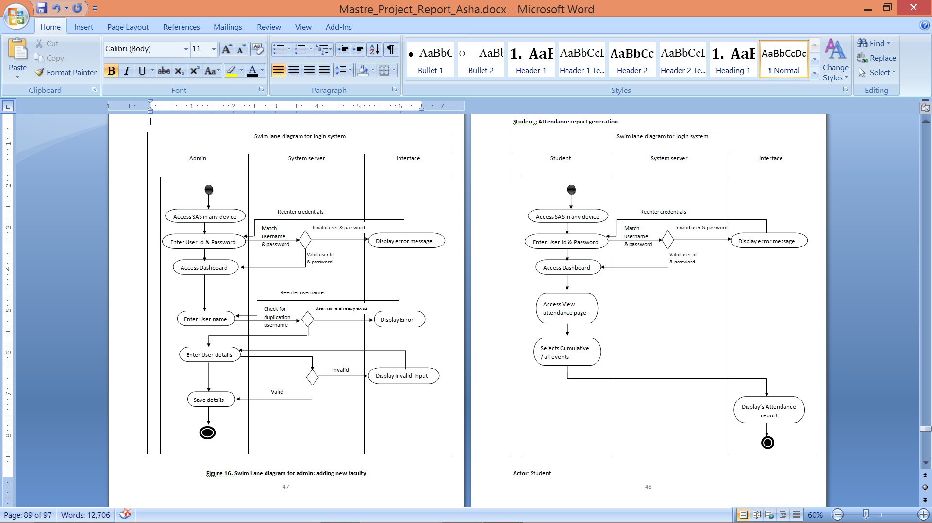

**Swim lane diagram for adding faculty**

##### FIGURE 30: Swim Lane Diagram for Admin: Adding New Faculty

### 8.4.3 STUDENT: Attendance Report Generation

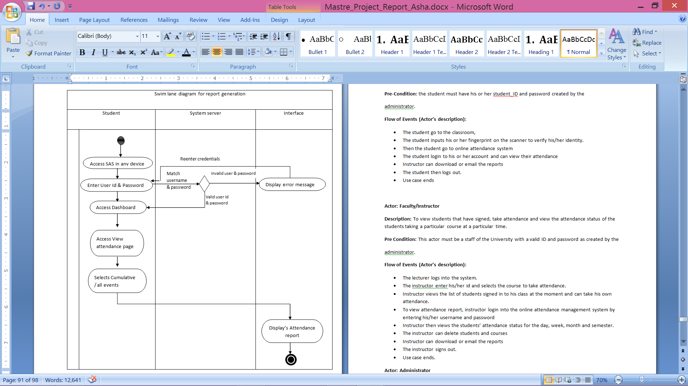

##### FIGURE 31: Attendance Report Generation

* ER DIAGRAM

The Entity Relationship diagram is a information modeling technique that diagrammatically represents an information systems entities and therefore the relationships between those entities. An ER diagram could be an abstract and representational model of information that is employed to represent the system framework infrastructure.

The ER diagram for group action management system represents all the entities particularly User entity contains the attributes ID, Name, Tbname and Pwd wherever the ID is its primary key. The course entity contains the attributes Scode, Sname and Tname wherever scode is pimary key the class diagram for the online attendance management system is shown in Figure 32

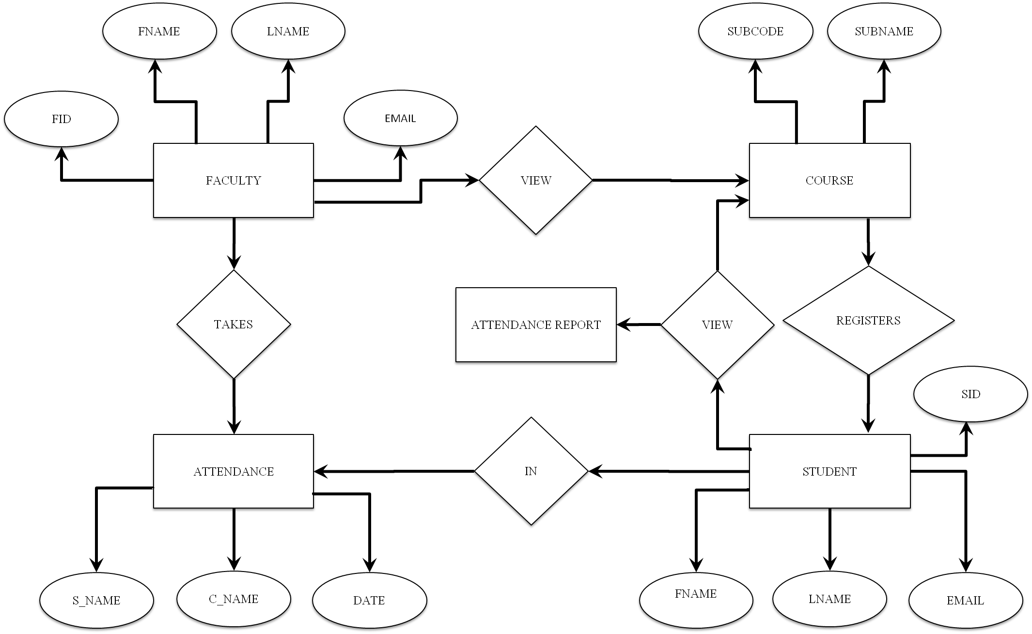

##### FIGURE 32: ER Diagram for Students Database and Attendance Records

# SECTION 9

# DATA DESIGN

## 9.1 INTERNAL APPLICATION DATA STRUCTURE

The overall application is divided into three modules:

* Bootstrap Plug-in
* Attendance Management System
* Database

Bootstrap framework should be added in the application and linked as references into the pages for performance. Attendance Management System gets responsive interface from Bootstrap plug-in and requests data from database. Database sends and stores the requested data to/from the application.

The overall structure of the application is shown in Figure [33] and its performance layout in different devices is illustrated in Figure 40.

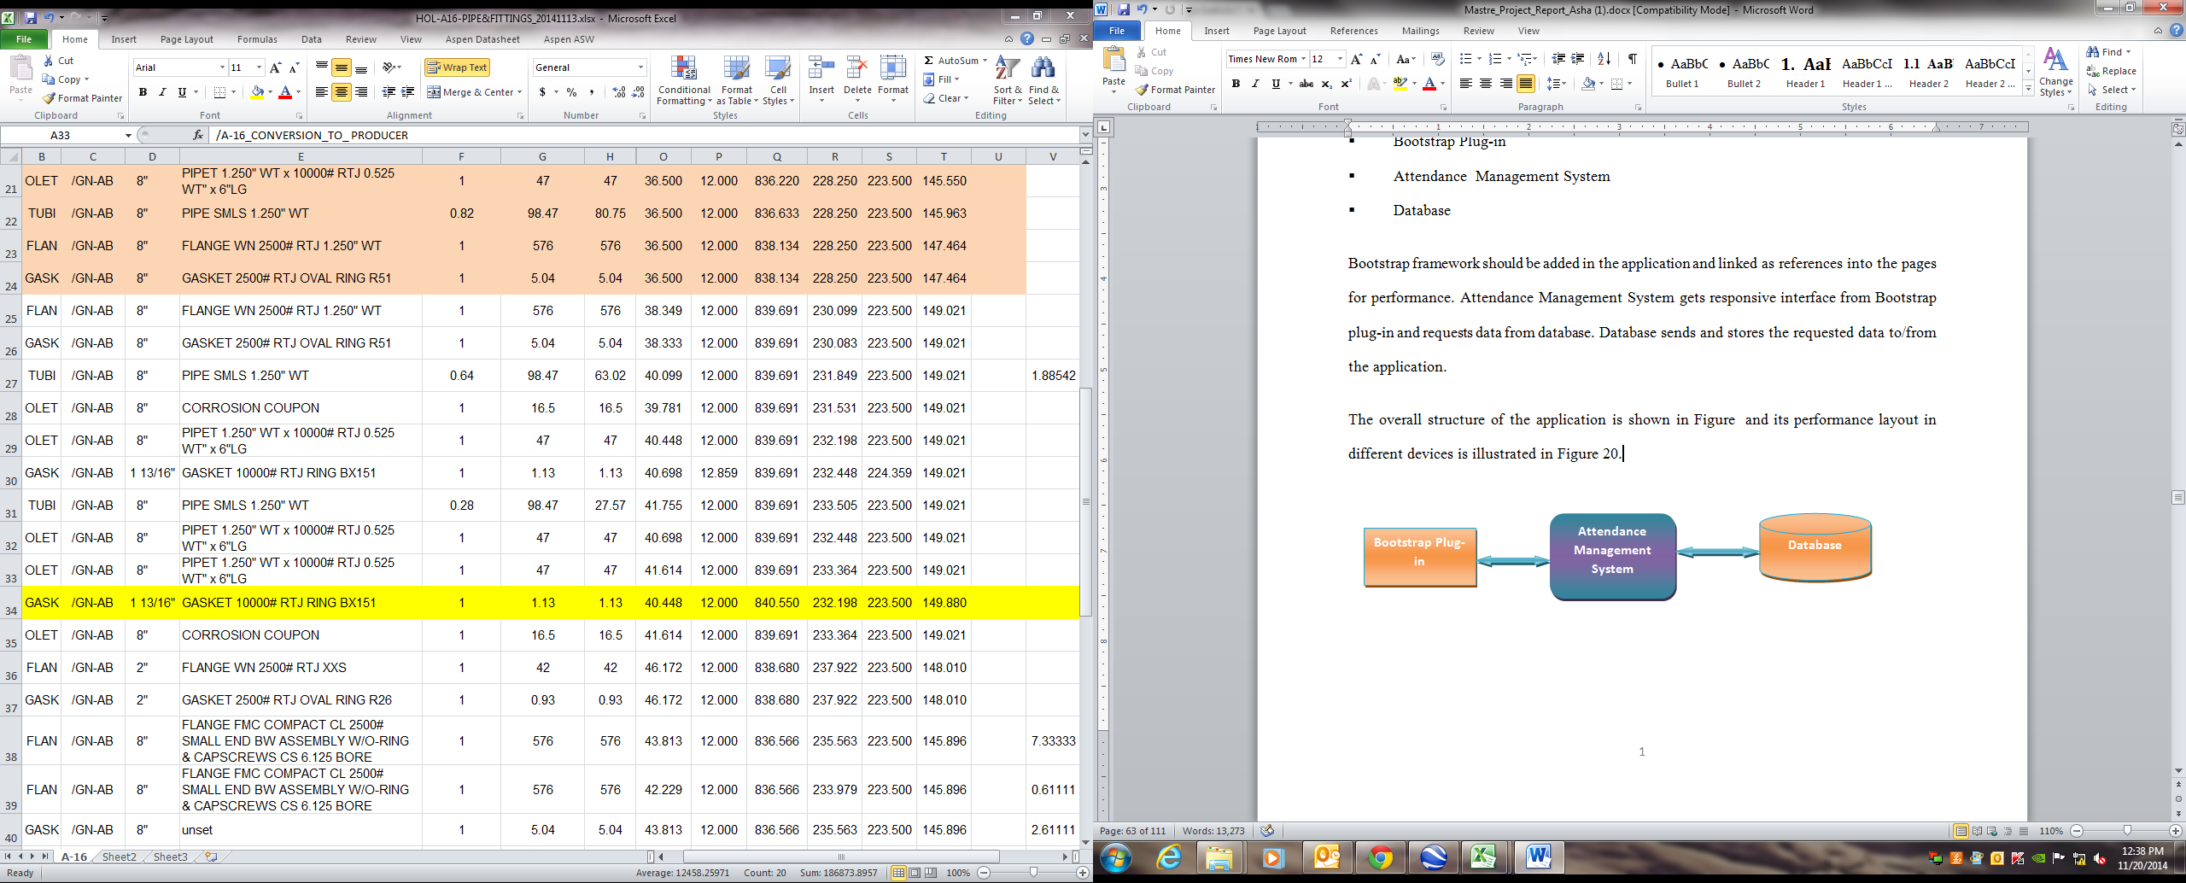

##### FIGURE 33: Internal Application Data Structure

## 9.2 DATA FLOW DIAGRAMS

* Context Level DFD:

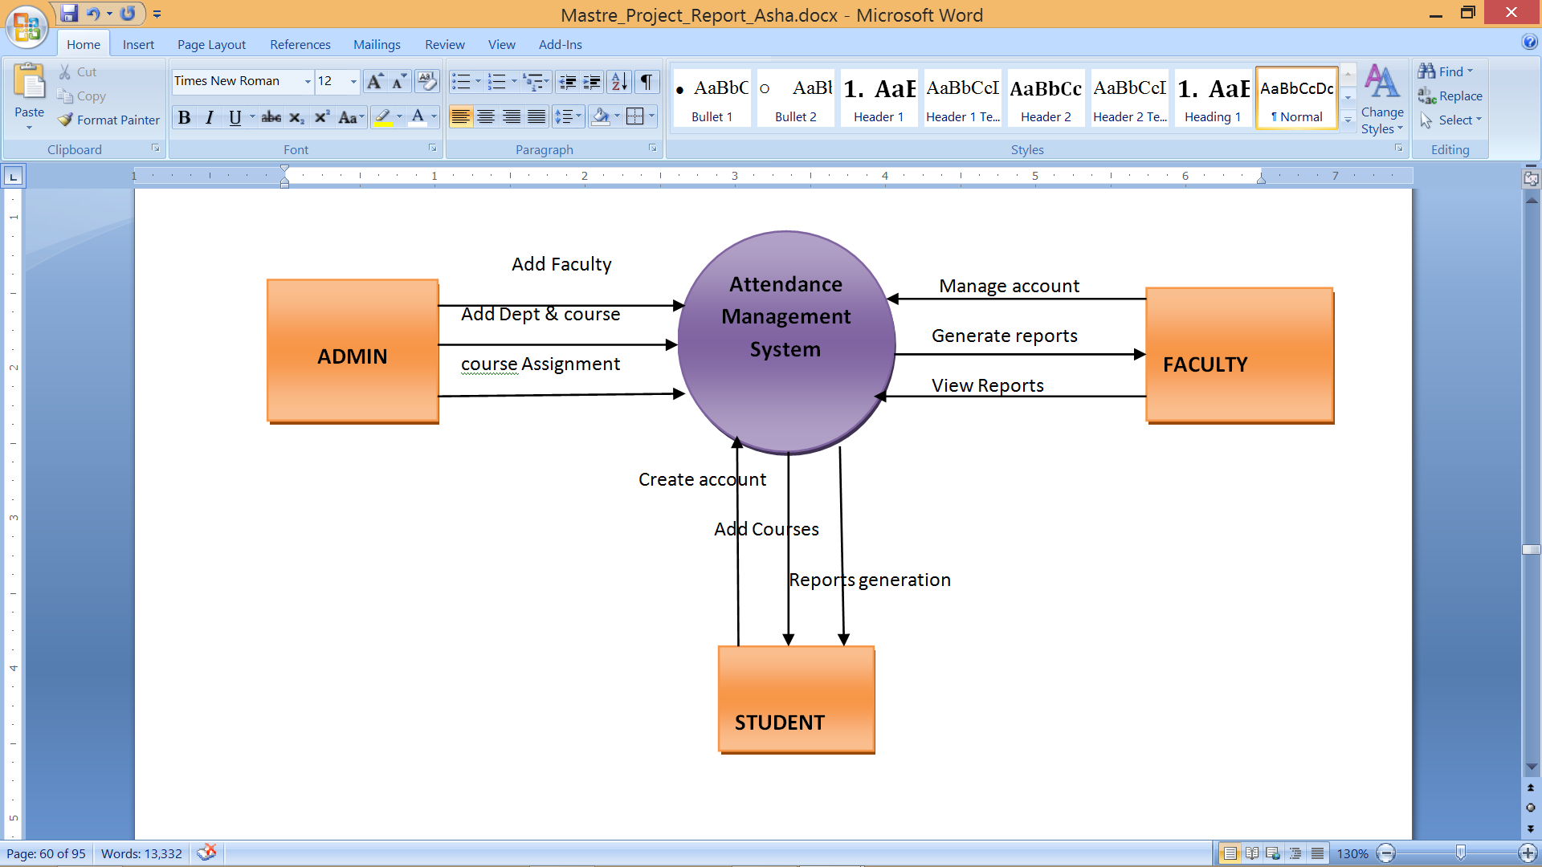

##### FIGURE 34: Context Level DFD

* Context Level 1 DFD:

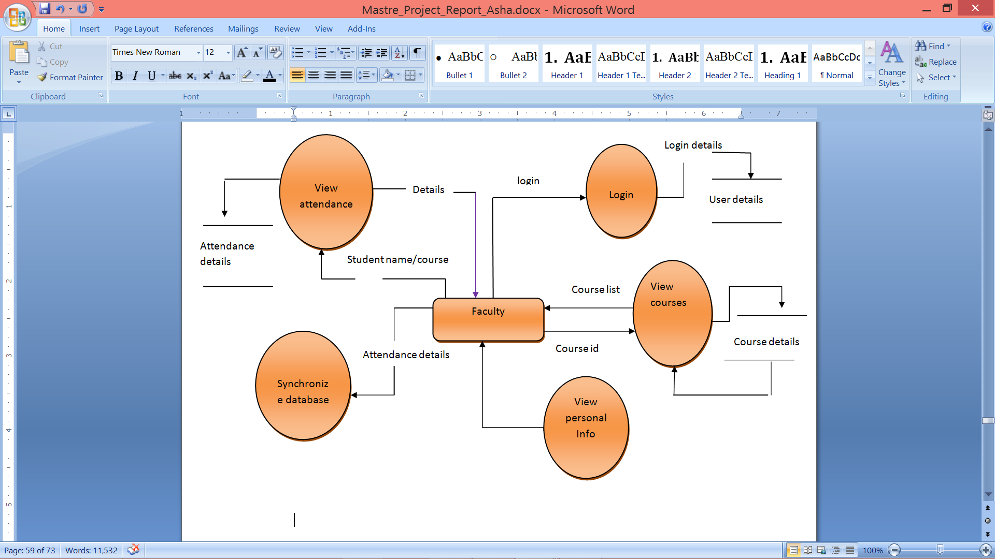

##### FIGURE 35: Context Level 1 DFD

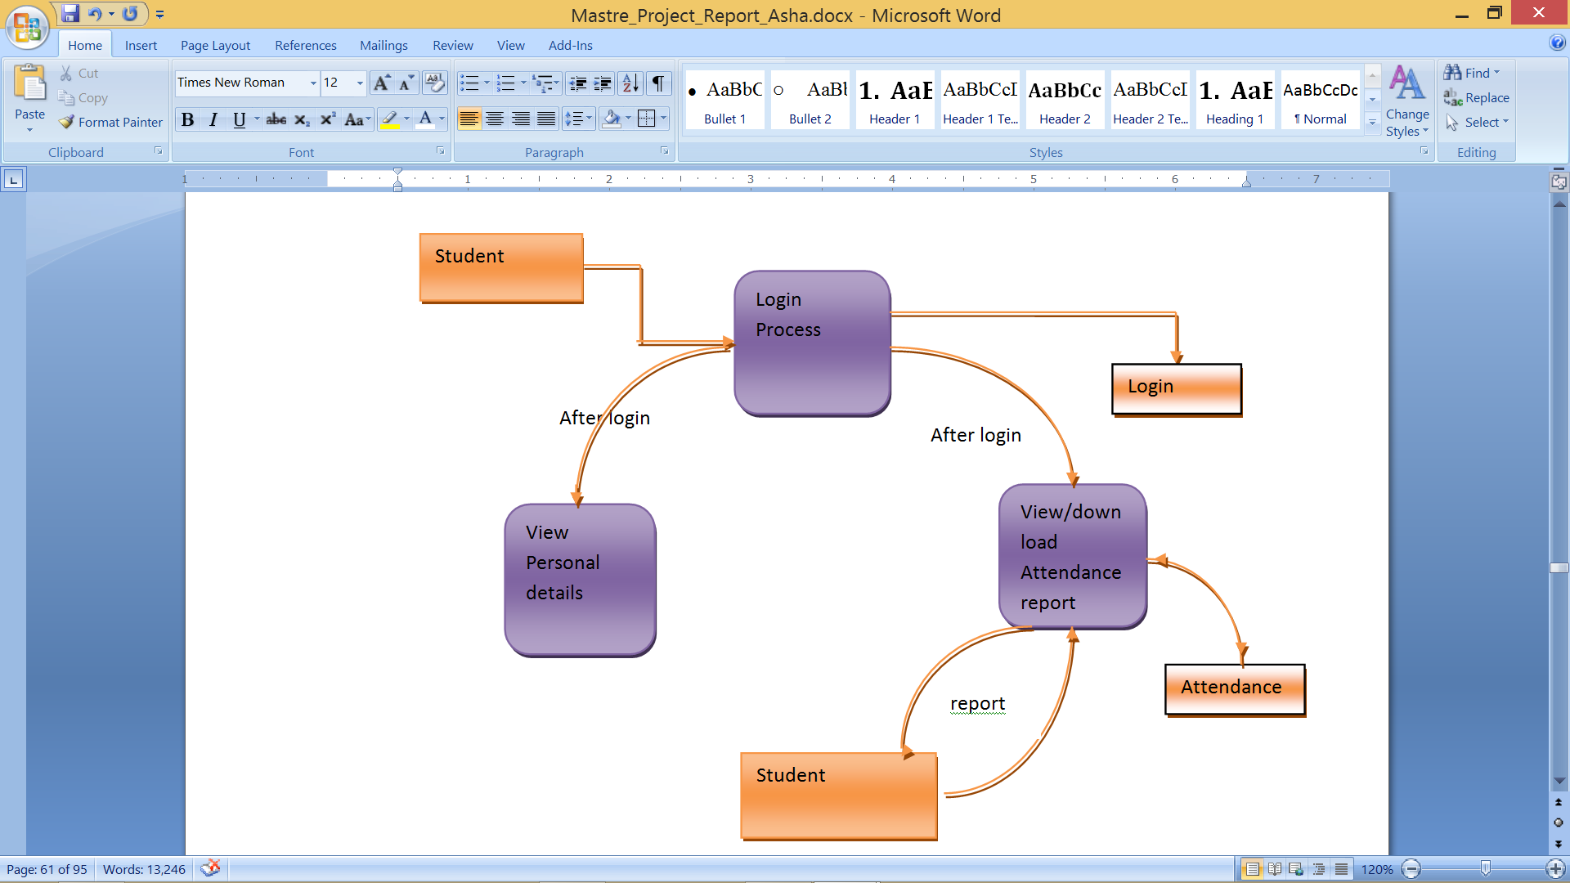

##### FIGURE 36: Context Level 1 DFD

* Context Level 2 DFD:

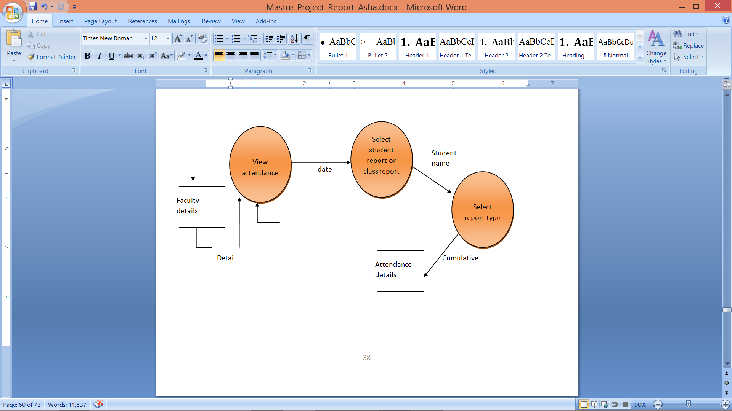

##### FIGURE 37: Context Level 2 DFD

* Sequence Diagram:

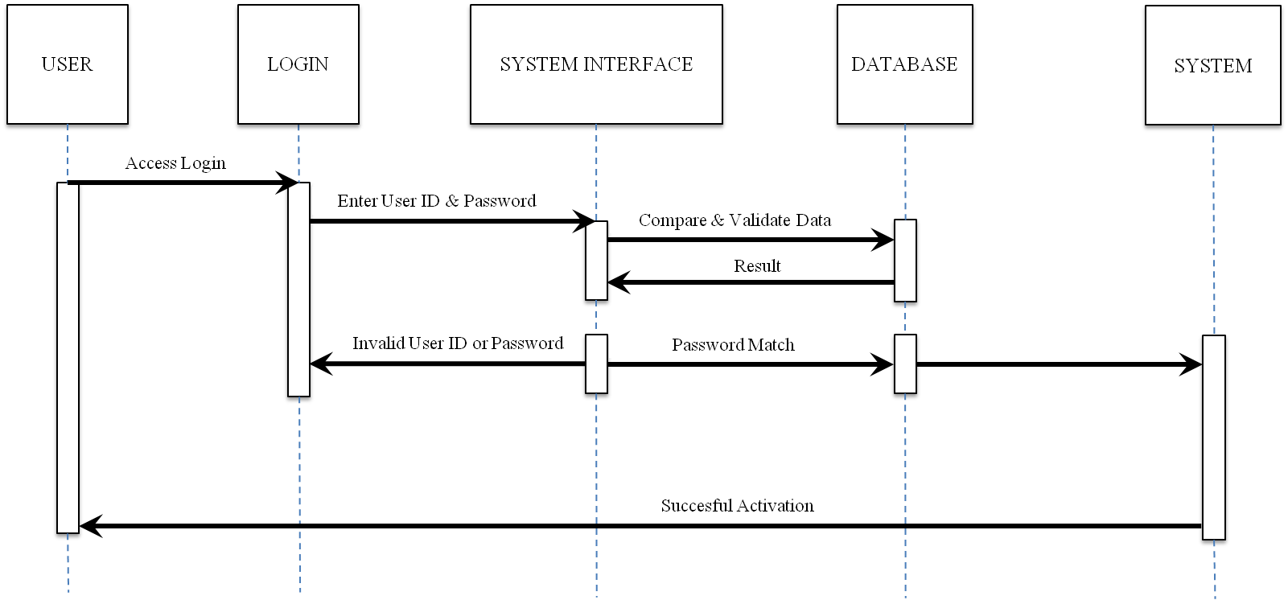

##### FIGURE 38: Login Sequence Diagram

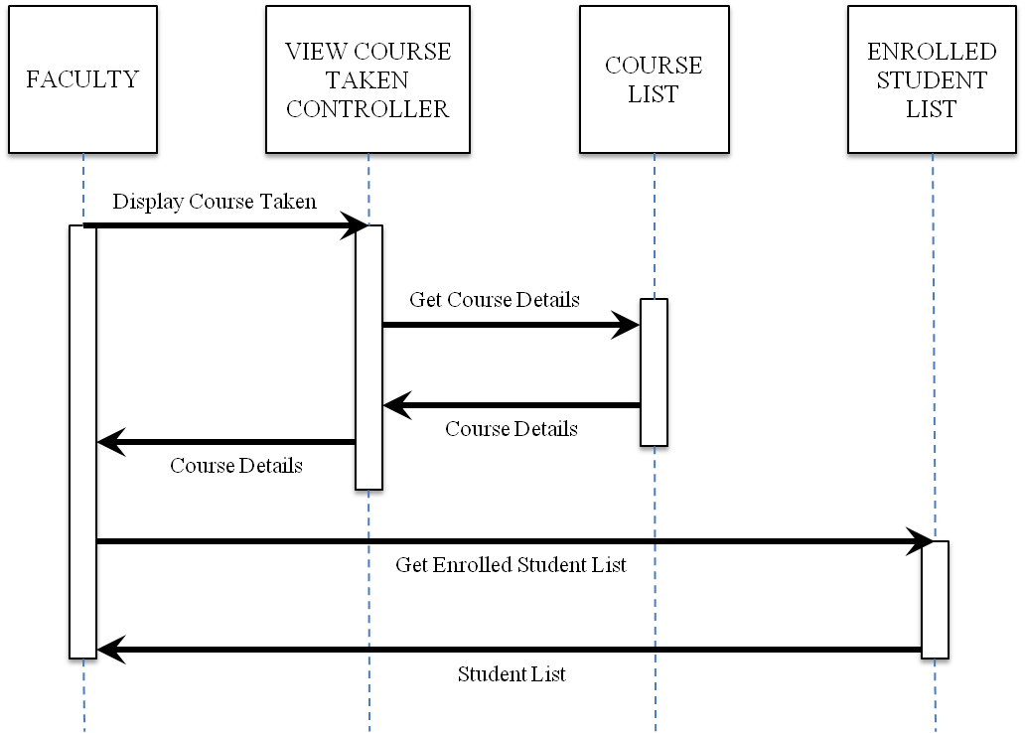

##### FIGURE 39: Login Sequence Diagram Take Attendance

# SECTION 10

# SCREENSHOTS AND CODE SNIPPETS

“Student Attendance Management System” is driven by both desktop & web applications. Web application is developed using “Bootstrap” due to its responsive nature, and it’s scalability with device sizes. Increasing user satisfaction by providing same user interaction on different devices.

## 10.1 SCREEN SHOTS AND CODE SNIPPETS

Figure 40 depicts the web application Login page. The application users are:

* Administrator
* Faculty
* Student

Username and password is verified in the database.

Figure [40] provides the basic navigation access to the user allowing him to choose their login type.

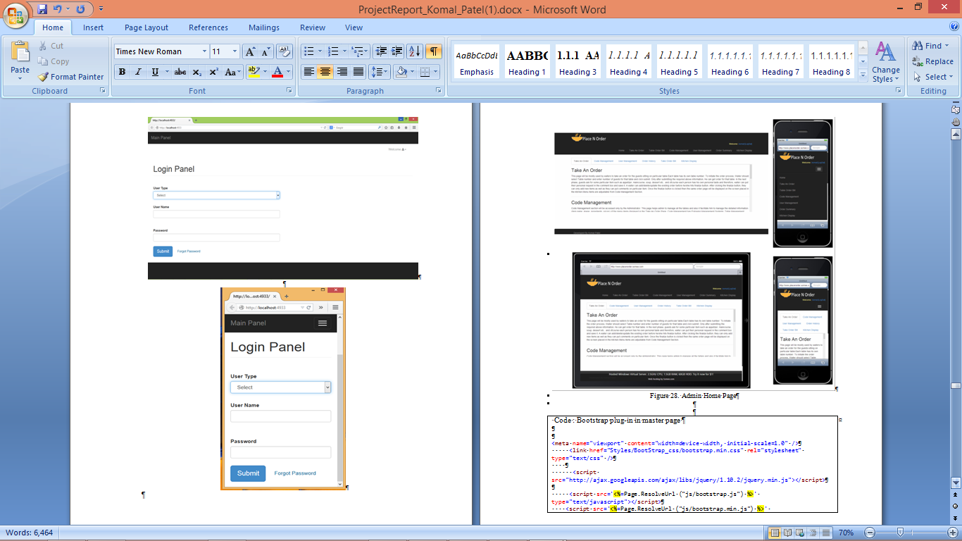

##### FIGURE 40: Users Login Screen

After the user has logged into this system, it navigates user to the home page automatically. Figure 41 shows the user’s home page, it displays functions of all the tabs.



##### FIGURE 41: Admin Home Screen

* Faculty Screen:

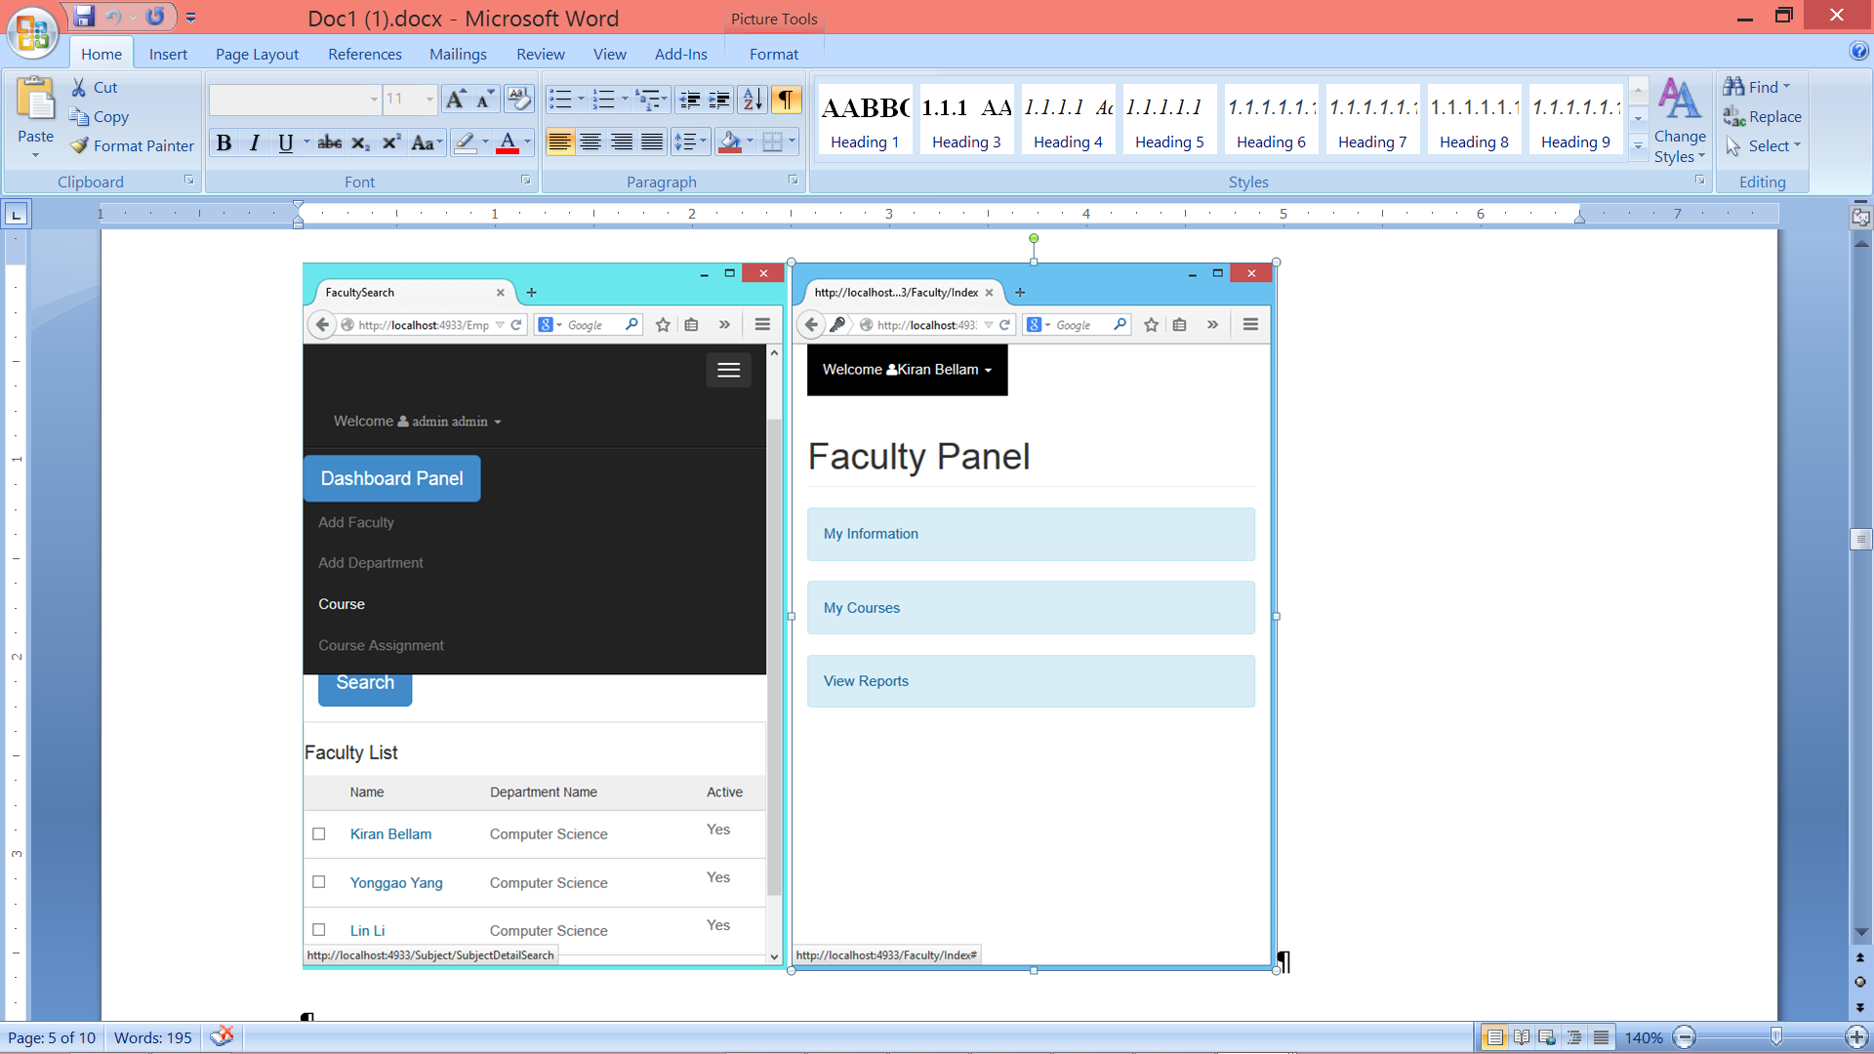

##### FIGURE 42: Faculty Panel

* Validations:

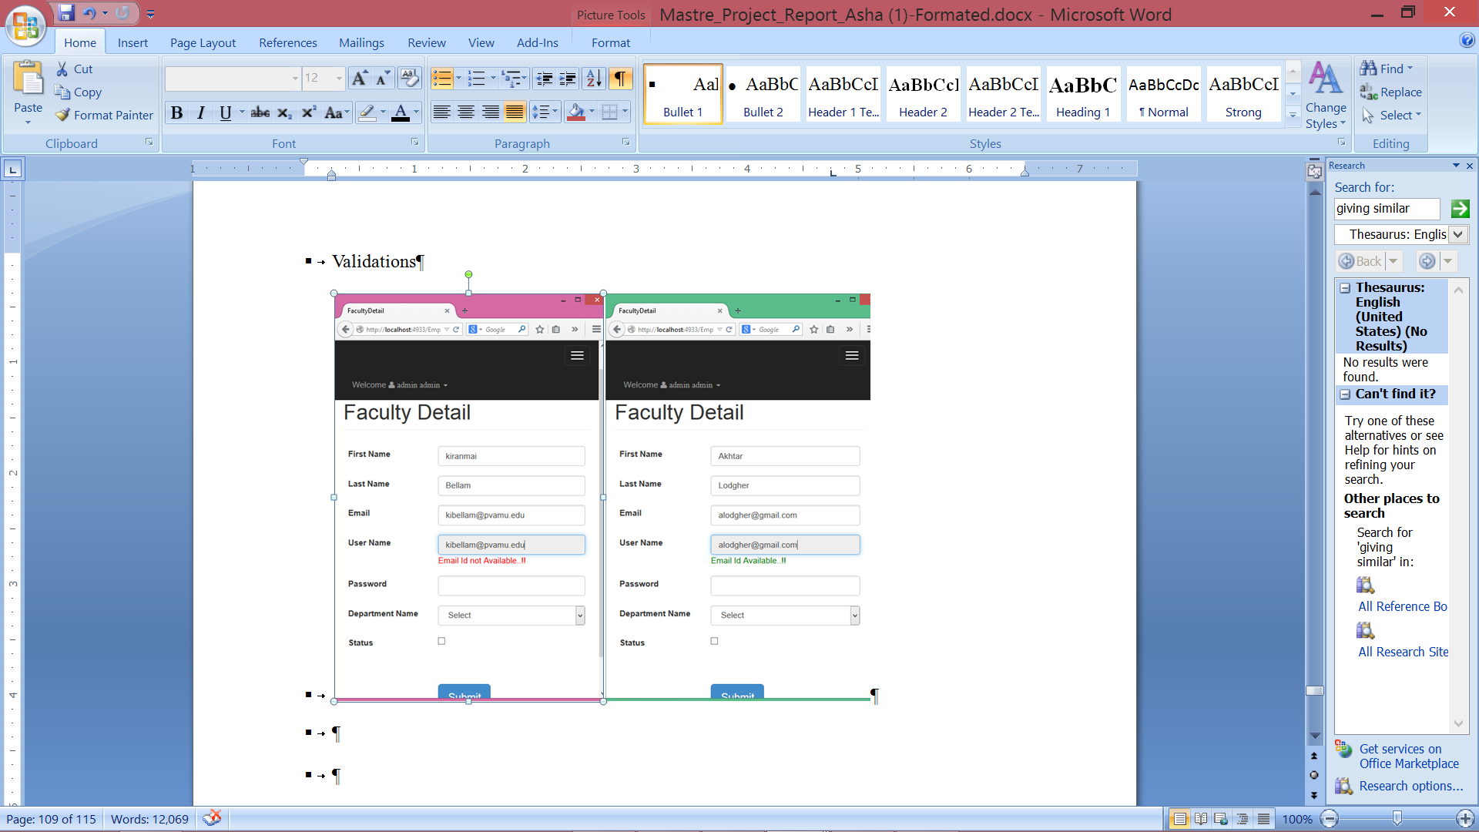

##### FIGURE 43: Checking Email

* Desktop Application:
  + Faculty Login Screen:

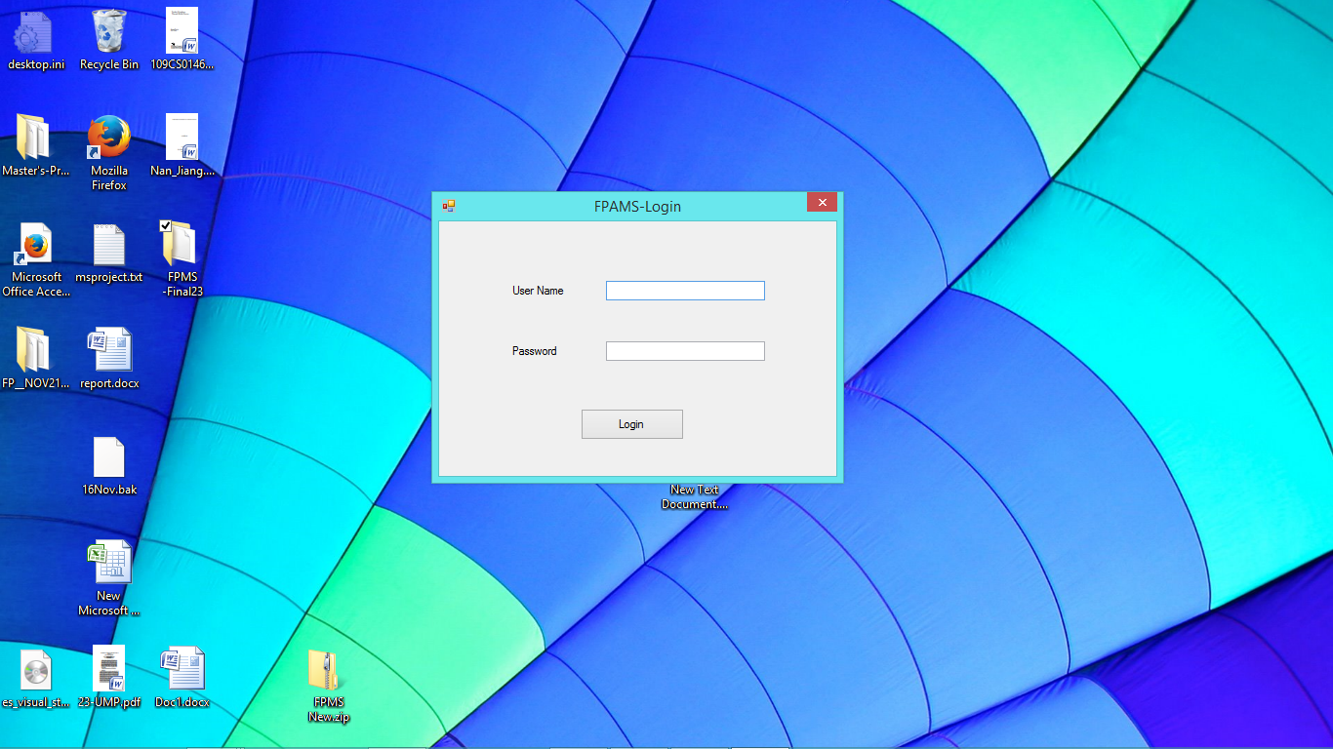

##### FIGURE 44: Login Screen

* + Taking Attendance :

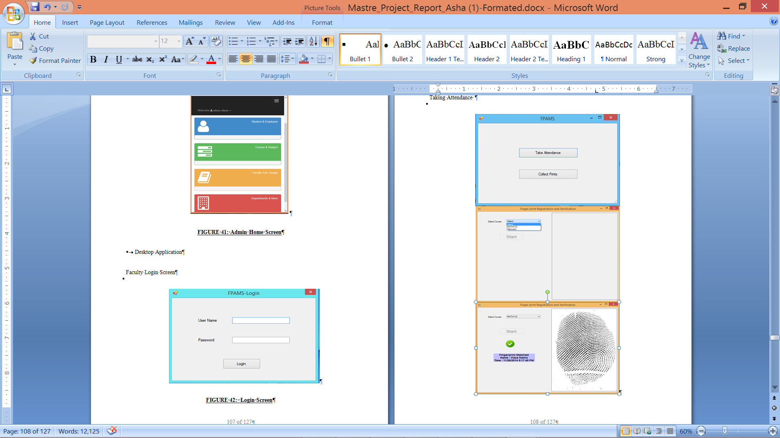

##### FIGURE 45: Taking Attendance Interfaces

* Collecting Students Fingerprints

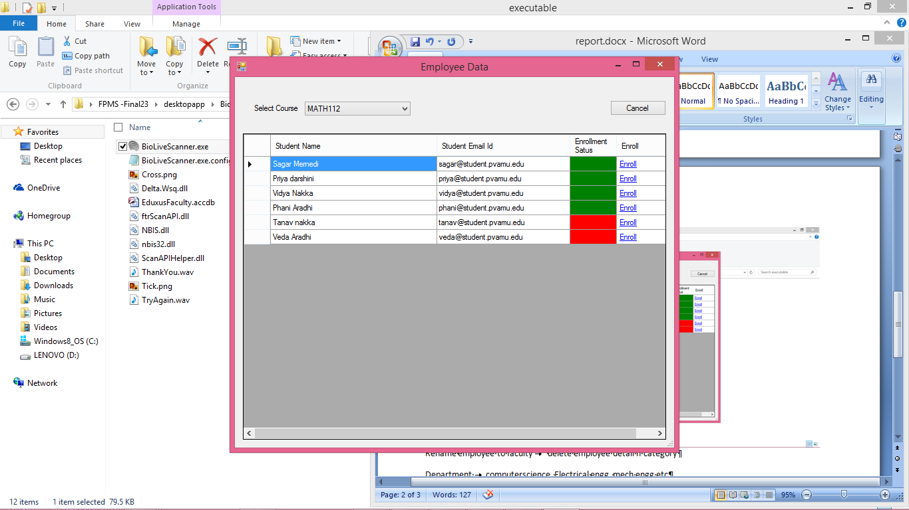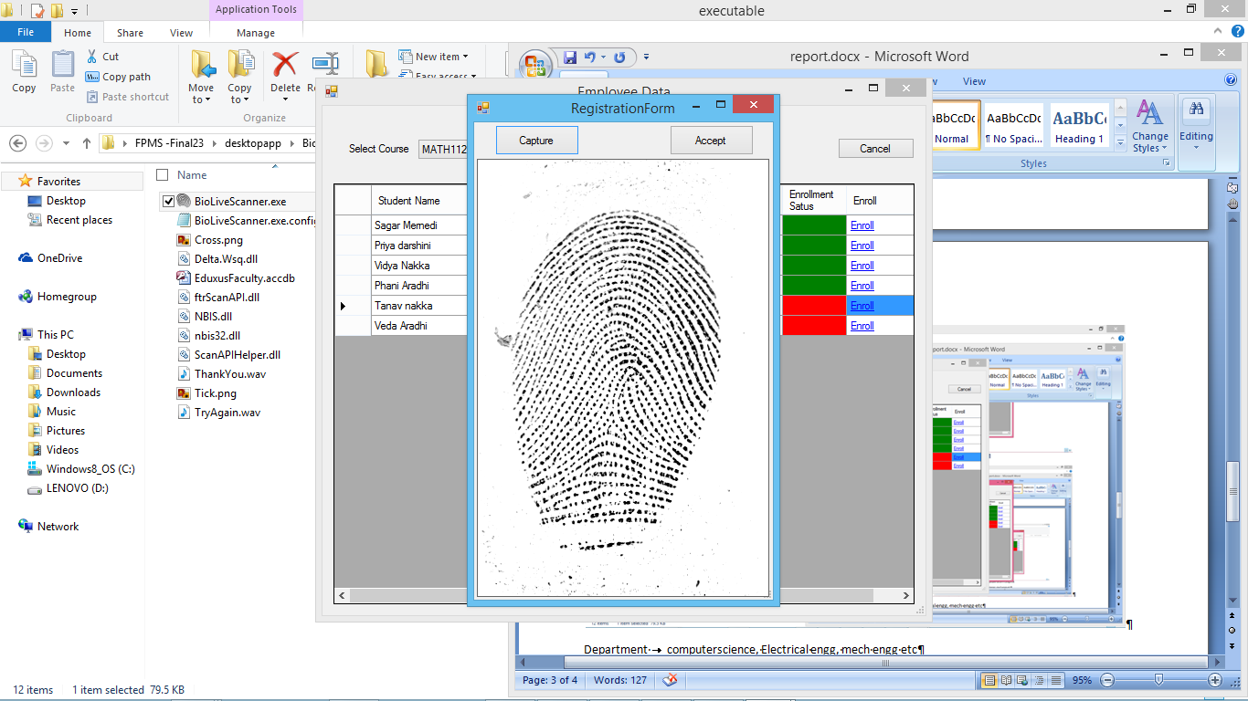

##### FIGURE 46: Collecting Fingerprints

* Attendance Report Screen

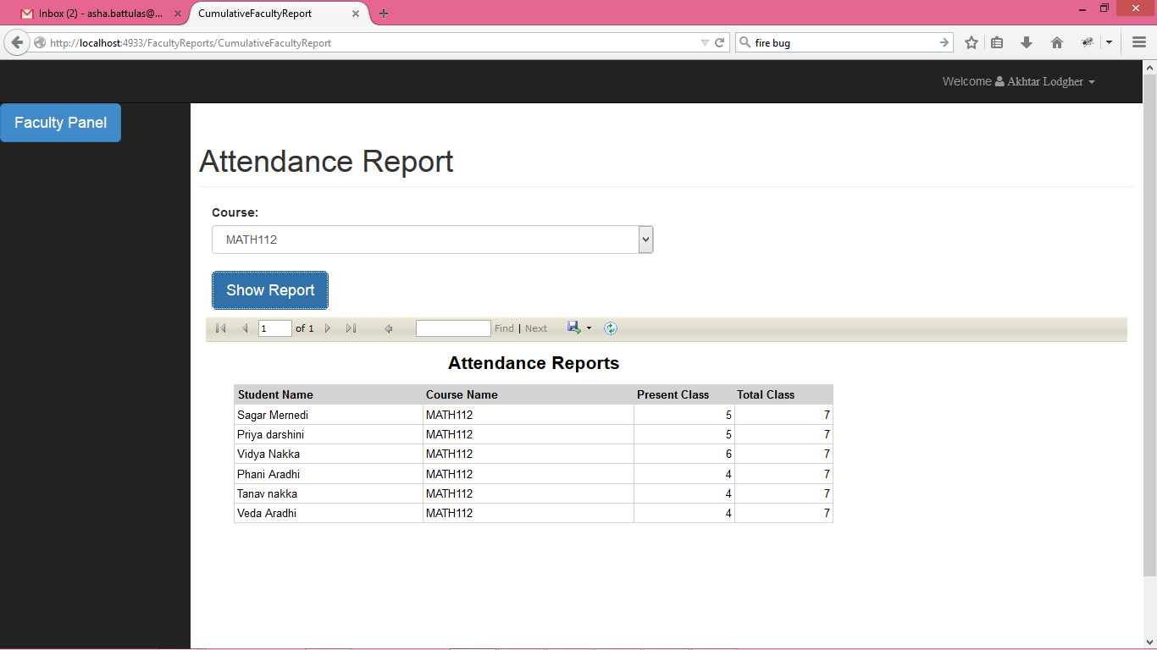

##### FIGURE 47: Course Cumulative Report of Class Math112

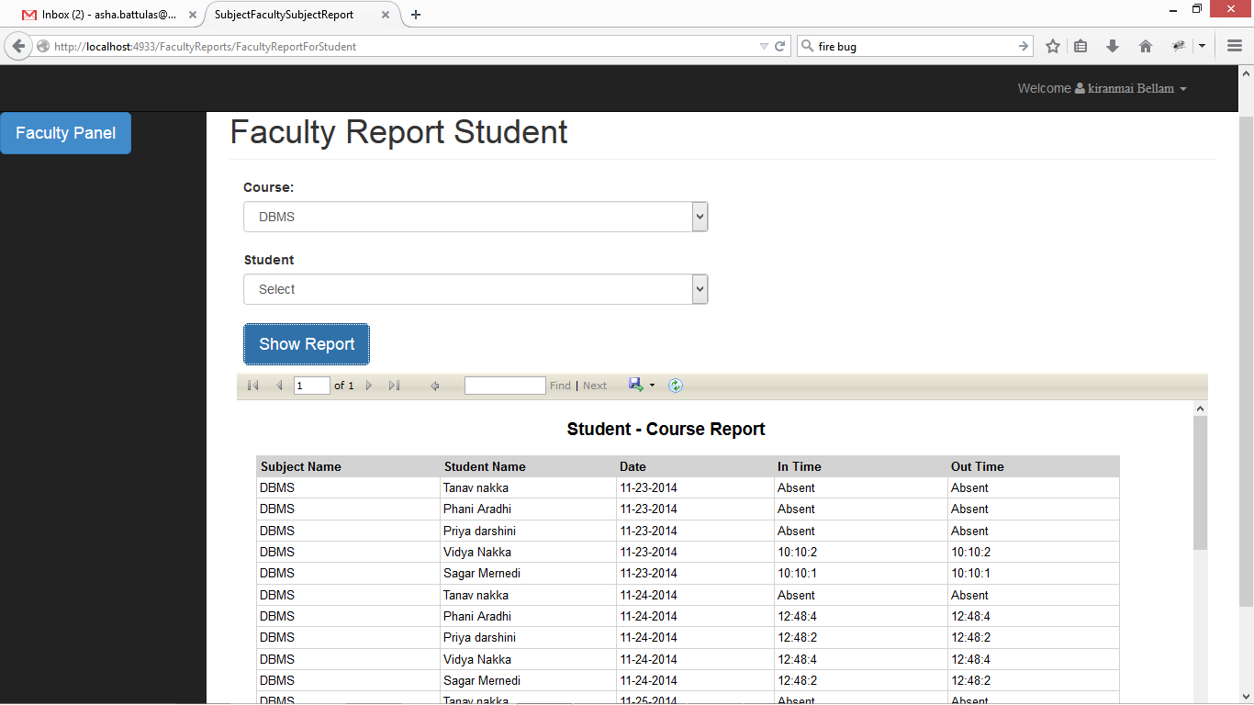

##### FIGURE 48: Course All Event’s Report of Class DBMS

* Code Snippets:
  + Get Form Fields:

The following is the code to get the form field details such as field name, field type and display order sequence as entered by the registered user of the system.

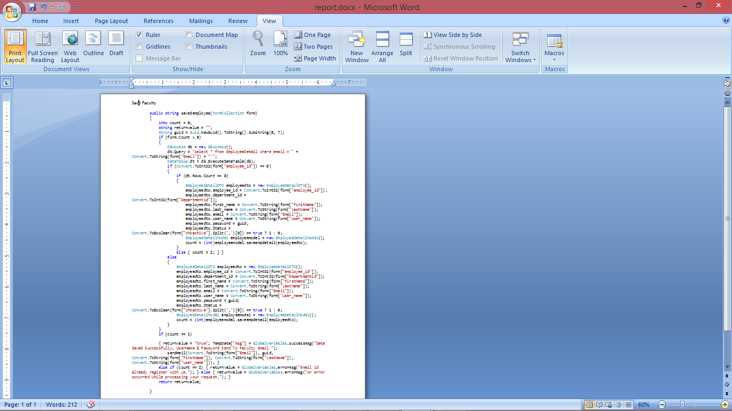

* + Send Email:

The following is the code used to send notifications via email to the user.

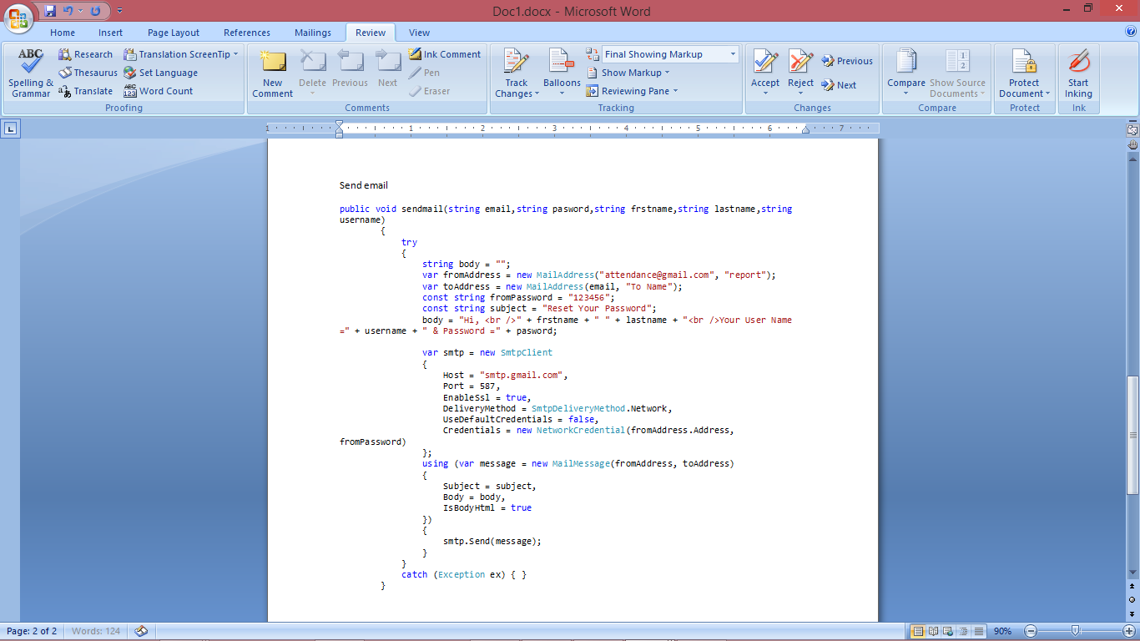

* + Getting Data from DB:

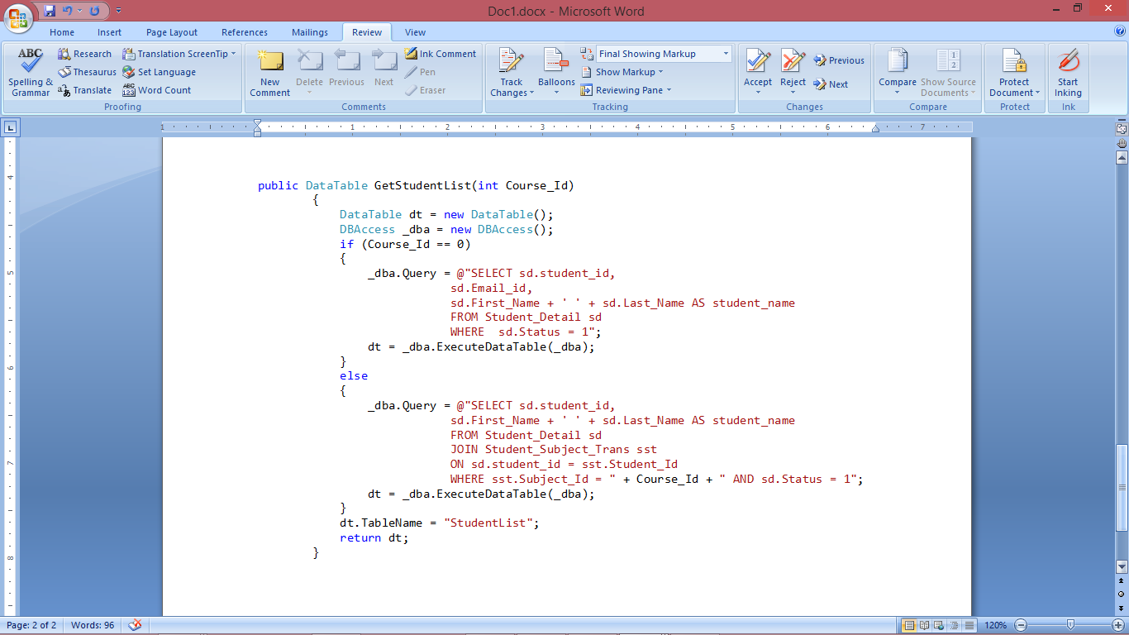

* + Saving Data from Form to DB:

Getting data from dropdown list

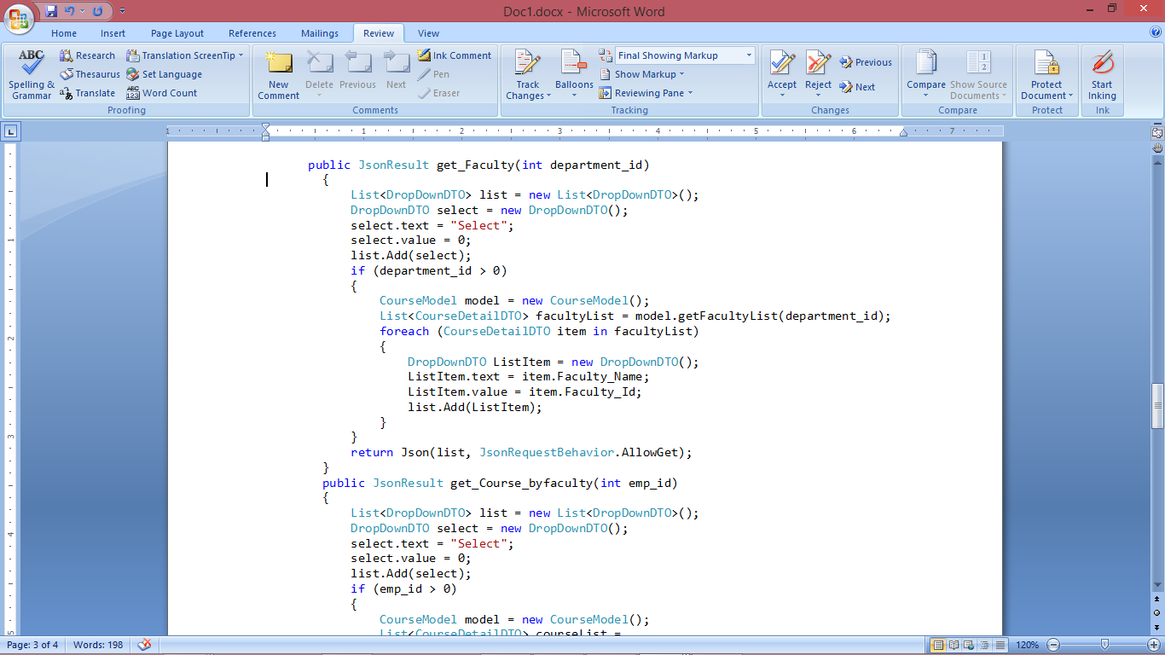

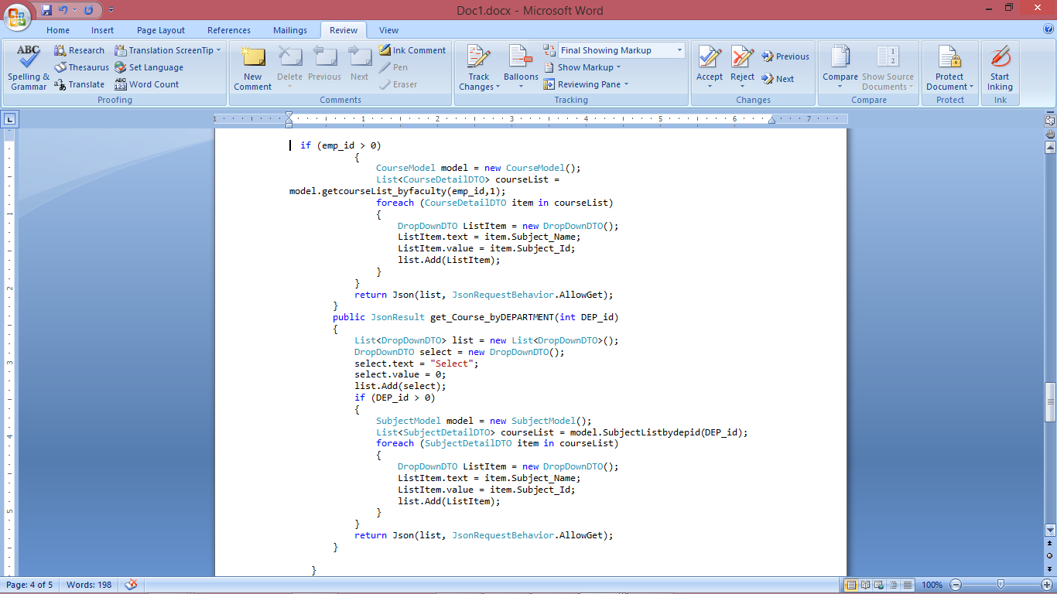

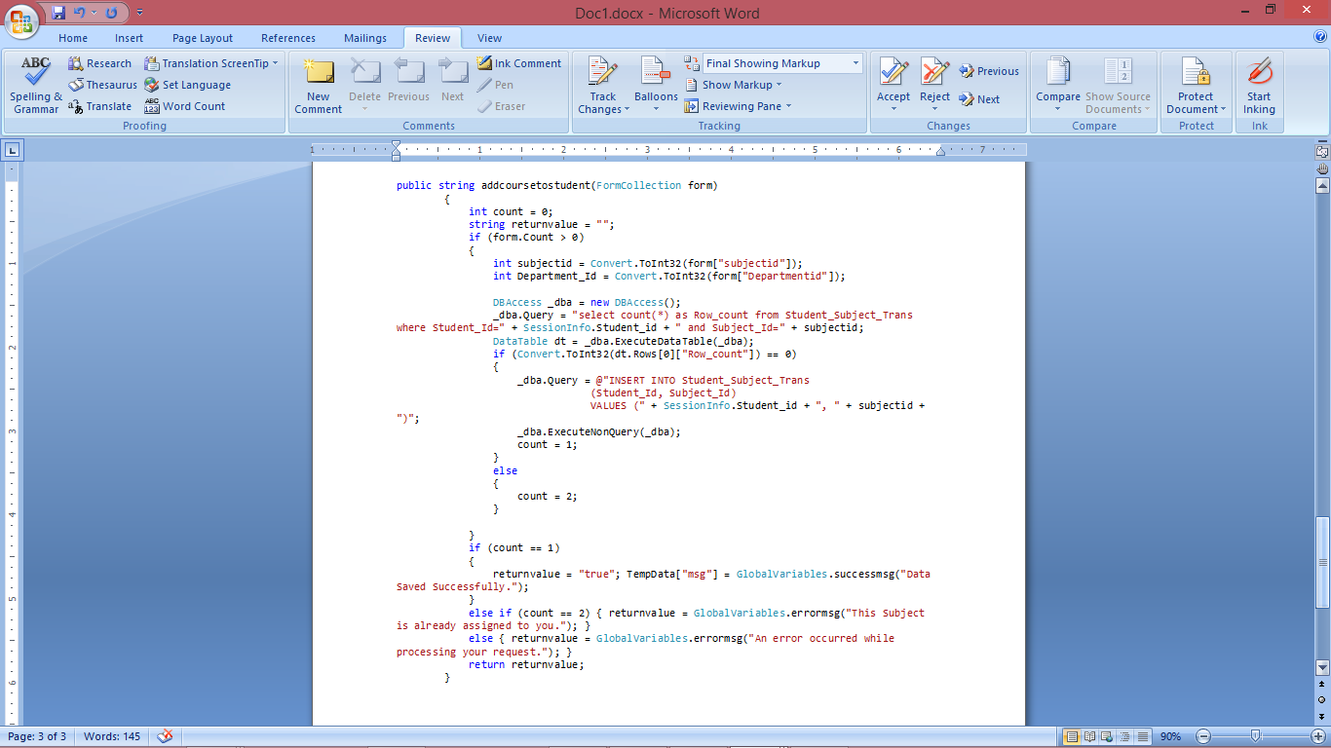

* + Deleting data from DB

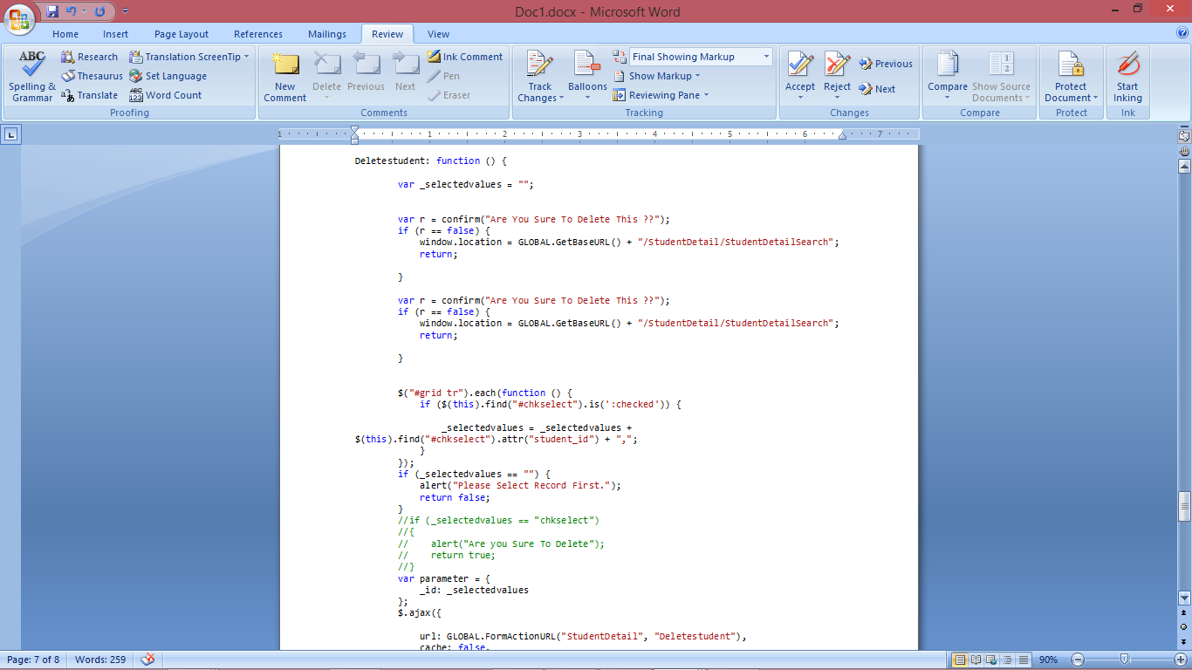

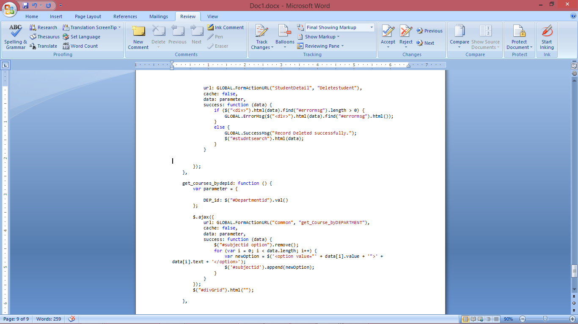

# SECTION 11

# TESTING

The main intention of testing of a web design is to uncover errors. This can be achieve by following a series of steps. Unit and integration tests concentrate on functional verification of a component and integration of components into the software architecture. System testing validates software once it has been integrated into a larger system. Test strategy and preliminary test case specification are presented in this section.

## 11.1 TEST CLASSES

* Unit Testing:
  + User validation test
  + Navigation test
  + User Input event recognition test
  + Communicate with server
  + Retrieving data from server
  + Parsing information into Data table
  + Binding data to UI test
  + Validating quantity test
* Integration Testing:
  + Updating data test.
  + Storing data into memory test.
  + Removing data from memory test
  + Storing data into DB for further analysis of system.
  + Auto updating information in database.
* System Testing:
  + Orientation support test.
  + Different web browser test

## 11.2 EXPECTED SOFTWARE RESPONSE

* Navigation test: Web pages should navigate back and forth to different pages.
* Responsive Design Test: The developed application design adapts so as per the display of the device.
* User Input event recognition test: Attendance Management system should notify respective event based on the user input.
* Communicate with server test: Attendance Management system should able to successfully connect to server.
* Retrieving data from server test: able to get data based on the request sent to server.
* Parsing information into report test: Parse data to system recognized format.
* Binding data to UI test: data displayed on the UI is as per data parsed.
* Validating quantity test: User should able to enter only numeric value.

## 11.3 PERFORMANCE BOUNDS

* Bootstrap features are not compatible with older versions of web browsers.
* A device must be connected to internet in order to access system.
* User should have an understanding of all the functions given to them which can help them to operate easily.
* There may be some issues in retrieving all the information if system server is busy.
* There is no memory available on the machine than system cannot store data on the device.
* Advanced Bootstrap plug-ins performance is better in client side events compared to server side.
* Dynamic driven controls of Bootstrap with Asp.Net may change behavior in page post back events.

# SECTION 12

# CONCLUSION & FUTURE WORK

A website designed using responsive web design tools, like Bootstrap, automatically scales the website based on a device type, ensuring that all required functionality is available on all device types. In this project, student attendance management system can be viewed on handheld devices which can be used by a faculty and students to view their attendance report.

During this project, I got a good chance to practice my technical knowledge. I spent the most time to do the ER diagram and database. They are the basic but necessary part of this system. I did not know ER diagram clearly at the beginning, especially the entity and relationship. So my instructor and I held a meeting per week to process my project. At the same time I found out the supporting theories and samples to prove my idea through websites. During the meeting, I discussed with my instructor. I could get the right opinions or knowledge via discussions and website searching.

## 12.1 FUTURE WORK

The system can be further enhanced and several other functionalities can be added. The fingerprint transfer from the device to the server can be wireless.

# SECTION 13

# REFERENCES

[1] K. Knight, Responsive Web Design: What It Is and How To Use It, Internet: http://coding.smashingmagazine.com/2011/01/12/guidelines-for-responsive-web-design/, Jan.12, 2011 [Feb. 1, 2014]

[2] Mohorovicic, S., "Implementing responsive web design for enhanced web pres-ence,"Information & Communication Technology Electronics & Microelectronics (MIPRO), 2013 36th International Convention on, vol., no., pp.1206,1210, 20-24 May 2013

[3] “Twitter Bootstrap Tutorial”, Internet: http://www.tutorialrepublic.com/twitter-bootstrap-tutorial/ [Feb. 12, 2014]

[4] Rishab Mishra,(2011, May 5). Student Attendance System Based On Fingerprint Recognition and One-to-Many Matching[online]. Available: ethesis.nitrkl.ac.in/2214/1/thesis.pdf

[5] Futronic Fs88. FS88 FIPS201/PIV Compliant USB2.0 Fingerprint Scanner Availa-ble[online] : http://www.futronic-tech.com/product_fs88.html

[6]. Fernando Alonso-Fernandez, Fingerprint Recognition. Available[online]: http://hh.diva-portal.org/smash/get/diva2:239227/FULLTEXT01.pdf

[7] Mehta Sohil, (2014, oct). RFID based Employee Attendance & Database Management System (READS Version 1.0) Using RFID Module [RKI-1512] Available [online]: http://ismitmajithia.weebly.com/uploads/2/2/9/8/22984604/project_report_on_read_system_final.pdf

[8] David H. Chang, Fingerprint Recognition through Circular Sampling. Available [online] : https://www.cis.rit.edu/research/thesis/bs/1999/chang/thesis.html

[9] C#Language Specification http://www.ecma-international.org/publications/files/ECMA-ST-WITHDRAWN/ECMA-334,%203rd%20edition,%20June%202005.pdf. [10]Applying MVC and PAC patterns in mobile applicationshttp://arxiv.org/ftp/arxiv/papers/1001/1001.3489.pdf

[11] Brian Kotek, MVC design pattern brings about better organization and code reuse http://www.techrepublic.com/article/mvc-design-pattern-brings-about-better-organization-and-code-reuse/

[12] Chitresh Saraswat, (2010, feb) An Efficient Automatic Attendance System using Fingerprint Verification Technique[online]. Available: http://www.enggjournals.com/ijcse/doc/IJCSE10-02-02-28.pdf.

[13] Visual Studio 2012 http://msdn.microsoft.com/en-us/library/dd831853(v=vs.110).aspx

[14] Farahanum, student’s attendance system using fingerprint technology Available : http://eprints.uitm.edu.my/666/1/FARAHANUM_BINTI_MASRUNI_06_24.pdf

[15] Roger S. Pressman, R.S. Pressman and Associates, “Software Engineering: A Practitioner’s Approach, 7/e”, Seventh edition, pp-31-212, ISBN: 0073375977, 2010.

[16] Sangram Bana, et Fingerprint Recognition using Image segmentation Available[online] http://www.academia.edu/7590564/Fingerprint_Recognition_using_Image_Segmentation

[17] Craig I. Watson, Michael D, and al. the nbis-ec software is subject to u.s. export control laws. Available [online] : http://www.nist.gov/customcf/get_pdf.cfm?pub_id=51096

[18] Craig I. Watson, Michael D, and al. the nbis-ec software is subject to u.s. export control laws. Available [online] :http://www.nist.gov/customcf/get_pdf.cfm?pub_id=51097

[19] http://msdn.microsoft.com/en-us/library/aa697427%28v=vs.80%29.aspx